NETWORK NEWS
ST PETER’S ANGLICAN CHURCH
MERCURY BAY MISSION DISTRICT
September - October 2023

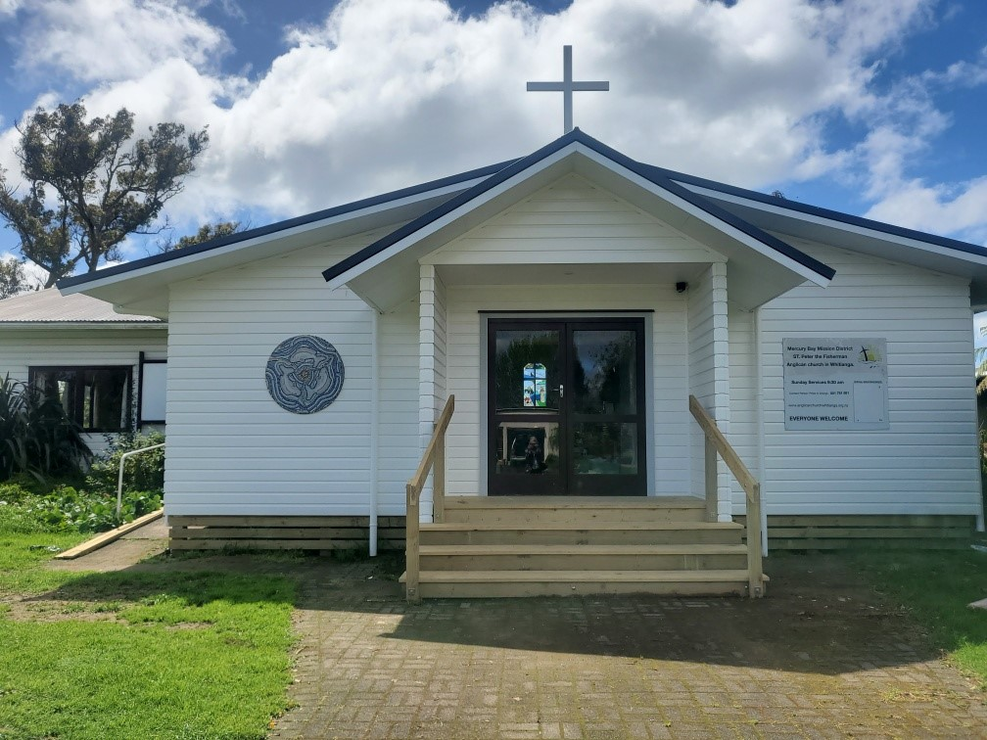

St Peters Church

OUR MISSION STATEMENT:

TO KNOW AND MAKE KNOWN THE LOVE OF GOD”

September - October 2023 Worship Services at St Peter’s
Sunday 3rd September  Presider: Gillian Reid  Gospel and Reflection | HOLY COMMUNION 9.30am  Liturgist: Kaye Evans  Gillian
Sunday 10th September  Presider: Gillian Reid  Gospel and Reflection | HOLY COMMUNION 9.30am  Liturgist: Sharon Short  Maxwell
Sunday 17th September  Presider: Gillian Reid  Gospel and Reflection: | HOLY COMMUNION 9.30  Liturgist: Nicky Hewlett  Gillian
Sunday 24th September  Presider Gillian Reid  Gospel and Reflection  Sunday 1st October  Presider: Gillian Reid  Gospel and Reflection  Sunday 8th October  Presider: Gillian Reid  Gospel and Reflection  Sunday 15th October  Presider: Gillian Reid  Gospel and Reflection:  Sunday 22nd October  Presider Gillian Reid  Gospel and Reflection  Sunday 29th October  Presider Gillian Reid  Gospel and Reflection | HOLY COMMUNION 9.30am  Liturgist: Dawn Schibli  Maxwell  HOLY COMMUNION 9.30am  Liturgist: Kaye Evens  Gillian  HOLY COMMUNION 9.30am  Liturgist: Dawn Schibli  Maxwell  HOLY COMMUNION 9.30am  Liturgist: Sharon Short  Gillian  HOLY COMMUNION 9.30am  Liturgist: Nicky Hewlett  Maxwell  HOLY COMMUNION 9.30am  Liturgist: Kaye Evans  Gillian
GILLIAN’S MONTHLY MUSINGS
We are currently well into the Liturgical segment of the church year known as ‘Ordinary Time’. I am often asked what this means – so here is my potted version.
The Christian year includes two central cycles focused on major events in the life of Christ: the Christmas cycle (Advent-Christmas-Epiphany) and Easter cycle (Lent-Easter-Pentecost). Each of these seasons begins with a time of preparation and anticipation followed by a time of celebration. A season designated as Ordinary Time follows each cycle.The word "ordinary" here does not mean “routine” or “not special.” Instead, it refers to the "ordinal numbers" (first, second, third, etc.) used to name and count the Sundays (such as the Third Sunday after Epiphany). This term comes from the Latin ordinalis, meaning "numbered" or "ordered." (I am happier with Latin than I am with math. )
The first period of Ordinary Time, the Season after Epiphany, begins on Epiphany Day and ends on the day before Ash Wednesday (the beginning of Lent). The central theme of this season is the calling of disciples and the early ministry of Jesus. We are currently in the second period of Ordinary Time, the Season after Pentecost, that follows the Easter cycle. It begins the day after Pentecost and continues to Advent. The purpose of this season is to support new disciples and the whole congregation in living out the gifts and callings discerned during the Easter Season and commissioned on the Day of Pentecost.
Every year, we experience the contrast between the central seasons of Christmas and Easter, where we see God in the significant events around the coming of Christ, and the in-between times, where we see, speak about and join God’s ongoing work in the world. We thus experience two regular cycles of preparation, celebration and action, with the Ordinary Times as the primary periods of action. The actions we take over this time relate to our personal journeys of faith, and how we live them out in our daily lives.
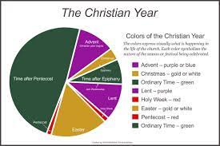
There is a very significant part of our year assigned to this. Clearly it is hoped that our actions reflect the time allocated to them.

Manaakitanga,
Gillian

Health News - The wisdom of a Japanese Doctor
Q: Doctor, I've heard that cardiovascular exercise can prolong life. Is this true
A: Heart only good for so many beats, and that's it... Don't waste time on exercise. Everything wear out eventually. Speeding up heart not make you live longer; it’s like saying you extend life of a car by driving faster Want to live longer? - Take nap.
Q: Should I reduce my alcohol intake?
A: Oh no. Wine made from fruit. Fruit very good. Brandy distilled wine, that means they take water out of fruity bit so you get even more of goodness that way. Beer also made of grain. Grain good too. - Bottoms up!
Q: What are some of the advantages of participating in a regular exercise program?
A: Can't think of one, sorry. My philosophy: No pain..very good!
Q: Aren't fried foods bad for you?
A: YOU NOT LISTENING! Food fried in vegetable oil. How can getting more vegetable be bad?
Q: Is chocolate bad for me?
A: You crazy?!? HEL-LO-O-O!! Cocoa bean! Another vegetable! It best feel-good food around.
Q: Is swimming good for your figure?
A: If swimming good for figure, explain whale to me.
Q: Is getting in shape important for my lifestyle?
A: Hey! 'Round' is also a shape!
Well... I hope this has cleared up any misconceptions you may have had about food and diets.
And remember:
Finally, the Japanese Doctor summed up: Look mister, Life should NOT be a journey to the grave with the intention of arriving safely in an attractive and well-preserved body, but rather to skid in sideways - Beer in one hand - chocolate in the other - body thoroughly used up, totally worn out and screaming "WOO-HOO, what a ride my life was"!!!!! Eat whatever you like because you will still DIE, don't be deceived.
1. The inventor of the treadmill died at the age of 54.
2. The inventor of gymnastics died at the age of 57.
3. The world bodybuilding champion died at the age of 41.
4. The best footballer in the world Maradona died at the age of 60. But remember:
5. The KFC inventor died at 94.
6. Inventor of Nutella brand died at the age of 88.
7. Imagine, cigarette maker Winston died at the age of 102.
8. The inventor of opium died at the age of 116 in an earthquake.
9. Hennessey Cognac inventor died at 98.
How did these doctors come to the conclusion that exercise prolongs life?
The rabbit is always jumping up and down, but it lives for only 2 years and the turtle that doesn’t exercise at all, lives 400 years.
So, take some rest, Chill, stay cool, eat, drink and enjoy your life.

Childhood Memories - Gillian
I am the eldest of three, with a sister and brother, who all grew up in Pt Chevalier, Auckland. It was a very working-class upbringing in a working-class suburb. The end of the war clearly influenced our growing up experiences. Our clothes were all made by my mother, she reused plastic bags long before anything like avoiding plastic waste was ever considered, and our vegetables and fruit came from Dad’s vegetable garden or off the dozen or so fruit trees in our back yard. (I never knew people actually bought lemons until I went to England on my OE in my twenties). My Grandad taught me how to spit Loquat pips, from the Loquat tree in his garden, and that watermelon is best eaten when it’s just harvested, cut into large chunks, and sitting on the ground with him. Ditto spitting the pips.
I caught Polio in the epidemic of 1947-48, just before I was due to start school. All the schools were closed for ages, and when they re-opened, I was about 6 months younger than everyone else in my classes, which was a bit hard. I didn’t have Polio really badly, although I wore boots and leg braces for what seemed like a long time. I was so envious of the girls in their ‘Patent Leather Mary Jane shoes’ and that has probably influenced my shoe appeal ever since. After the braces came off, Mum thought that learning ballet may help strengthen my legs, so I was duly enrolled in Miss Marmont’s Ballet school. That can only be considered an unmitigated disaster. I was always daydreaming, and forgetting my steps, and in the only major ballet recital I was sent to, at one point completely forgot to go on stage with my class, still mucking around at the back with a friend from another ballet school. So ended my potential career as a ballet dancer.
I would have been at least 9 or 10 before we got our first refrigerator – we had an icebox up to then, the block of ice refreshed every week by the Ice Man. We didn’t have a car until I was well into my teens, a Hilman Minx, and my Dad taught me how to drive – it was especially challenging trying to do a handbrake start on the hugely steep Bullock Track by Western Springs.
We walked to Pt Chevalier Primary School – well everybody did – and also to church on Sundays, (The Anglican Church of the Ascension). Firstly, Sunday School then later in the Church Choir and Young Anglican Group – where I fared somewhat better than my ballet efforts. All of them quite large groups, full of us ‘baby boomers’. We learned to read by using phonetics, and to write using pens and inkwells – which were filled every morning by the ‘ink monitors’. We had school milk, delivered in crates of half-pint bottles, which in the Summer had plenty of time to go off before we were issued them at morning playtime.
Before Selwyn Village was built, Mum used to take my sister and me to a big area of scrub near the beach, to collect blackberries in season, into tin Billy Cans. More was eaten than went into the cans, but Mum cooked the fruit then hung it in muslin to capture the juice for blackberry jelly. We local kids were very annoyed when Selwyn Village was built as that area was also a favourite play area for us all.
We also mostly walked to Pt Chevalier beach – quite a lot further - for swimming and generally hanging out with our friends. In those days the boys would show off by diving off the end of the Point (known for some reason as the Piper Rocks, possibly because of what could be caught there fishing), and swim under the rocks to bring out crayfish – which of course made all the girls scream. I had my first boyfriend, George Wheeler, when I was in Standard Four, and my Dad told me he was to stop hanging around unless he was willing to come and mow our lawn – which he then did.
I also joined Girl Guides, and managed to do reasonably OK there as well, although that was where I decided that camping under canvas with little or no facilities was definitely not how I planned to spend my adult recreation/holiday times.
I went on to Pasadena Intermediate School – the very early days of actually having Intermediate Schools – and then to Auckland Girls’ Grammar. This was just at the end of having Trams and moving to ‘high-tech’ Trolley Busses, where the poles up to the overhead lines came off at least once every trip. I suspect the drivers never got used to having the vehicle not held on tracks as the trams were. AGGS was also a big school – baby boomers bumping the numbers up to nearly 3,000. Our school uniforms were rigorously checked for suitability – the hems had to just clear the floor when we knelt for prayers. We also had to wear only approved PE gear – which included “bloomers” – a sartorial feature we seriously hated even then. There were 9 Academic “A” streams when I started, and my steady academic downfall started then. Because I was good at English and literature I was placed in the top stream – and my deficiencies in all math and science programs became all too obvious as time went on. My math and science teachers informed me at the time of moving into the fifth form, that I was strongly advised not to consider any of their programmes for School Certificate. They would probably roll over in their graves if they found out I eventually made a career in Computers.
It all felt like a very ordinary upbringing in a very ordinary suburb, but looking back now, we had such a safe, comfortable, unencumbered life, it was probably a magical existence we never realised would not go on for ever.
October Birthday Wishes
In the month of October, we wish a Happy Birthday to Lisa Biddick

Don’t Forget our Outreach and Activity Groups
Knit for a Purpose:
Meets on the first and third Friday of the month, from 10.00am to 12.00pm, for good coffee, morning tea, and fellowship, while making garments and blankets for children in the care of the Anglican Trust for Women and Children. Knitting yarn, needles and patterns supplied, along with encouragement and helpful advice if needed. New members are always welcome.

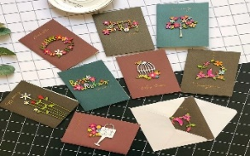
Card Making:
Meets on the second and fourth Friday of the month, from 10.00am to 12.00pm, for good coffee, morning tea, fellowship, and loads of laughs as we try to follow our teacher’s guidance to make personalized greeting cards. (There are no such things as mistakes, just creative differences, easily concealed if desired). Heaps of resources are available to share. New members, skilled or unskilled, are always welcome.
Seniors Strength, Balance, and Mobility classes:
Meets every Thursday morning, 10.00am to 11.00am. For ‘seniors’ - how to exercise sitting down or leaning on a chair, without breaking out in a sweat. All levels of personal unfitness welcome! Join in any time.

Men’s gardening group:
Meets on Friday afternoon, 1.00pm for a couple of hours working in the church garden producing vegetables for Community Social Services and maintaining the church grounds. All keen (or just hopeful) gardeners welcome. Contact Maxwell on 0274 906 120.

WHO’S WHO AT ST PETERS
Clergy: Priest in Charge | Rev. Dr. Gillian Reid
Verger | Vic Dalbeth
Licensed Lay Ministers: | Sharon Short  Nicky Hewlett
 | Dr. Maxwell Reid
Vestry: People’s Warden | Jill Laird
Priest’s Warden | Sharon Short
Synod Rep | Nicky Hewlett
Secretary and Synod Rep | Kaye Evans
Treasurer | Bob Schibli
Webmaster & Safety Officer  Maintenance coordinator  Vestry Member | Maxwell Reid  Alan Andrews  Anna Andrews
Worship Team: | Gillian Reid
(Roster Coordinator): | Maxwell Reid
 | Dawn Schibli
 | Nicky Hewlett
Sharon Short
Jill Laird
Kaye Evans
Pastoral Care Team: | Dawn Schibli
 | Gillian Reid
 | Nicky Hewlett
 | Jill Laird
 | Sharon Short

website: wwwanglicanchurchwhitianga.org.nz
Facebook: ww.facebook.com/stpeter.thefisherman.96
Mercury Bay Mission District contact person: Jill Laird
Ph. 8660641, jilliannelaird48@gmail.com

