NETWORK NEWS
ST PETER’S ANGLICAN CHURCH
MERCURY BAY MISSION DISTRICT
September 2022

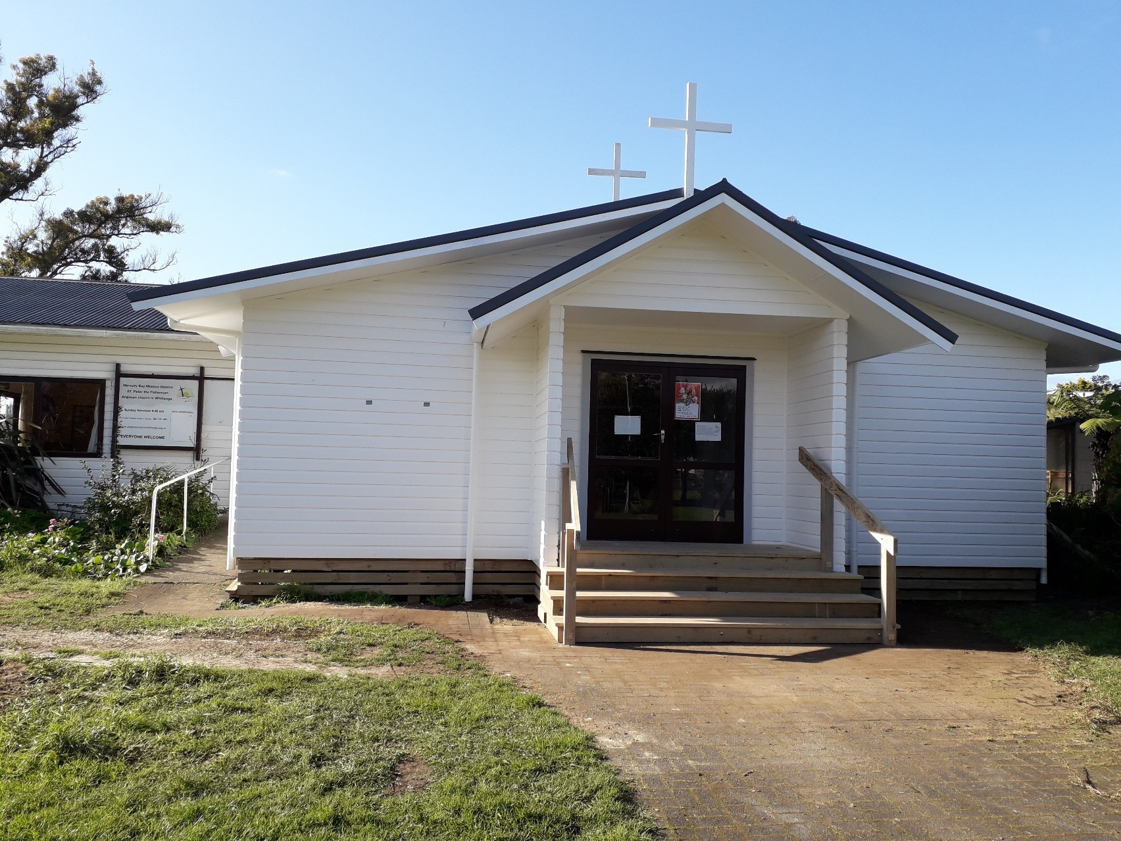

St Peters Church as at 30TH August 2022

OUR MISSION STATEMENT:

TO KNOW AND MAKE KNOWN THE LOVE OF GOD”

SEPTEMBER WORSHIP SERVICES AT ST PETER’S
Sunday 4th September  Presider: Gillian Reid  Gospel and Reflection | HOLY COMMUNION 9.30am  Liturgist: Dawn Schibli  Gillian Reid
Sunday 11TH September  Presider: Gillian Reid  Gospel and Reflection | HOLY COMMUNION 9.30am  Liturgist: Sharon Short  Maxwell Reid
Sunday 18th September  Presider: Gillian Reid  Gospel and Reflection: | HOLY COMMUNION 9.30  Liturgist: Nicky Hewlett  Gillian Reid
Sunday 25th September  Presider Gillian Reid  Gospel and Reflection | HOLY COMMUNION 9.30am  Liturgist: Dawn Schibli  Maxwell Reid
Weekly Service Roster
If you swap a duty with someone else – reading, chalice bearer, prayers etc., as well as changing it on the roster by the door please would you let the Liturgist for that Sunday know as they may not check the alterations during the week. This will make it much easier for them when putting the service together. Many thanks.

GILLIAN’S MONTHLY MUSING

The radio station Maxwell and I listen to in the mornings, has just started a little segment called “Today’s Good News Story”. Activated, primarily, I think, because like us, the newsreaders seem to be stuck with one depressing news story after another and wanted something to lighten up their and our mornings. They have a point. On a daily basis we seem to be seeing or hearing or reading about one disaster or tragedy after another. So much, and so big, that it is hard to wrap your head around the enormity of the challenges people are facing, with lives changed forever and futures in doubt.
I know that the Good News of Jesus is going to be my light and salvation, but the here and now of human and environmental challenges tearing lives apart can sometimes make it hard to hear the words through all that ‘white noise’. Every time I face a difficult decision, or uncertainty, I use the WWJD mantra, and without fail it sets me right. What Would Jesus Do?
Pray that lives in turmoil can be set right. Pray that people misusing and abusing power can step back and realise the human consequences of their actions will only leave them guilty of crimes and damage that will never be forgotten. Plus, they have become the inheritors of devasted environments and people who may never be brought back to health and usefulness. Pray that we can turn back the increasing impact our own environmental carelessness is having on this one world we have to live in. It is easy to think of examples of all the above. Ukraine, and our own area of Nelson are typical top of mind situations.
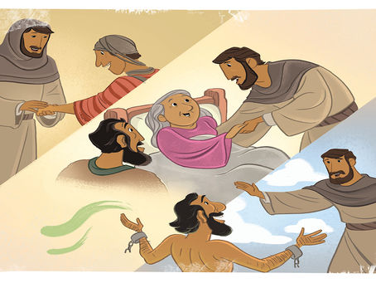
Jesus would ask more of us. He also said Prayer is fine, but without action it is dead. We have to live out this part of His Good News in real actions to counter the issues we face and see in this broken world. Otherwise, Jesus’ Good News will never be heard and valued. Every time we do even a small thing to help ease the burdens others are carrying, we spread the Good News. Better than just a one minute clip on the local radio station.
Manaakitanga,
Gillian

**********************************************
LAUGHTER Really IS THE BEST MEDICINE !!!!

Don't let your worries get the best of you; remember, Moses started out as a basket case.
A guy’s wife kept asking her husband, “if I die, would you marry again?”. He said “no”, but after the tenth time he was asked, he gave in and said, “alright then, yes”. She continued, “and would you let her use my golf clubs?” He replied “No! – anyway, she’s left-handed”.
“Darling, where do we keep our old VHS tapes?” “In the attic, why?” “Because I want to find one showing Australia winning the Bledisloe Cup!”

Memorable THOUGHTS ON LIFE
“An educated person, I think, is one who not only knows a lot but knows how to do a lot of things.” ― Henry Ford
“The whole secret of a successful life is to find out what is one’s destiny to do, and then do it.” ― Henry Ford

Success is not final, failure is not fatal, it is the courage to continue that counts – Sir Winston Churchill

“If ordinary means I have suddenly got to produce a household of kids and iron Peter's shirts, I'm sorry, I'm not interested.” -- Helen Clark

“With practice and focus, you can extend yourself far more than you ever believed possible.”
-- Sir Edmund Hillary

Childhood Memories – by Anna Andrews
Early Years – Anna
I was born in Rotorua in 1958 the third child of four to Alex and Merle Parkinson. Ahead of me was my sister Christine and brother Glen. Glen was eleven years older than me, so he got to be an only child for eight years. My brother Bruce was two years younger. We lived about equal time in Rotorua and Taupo before moving to the logging town of Murupara when I was about 3. Dad was a chef and after being approached changed from the restaurant trade to industrial cooking at the KLC Single Men’s camp in Murupara. We lived in the Single Men’s camp - one of only two families – the other being the Camp Sergeant. We had I think the best spot in town. In the front of us was the rugby grounds, to the left the netball and tennis courts and to the right the town swimming pool (had to wait a few years for that to be built and ready for use). Then it was a quick run across the rugby field to the primary school we attended or to the town centre. When the circus came to town, they were in the paddock next to the swimming pool so again right on our doorstep.
There are two rivers that run past Murupara, and many weekends were spent swimming in them. Adult supervision meant “be home by 5”. There were bike rides out to the Bailey bridge to swim and forest and native bush to play in to let our imaginations run wild. Blackberry picking was always a good one and my friend’s mother actually paid us for our fruit! We would have gone anyway but did perhaps cut down the amount eaten slightly whilst we collected the berries.
I enjoyed gymnastics but there was no club in Murupara so apart from the little we did through PE at school (a few mats and the vaulting horse was it). I very much enjoyed getting our younger neighbours and friends to crouch down and I would see how many I could dive over ending with a forward roll - mostly successfully - onto our couch squab. High jump with a broom stick between chairs was also popular (plus a dive forward roll over could also be a challenge. We enjoyed jumping from a large box to the top bar of the swings (still have a callous on one hand from that). Was enrolled for ballet, got the shoes, and promptly used them to walk across the top bar of the swings. Very few ballet lessons followed that.
As both Mum and Dad worked, we had a housekeeper who came in at 6 in the morning till one and then again 3 to 6.30. We had some good ones – Celia was a favourite. I recall one time she looked after us while Mum and Dad were out of town. However, that particular week a tangi unfolded. Celia’s husband being one of the elders left no option but for Christine, Bruce, and I to move with them down to the local Pa staying several nights in the meeting house. Again, a lot of fun – well we thought it was. Mum was a little shocked, as she did not know where we were when she got home. Mrs. Kaire another housekeeper made a fabulous Apple Pie and had three grandsons who were excellent to play a game or two with. Plus, she enjoyed knitting and we

would get up early to sit for an hour or so with her knitting in the kitchen. At the other end of the scale was Nan who had come from Scotland. She found electrical appliances a huge challenge and so in turn cooking for us. Although come Sunday she felt we three children should sing hymns with her while she played with the heaviest hands, I have ever seen use our piano – singing very loudly herself – we just had to move our lips. She did not last that long!
One club we did have was a “Marching Girls Club”. I was an inaugural member of the Murupara Oregon Midget Marching Team. We even had our own song (which I found later was the music to a rather “saucy” song – someone had a sense of humour). We even made the North Island Championship one year in Hamilton! For many that was like a trip overseas. We actually did not even stay the night – we left on a hired Road Services Bus before light and came home very late. No motels or eating out for us. I got to be leader once – we made a guest appearance at the Minginui Gala Day. I got to blow that whistle at last. I do remember we had to march on rather uneven ground and the grass was overdue for a mow, but we did our best.
A memory is the Marching team always needed a top up of funds for new uniforms and money to help with travel. An efficient method over the four years I was involved was our annual “bottle drive” through all the streets in town. This always provided us with a healthy reward for our efforts.
I always enjoyed numbers and as I was too young to work in the Kitchen, unlike my sister who got holiday work especially if Dad was doing catering for some event. She even got paid! As for me I use to look after the camp canteen on Friday and Saturday mornings from 6 am to School time on a Friday and about 9ish on Saturday as these were Mum’s days off. It meant Dad did not have to look after both the Kitchen and the Canteen when Mum was not there. I did not get paid! However, let’s just say I usually had a soft drink or some chocolate to help see me through plus I really enjoyed adding up what the customer had bought and giving the change (no machine - just a pencil and paper – Maths for 3 solid hours!). By the way my sister is a wonderful cook and is able to cater for the masses…. I enjoy her cooking.
At about aged six we started coming to Cooks Beach for holidays and within a year of using a friends batch Mum and Dad bought a place in Riverview Road, Cooks Beach which they retained for around 45 years. For the first five or so years the local farmers – Harsant’s – delivered milk from the back of a trailer around the streets at Cook Beach each evening. Harsant’s farm is now a huge housing development at the Purangi end of Cooks Beach. We enjoyed our 3 weeks at Christmas each year plus all statutory holiday long weekends. Christmas holidays were the best with lots of fun with our neighbours which included four families. Many a trek over to Lonely Bay, swimming at Flaxmill Bay, bonfires, collecting pipis, fishing at the wharf, and other fun games. Another fun activity was jumping or diving off the wharf on the Whitianga side. All went well

until my brother Bruce decided he would give the jumping off a go. Trouble was he could not swim – his excuse after being rescued (not by me) was “Anna did it". Once again “be home by 5” was the rule but at the beach we got to go out after dinner to play with our friends. Other Cooks Beach memories include catching the ferry and going to the Sound Shell – at night – “after 5” for the Summer Concert which was a lot of fun especially with the likes of “Lou and Simon” as entertainment. It was great to attend (very few concerts in Murupara!). Another is racing in our dinghy’s up and down the tidal creek behind our Bach at Cooks Beach or just exploring to see how far up the creek we could get in them.
It was about a 5-hour non-stop journey to Cooks Beach from Murupara and of course we did stop – takeaways at Te Aroha usually. Always a bit of squeeze at Christmas with the cat in a beer crate with a lid nailed down to keep him in and he was seated on the back seat with Chris and I. My brother in the front with Mum with his round tin to empty, whatever he had eaten (or even considered eating) into as we made our way north. Mum liked to sing, and my sister liked to make sure we had the words perfect. So, the song book was duly prepared by playing and replaying records countless times during the months before we did our trip, sketches of pretty flowers were included on each page, and we sang. If I happened to get the words wrong (often) Chris would make us start again. You did learn them, and I have to say some songs I still know from beginning to end from those days. Bruce seem to get a free pass as he had other things to do….. Mum would at times go rogue and sing some songs she liked and knew, and Dad would join in occasionally on those ones such as “Blue Heaven” and others from that era.
A Christmas memory I have started out a little gloomy with both Christine and Bruce getting new bikes for Christmas before we left to go Cooks Beach which we always did on Christmas Eve. I have to admit to feeling a little (let’s say) down given my bike was second hand (even the basket on the front was second hand) and not a shiny red colour like theirs. Well Christmas day was just the best ever I got much more than my brother and sister, and all was forgiven and shiny red whatever’s forgotten. Plus, I did get a Raleigh 20 when I turned 13 so on reflection it was a pretty much spot on “fair and even” between us all. We moved to Kawerau in 1971 where I started college. Mum and Dad did not enjoy Kawerau at all – it was bigger and not the close community relationships they had in Murupara, so they were only there for three years before heading to Cooks Beach to live permanently. Dad threw in the Commercial Cooking after the Kawerau Mill stint (1200 men to provide breakfast lunch and dinner per day). Dad took up the role of Hydatids Control Officer for the whole of the Coromandel after some training at Massey. He said he knew every man and his dog on the Peninsula and Mum enjoyed going with him. I stayed on in Kawerau to finish my schooling as I was part way through the fifth form at the time when they moved so ended up boarding with my friend’s family. I actually started work for Caxton Paper Mills in Kawerau as a trainee Cost Accountant but after a couple of years I chose to go to university to study Accountancy. I considered myself pretty grown up by then.

September Book Review –
Air Marshal Sir Keith Park, by Murray Rowlands
In May 2009 the Westminster City Council agreed to erect a 2.78-metre (9-foot) statue of the New Zealander Sir Keith Park in Waterloo Place. This was unveiled on 15 September 2010 by the then Mayor of London, Boris Johnson on the 70th anniversary of the Battle of Britain. The cast model for this statue was made by Weta Workshop in Wellington, a temporary statue of Park which was unveiled on the empty fourth plinth in Trafalgar Square in November 2009. This fiberglass sculpture was in place until May 2010, when it was moved to the Royal Air Force Museum in London. He has been further memorialised with a bronze statue in his hometown of Thames in the Coromandel Peninsular
When Sir Keith Park’s name is mentioned in relation to the battle of Britain, it is more often than not met with a blank stare. Who? This man led the main air defenses against the German Luftwaffe in 1940, saving the country from a looming invasion.
The Battle of Britain from July to September 1940 is one of the finest moments in Britain’s history. While credit rightly goes to “the few”, victory could never have happened without the inspirational command and leadership of New Zealander Keith Park. He and Air Chief Marshal Sir Hugh Dowding ensured that Fighter Command was prepared for the German onslaught. Promoted at the time to Air Vice Marshal, Park took over Number 11 Group, an area responsible for the defence of London and Southeast England in April 1940. A shrewd tactician and hands-on commander, Park carefully husbanded his limited resources and famously wore down Goering’s Luftwaffe, thus forcing Hitler to abandon his invasion plans.
Shamefully, Dowding and Park were dismissed from their commands in the aftermath of the victory due to shabby RAF internal politics and the old school tie associations. Fortunately, Park’s career was far from over as he was sent to take charge of the defence of Malta. His skilled management of the defence contributed to victory by the Allies in the Mediterranean and North Africa.

This balanced and well overdue account of his work hopefully ensures that Air Chief Marshal Sir Keith Park receives credit for victories that he so richly deserves.
This biography contains significant new information and insights into both Park’s professional career and his private life. Keith Park was a very modern commander who fully appreciated how all the elements of an armed force must work effectively together to produce optimal outcomes. His military career, saw him leave New Zealand in 1915 as a Corporal in the New Zealand expeditionary Force, taking part in the Gallipoli landing, and return in 1948 as a much-decorated retired Air Chief Marshal. Through all this he remained an undemonstrative, modest man who led by example. He had no time for the lax and incompetent. In crisis after crisis, he displayed leadership of the highest order. Few individuals during World War 2 did more than Sir Keith Park to defend and uphold the values of freedom and justice while Britain and her commonwealth stood alone. In this book Murray Rowlands (originally from Christchurch) makes that clear and sets out the debt we owe him. This defiance of Park’s was only the beginning of every decent country in the world joining the fight against the villainous oppression of a disgusting regime.
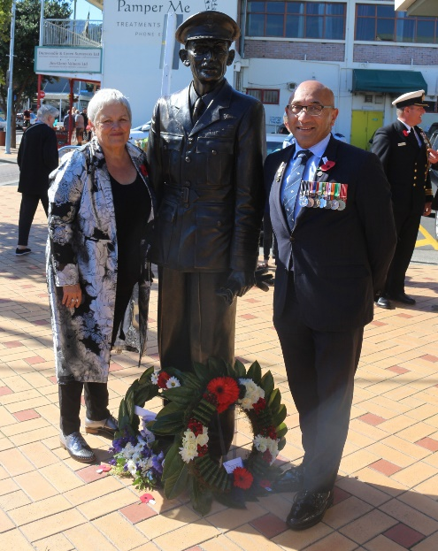
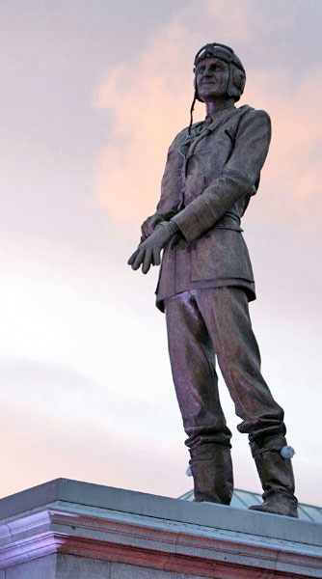
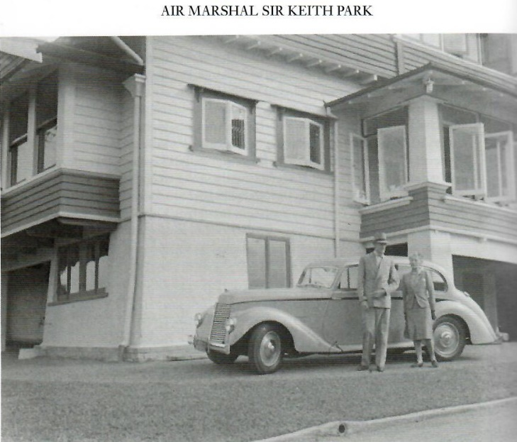
- The statue in Thames. (His hometown in the Coromandel).
- The statue in London.
- Outside his home in Remuera, Auckland.

Some Prayers for quiet reflection
True peace, through the life and death of Jesus, through the life and death of Jesus, you show us that we must live more than just the mere law. Indeed we must be the people of true faith and hope. Give us courage as your forgiven people, to be truly humble, and forgiving of others. With Jesus we pray. Amen.
Lord, I pray that you will cleanse me, strengthen me, guide me, so that in all ways my life may be lived as you would have it lived, without cowardice and for you alone. Show me how to live in true humility, true contrition, and true love. Amen.

Lord, thank you for enabling me to be still in your presence. You are my strength, and I trust in you. Amen.
I come before you, oh Lord, and drink in this moment of peace, that I may carry something of your hope, love, and joy today in my heart. Lord, grant me tenacious winsome courage as I go through this day. When I am tempted to give up, help me to keep going. Grant me a cheerful spirit when things don't go my way. Amen.
Holy God, you never cease to call us, even though we tremble at the rumour of your presence. Like Paul, may we faithfully witness to your everlasting life, experienced in the person of Jesus. Send us out into the deep places of our world, that we may humbly share your abundant grace with all. Amen

Operation Christmas Child
Yes, Christmas is not far away, and again we have the opportunity to support OCC in its endeavours to bring a small amount of cheer into the lives of children who otherwise woud have little to celebrate at Christmas. We have the boxes available for people to collect and fill with small gifts which will make Christmas memorable for these children.This year we wwill also have a table in the church for people to contribute items suitable for the boxes, if they don’t feel they can fill a whole box

themselves. These items can be picked up and used to fill other boxes, so again, even a small gift can be part of a larger one. The Good News again.
The boxes will be collected at Labour Weekend, so now is a good time to start getting the bits and piece to make up a box or two which genuinely will make a big difference to a small person.
FOOD BASKET – don’t forget your donation to the Social Services Food Basket. This is a very worthy cause, as there are families in Whitianga who are really struggling.

September Birthday Wishes
Nobody to embarrass this month.
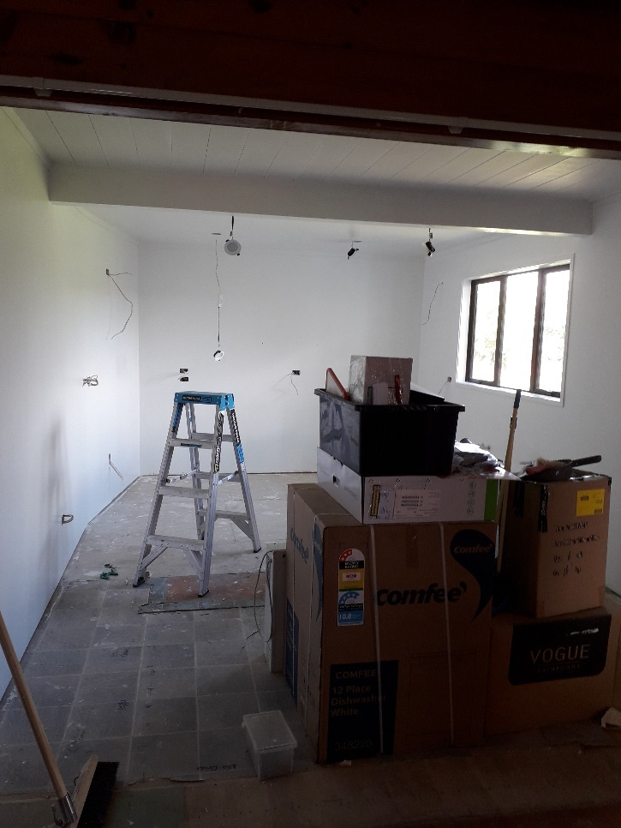New Kitchen progress

Don’t Forget our Outreach and Activity Groups
Knit for a Purpose:
Meets on the first and third Friday of the month, from 10.00am to 12.00pm, for good coffee, morning tea, and fellowship, while making garments and blankets for children in the care of the Anglican Trust for Women and Children. Knitting yarn, needles and patterns supplied, along with encouragement and helpful advice if needed. New members are always welcome.

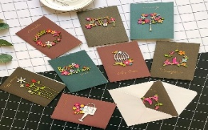
Card Making:
Meets on the second and fourth Friday of the month, from 10.00am to 12.00pm, for good coffee, morning tea, fellowship, and loads of laughs as we try to follow our teacher’s guidance to make personalized greeting cards. (There are no such things as mistakes, just creative differences, easily concealed if desired). Heaps of resources available to share. New members, skilled or unskilled, are always welcome.
Seniors Strength, Balance, and mobility classes:
Meets every Thursday morning, 10.00am to 11.00am. For ‘seniors’ - how to exercise sitting down or leaning on a chair, without breaking out in a sweat. All levels of personal unfitness welcome! Join in any time.

Men’s gardening group:
Meets on Friday afternoon, 1.00pm for a couple of hours working in the church garden producing vegetables for Community Social Services and maintaining the church grounds. All keen (or just hopeful) gardeners welcome. Contact Maxwell on 0274 906 120.

WHO’S WHO AT ST PETERS
Clergy: Priest in Charge | Rev. Dr. Gillian Reid
Verger | Vic Dalbeth
Licensed Lay Ministers: | Sharon Short  Nicky Hewlett
 | Dr Maxwell Reid
Vestry: People’s Warden | Jill Laird
Priest’s Warden | Sharon Short
Synod Rep | Nicky Hewlett
Secretary | Kaye Evans
Treasurer | Bob Schibli
Webmaster & Safety Officer  Vestry member | Maxwell Reid  Alan Andrews
Worship Team: | Gillian Reid
(Roster Coordinator): | Maxwell Reid
 | Dawn Schibli
 | Nicky Hewlett
Sharon Short
Jill Laird
Pastoral Care Team: | Dawn Schibli
 | Gillian Reid
 | Nicky Hewlett
 | Jill Laird
 | Sharon Short

website: wwwanglicanchurchwhitianga.org.nz
Facebook: ww.facebook.com/stpeter.thefisherman.96
Mercury Bay Mission District contact person: Jill Laird
Ph. 8660641, jilliannelaird48@gmail.com

Progress on our building extension
It is all getting quite exciting. The security fencing has gone, and the new front entrance is now useable. It’s lovely to be able to use our front door again. The kitchen units will be here about September, and we will have our new toilets operational about the same time. It has been a long wait, but the end is close!
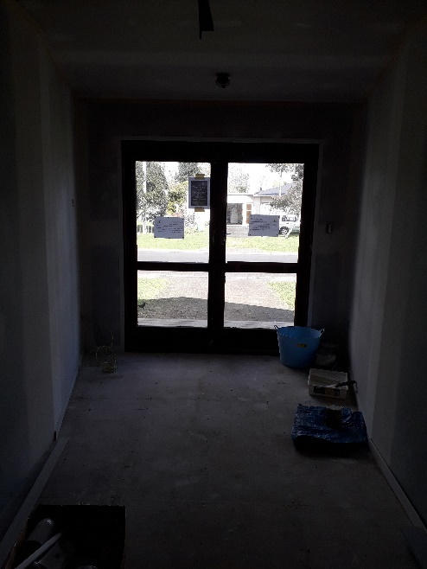
New welcoming area
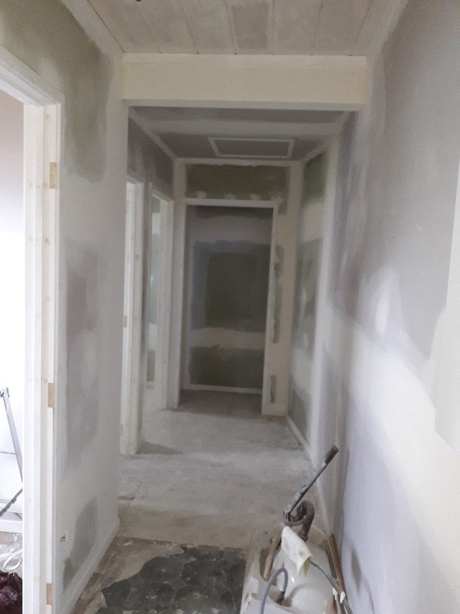
Corridor leading to new storeroom, cleaning cupboard and two toilets, being painted by parishioners.

