NETWORK NEWS
ST PETER’S ANGLICAN CHURCH
MERCURY BAY MISSION DISTRICT
October 2022

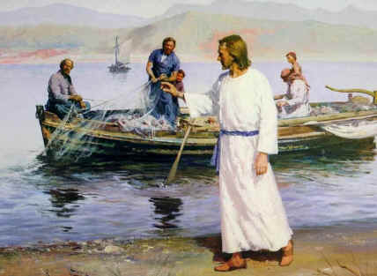

St Peters Church

OUR MISSION STATEMENT:

TO KNOW AND MAKE KNOWN THE LOVE OF GOD”

OCTOBER WORSHIP SERVICES AT ST PETER’S
Sunday 2nd October  Presider: Gillian Reid  Gospel and Reflection | HOLY COMMUNION 9.30am  Liturgist: Nicky Hewlett  Gillian Reid
Sunday 9TH October  Presider: Gillian Reid  Gospel and Reflection | HOLY COMMUNION 9.30am  Liturgist: Dawn Schibli  Maxwell Reid
Sunday 16th October  Presider: Gillian Reid  Gospel and Reflection: | HOLY COMMUNION 9.30  Liturgist: Sharon Short  Gillian Reid
Sunday 23rd October  Presider Gillian Reid  Gospel and Reflection | HOLY COMMUNION 9.30am  Liturgist: Dawn Schibli  Maxwell Reid
Sunday 30th October  Presider Gillian Reid  Gospel and Reflection | HOLY COMMUNION 9.30am  Liturgist: Sharon Short  Gillian Reid
Weekly Service Roster
If you swap a duty with someone else – reading, chalice bearer, prayers etc., as well as changing it on the roster by the door please would you let the Liturgist for that Sunday know as they may not check the alterations during the week. This will make it much easier for them when putting the service together. Many thanks.

GILLIAN’S MONTHLY MUSINGS
Having spent much of the past two years trying to remember to carry and wear a face mask, it became almost surreal when that requirement was dropped, and suddenly we could again see the full expressions on people’s faces. Relying on eyes and body language to interpret moods or responses was challenging, and I certainly realised just how much the face matters in any interchange. Humans really do need ‘all of a self’ for understanding a message properly, and how wonderful it has been to see smiles again, to feel comfortable worshipping together again, and to be allowed to touch and hug one another again.
I expect we all have many regrets about what we have struggled through over that time. A previously unthinkable situation where a new virus was able to spread such chaos, illness, and death over the whole world. Until our scientists and medical researchers, working frantically to understand and find some prevention against it, were able to achieve that, we were all exposed and vulnerable to its attack. As isolated as we were, exposure, and subsequent spread of Covid-19 in its various manifestations still happened, and we will bear the economic and medical consequences of this pandemic for a long time.
And yet, no matter how fed up we all got with the constraints on the way we would wish to live our lives, I have been equally painfully conscious that there are absolutely millions of people around the world who have been, or still are, suffering through circumstances which make our feelings of deprivation seem completely pathetic. All those who have lost everything, in many cases including family members, because of land movements, fire or flood (and many New Zealanders weren’t immune from that either). On top of that, we are now part of the nightmare which is the invasion of Ukraine.
Not only have we witnessed the human cost to the people who have been invaded, lives and homes destroyed, but now the unthinkable is out in the open – the threat from Putin of using nuclear arms to achieve his intention of overcoming the resistance to his military invasion of that country. His hope, presumably, is that this threat will cow both Ukraine and the countries which have helped its resistance to his invasion. It won’t, and we are facing the possibility of a human disaster way beyond the 1960’s Cold War tensions that most of us can remember. At that time, Russia was the one to blink first.
I earnestly pray that the same outcome is reached in 2022. There are only losers in a nuclear war, and we are not far enough away to be immune to the consequences of taking that step.
Gillian

**********************************************
LAUGHTER Really IS THE BEST MEDICINE !!!!
Every time a little boy went to a playmate’s house, he found the friend’s grandmother deeply engrossed in her Bible. Finally, his curiosity got the better of him. “Why do you suppose your grandmother reads the Bible so much?” he asked. “I’m not sure,” said his friend, “but I think she’s cramming for her finals
A teenager brings her new boyfriend home to meet her parents. They’re appalled by his haircut, his tattoos, his piercings. Later, the girl’s mom says, “Dear, he doesn’t seem to be a very nice boy.” “Oh, please, Mom!” says the daughter. “If he wasn’t nice, why would he be doing 500 hours of community service?”
Memorable THOUGHTS ON LIFE

“When you do something beautiful and nobody noticed, do not be sad. For the sun every morning is a beautiful spectacle, and yet most of the audience still sleeps.” – John Lennon
“When you can’t make them see the light, make them feel the heat.” President Ronald Reagan
“A genuine leader is not a searcher for consensus but a moulder of consensus,” Dr Martin Luther King, Jr.

Former U.S. President who had wise sayings based on leadership. “Speak softly and carry a big stick; you will go far,” President Theodore Roosevelt
“You are never too old to set another goal or to dream a new dream.” – C.S. Lewis
The two most important days in your life are the day you are born and the day you find out why." – Mark Twain"

You only pass through this life once, you don't come back for an encore." — Elvis Presley
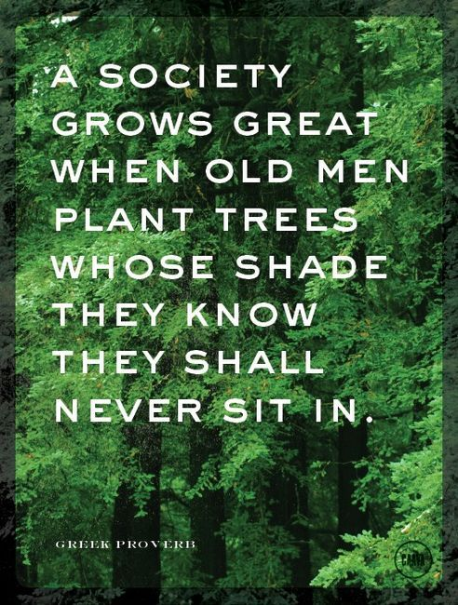

Queen Elizabeth’s Memorial message from Bishop Ross
I think over this past week since Queen Elizabeth died, I have been very conscious of how we are living through a very particular moment in history. One of those times that people will look back on and speak of how historic these weeks were. For me it’s not just been because it was the death of a sovereign who reigned for such a long period of time – the 70 years represented not only the longest monarch in British history but the second longest in the history of any nation. For me it’s been more about what I’ve heard people speak about her amazing virtue of service, her incredible dedication to the duty that she assumed those 70 years ago. We’ve seen so much of those clips where she undertook that promise to serve people, and we’ve been aware of how she has seen that through, consistently over that 70-year period.
Even up until two days before she died, there was that incredible photo of her standing and greeting the new Prime Minister of Great Britain. She saw it through to the end as she had dedicated herself to do. For me as I thought about that, I’ve realised what an incredible evangelist the Queen was. There would be very few people who have listened to her broadcasts at Christmas or at other times, that wouldn’t have been aware of the ways in which she spoke of her faith, not just as a responsibility to govern the Church of England, but in a way that was very meaningful about her own personal sense of faith in God and in Christ, and of being a follower of Jesus Christ. How often she would speak of the strength and hope that she found through her faith and especially when she and her nation had faced particular difficulties and challenges, and through the Covid time she has often spoken of that.
So for me I’ve been impressed as I’ve thought about it by the way in which the Queen is able to do that in a very unthreatening way. Nobody would have ever felt that she was being ‘preachy’ or would have felt overwhelmed by the sense of somebody trying to talk them into something that they maybe didn’t want. But she simply owned her faith and was real about it and spoke of the difference it made in her life. It got me thinking again about whether that’s something that we naturally do, whether we do find it in ourselves when we are speaking of, say, the challenges of life, about how our faith is meaningful to us, and helps us and guides us and strengthens us through things. I sometimes wonder whether we are people who are even prepared to admit to others that, when we talk about our weekends, we say ‘oh of course we went to church on

Sunday’. There’s that reticence in us, sadly often, to speak of the hope that we know through our faith in Jesus Christ, and for me, the Queen has modelled that wonderfully. So I want to celebrate that about her life, not only the virtue of service but that she found that in Christ and was able to speak of that as a follower of one who came not to be served but to serve. I hope, that following that example we might not only give ourselves in the service of others, but we might also find the courage to speak of the faith that enables us to do so.
May Queen Elizabeth rest in peace and rise in glory, to live forever in the presence of the God whom she had served her whole life.
Some Prayers for quiet reflection
Living Word, sow the seeds of your wisdom deep within us. Nourished by your Spirit may these seeds develop into the fruits of justice, love and mercy. Protect us from being choked by the world or distracted by shallow optimism. Instead, inspire us to appreciate you as the ground of our being. With Jesus we pray. Amen.
Lord, I pray that you will cleanse me, strengthen me, guide me, so that in all ways my life may be lived as you would have it lived, without cowardice and for you alone. Show me how to live in true humility, true contrition, and true love. Amen.

Lord, thank you for enabling me to be still in your presence. You are my strength, and I trust in you. Amen.
I come before you, oh Lord, and drink in this moment of peace, that I may carry something of your hope, love, and joy today in my heart. Lord, grant me tenacious winsome courage as I go through this day. When I am tempted to give up, help me to keep going. Grant me a cheerful spirit when things don't go my way. Amen.
Holy God, you never cease to call us, even though we tremble at the rumour of your presence. Like Paul, may we faithfully witness to your everlasting life, experienced in the person of Jesus. Send us out into the deep places of our world, that we may humbly share your abundant grace with all. Amen

Operation Christmas Child
Yes, Christmas is not far away, and again we have the opportunity to support OCC in its endeavours to bring a small amount of cheer into the lives of children who otherwise woud have little to celebrate at Christmas. We have the boxes available for people to collect and fill with small gifts which will make Christmas memorable for these children. This year we wwill also have a large bag in the church for people to contribute items suitable for the boxes, if they don’t feel they can fill a whole box themselves. These items can be picked up and used to fill other boxes, so again, even a small gift can be part of a larger one. The Good News again.
The boxes will be collected at Labour Weekend, so now is a good time to start getting the bits and piece to make up a box or two which genuinely will make a big difference to a small person.
FOOD BASKET – don’t forget your donation to the Social Services Food Basket. This is a very worthy cause, as there are families in Whitianga who are really struggling.

September Birthday Wishes
No birthdays this month

Don’t Forget our Outreach and Activity Groups
Knit for a Purpose:
Meets on the first and third Friday of the month, from 10.00am to 12.00pm, for good coffee, morning tea, and fellowship, while making garments and blankets for children in the care of the Anglican Trust for Women and Children. Knitting yarn, needles and patterns supplied, along with encouragement and helpful advice if needed. New members are always welcome.

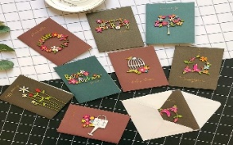
Card Making:
Meets on the second and fourth Friday of the month, from 10.00am to 12.00pm, for good coffee, morning tea, fellowship, and loads of laughs as we try to follow our teacher’s guidance to make personalized greeting cards. (There are no such things as mistakes, just creative differences, easily concealed if desired). Heaps of resources available to share. New members, skilled or unskilled, are always welcome.
Seniors Strength, Balance, and Mobility classes:
Meets every Thursday morning, 10.00am to 11.00am. For ‘seniors’ - how to exercise sitting down or leaning on a chair, without breaking out in a sweat. All levels of personal unfitness welcome! Join in any time.

Men’s gardening group:
Meets on Friday afternoon, 1.00pm for a couple of hours working in the church garden producing vegetables for Community Social Services and maintaining the church grounds. All keen (or just hopeful) gardeners welcome. Contact Maxwell on 0274 906 120.

WHO’S WHO AT ST PETERS
Clergy: Priest in Charge | Rev. Dr. Gillian Reid
Verger | Vic Dalbeth
Licensed Lay Ministers: | Sharon Short  Nicky Hewlett
 | Dr Maxwell Reid
Vestry: People’s Warden | Jill Laird
Priest’s Warden | Sharon Short
Synod Rep | Nicky Hewlett
Secretary | Kaye Evans
Treasurer | Bob Schibli
Webmaster & Safety Officer  Vestry member | Maxwell Reid  Alan Andrews
Worship Team: | Gillian Reid
(Roster Coordinator): | Maxwell Reid
 | Dawn Schibli
 | Nicky Hewlett
Sharon Short
Jill Laird
Pastoral Care Team: | Dawn Schibli
 | Gillian Reid
 | Nicky Hewlett
 | Jill Laird
 | Sharon Short

website: wwwanglicanchurchwhitianga.org.nz
Facebook: ww.facebook.com/stpeter.thefisherman.96
Mercury Bay Mission District contact person: Jill Laird
Ph. 8660641, jilliannelaird48@gmail.com

Progress on our building extension
It is all getting quite exciting. It’s lovely to be able to use our front door again. The kitchen units have arrived, and we will have our new toilets operational about the same time. It has been a long wait, but the end is close!
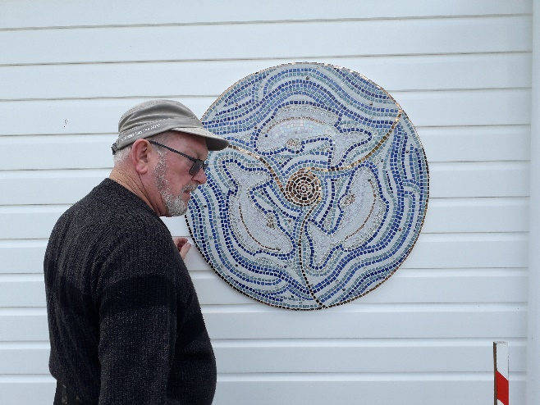
Julie Kipling has created the most beautiful mosaic for the front of the church. Husband Allan is installing it on the front of our church.
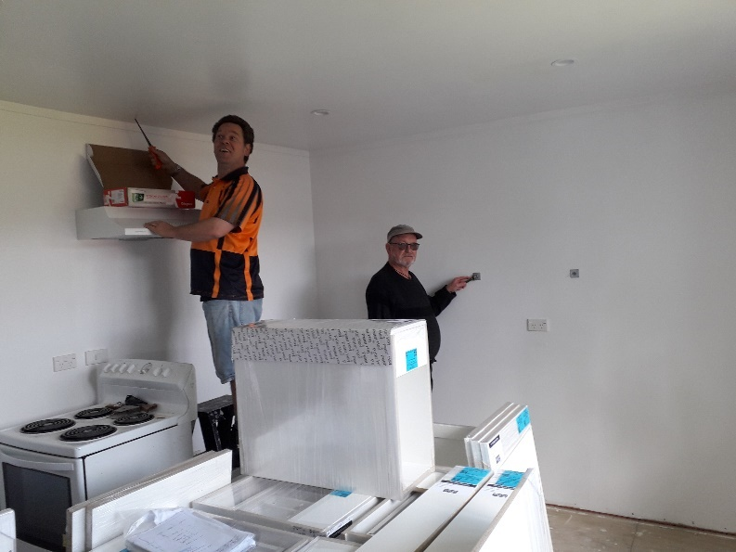
Alan is bolting the mosaic from the kitchen which will make it harder to steal! Damon Christiansen on the left is seen installing the oven extractor fan on the wall which he has kindly donated to the church. The kitchen units are in the middle awaiting the bench tops before installation.

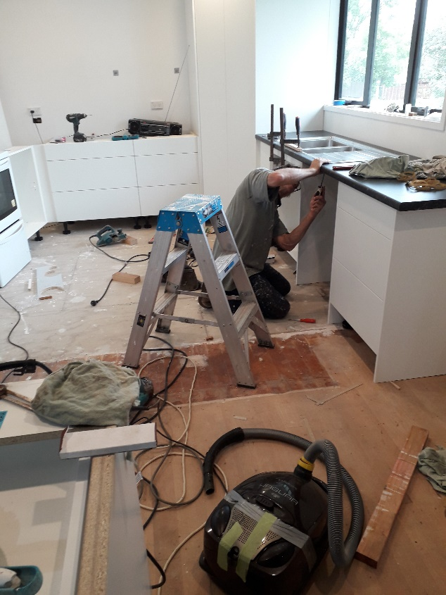
Tony Courtney installing twin sink unit.
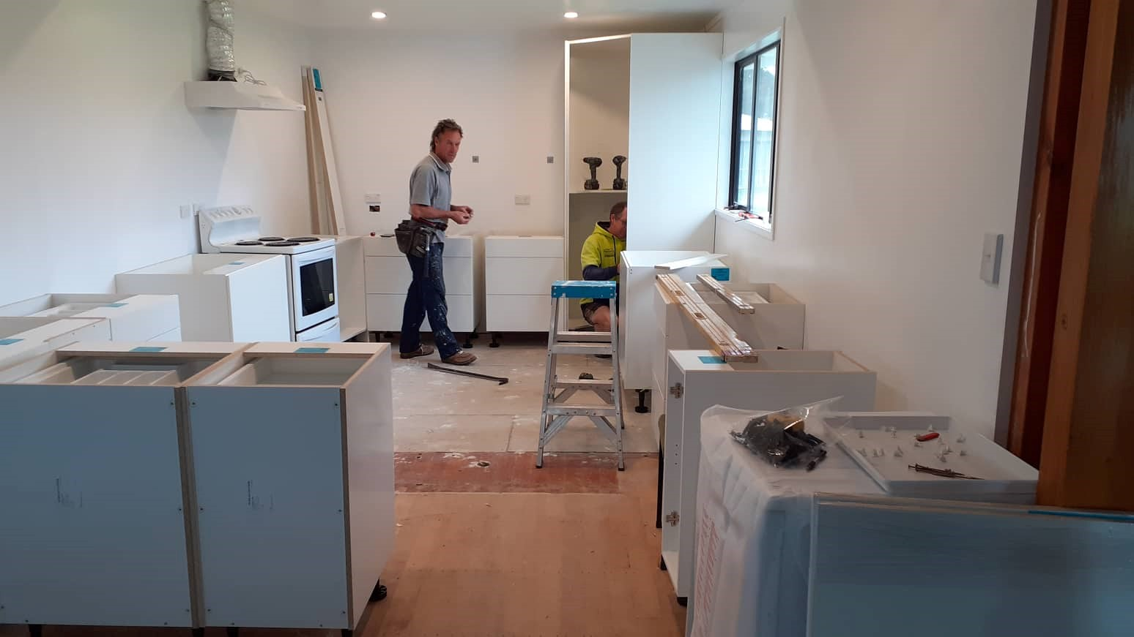
Tony Courtney (left), and Damon Christensen (in the new pantry).

