NETWORK NEWS
ST PETER’S ANGLICAN CHURCH
MERCURY BAY MISSION DISTRICT
November and December 2023

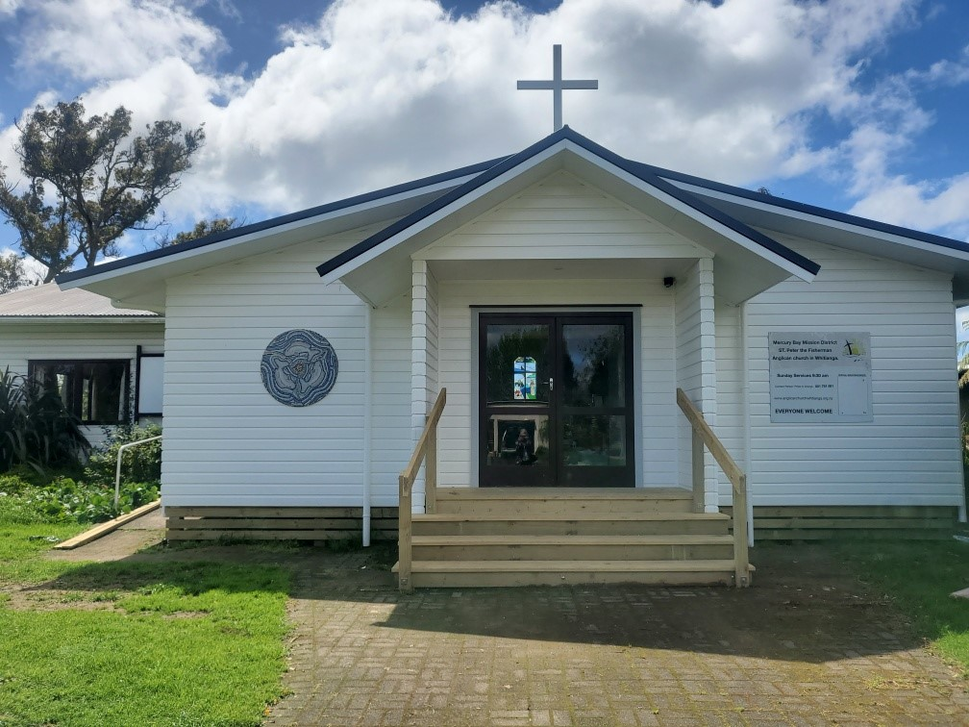

St Peters Church

OUR MISSION STATEMENT:

TO KNOW AND MAKE KNOWN THE LOVE OF GOD”

Our Sunday morning service times are changing to 9.00am start, commencing Sunday November 5th.

November Worship Services at St Peter’s
Sunday 5th November  Presider: Gillian Reid  Gospel and Reflection | HOLY COMMUNION 9.00am  Liturgist: Dawn Schibli  Maxwell Reid
Sunday 12th November  Presider: Gillian Reid  Gospel and Reflection | HOLY COMMUNION 9.00am  Liturgist: Nicky Hewlett  Gillian Reid
Sunday 19th November  Presider: Gillian Reid  Gospel and Reflection: | HOLY COMMUNION 9.00am  Liturgist: Sharon Short  Maxwell Reid
Sunday 26th November  1st Sunday in Advent  Presider Gillian Reid  Gospel and Reflection | HOLY COMMUNION 9.00am  Liturgist: Kaye Evans  Gillian Reid
Weekly Service Roster
If you swap a duty with someone else – reading, chalice bearer, prayers etc., as well as changing it on the roster by the door please would you let the Liturgist for that Sunday know as they may not check the alterations during the week. This will make it much easier for them when putting the service together. Many thanks.

December Worship Services at St Peter’s

Sunday 3rd December  Second Sunday in Advent  Presider: Gillian Reid  Gospel and Reflection | HOLY COMMUNION 9.00am  Liturgist: Dawn Schibli  Gillian Reid
Sunday 10th December  3rd Sunday in Advent  Presider: Gillian Reid  Gospel and Reflection | HOLY COMMUNION 9.00am  Liturgist: Nicky Hewlett  Gillian Reid
Sunday 17th December  4th Sunday in Advent  Presider: Gillian Reid | CAROL SERVICE 9.00am  Liturgist: Gillian Reid
Tuesday 19th December  Presider: Gillian Reid | Remembered at Christmas Service  7pm at St Peters
Sunday 24th December  Christmas Eve  Presider Gillian Reid  Gospel and Reflection | HOLY COMMUNION 8pm  At St Peter’s Whitianga  Liturgist: Sharon Short  Gillian Reid
Sunday 25th October  Christmas Day Service  Presider Gillian Reid  Gospel and Reflection | HOLY COMMUNION 10.00am  At Hahei Community Hall  Liturgist: Kaye Evans  Gillian Reid
Sunday 31st December  New Year’s Eve  Presider: Gillian Reid  Gospel and Reflection | HOLY COMMUNION 9.00  Liturgist: Dawn Schibli  Maxwell Reid
GILLIAN’S MONTHLY MUSINGS
It is always encouraging for me to know that as a small congregation we are able to do some quite big things. I think everyone is involved in one or more ways for the provision of our Sunday services – including the ‘back of house’ work necessary for their smooth operation.
We demonstrate a strong social conscience with regular support to needs such as the Operation Christmas Child programme, and our Social Services Food Bank. For our size we contribute significant amounts of our income to charitable causes outside ourselves. This year is no exception for our ‘Faith in Action’ work into our communities. We clearly enjoy being together – demonstrated by the fact almost all of us stay for Morning Tea and fellowship after our service. From where I sit, stand, and preside, I feel a strong sense of faith in action within the walls of our lovely building. Hugely helpful for all of us involved in leading and presenting components of the services.
Yes – alright – we could all probably sing a bit more strongly rather than mostly ‘enjoy’ the presentation of the hymns we have each week, and I confess that at times I have been so engaged in what I see on the screen I forget I am supposed to be joining in.
The upgrade to our kitchen, toilets, and storage facilities is so well embedded I think we are forgetting what a big mountain the project felt like when we approached it. In particular it has generated more use of our facilities with storage now readily available for all the groups using our place, making their lives a whole lot easier. We are now getting closer to another major step forward in the life of our Ministry Unit. Vestry (with me as its voice at the moment) is working towards confirming the use of our vacant section 9 Dundas St for the building and rental of low-cost housing for pensioners. There will be more updates on this as we move forward on this significant social housing project.
Moving towards the blessed season of Christ’s birthday (Mass) is feeling good in our church family. Painfully aware of the fact so many will not be having a happy and joyous Christmas, we have much for which to be grateful as we walk forward in Jesus’ name.
Manaakitanga, Gillian

**********************************************
LAUGHTER Really IS THE BEST MEDICINE !!!
I just discovered my age group! I am a Seenager. (Senior teenager)
I have everything that I wanted as a teenager, only 50-60 years later.

I don't have to go to school or work.

I get an allowance every month.

I don't have a curfew.

I have a driver's license and my own car.

The people I hang around with are not scared of getting pregnant, they aren't scared of anything, they have been blessed to live this long, why be scared?

And I don't have acne.

Life is Good! Also, you will feel much more intelligent after reading this, if you are a Seenager.

Brains of older people are slow because they know so much.

People do not decline mentally with age, it just takes them longer to recall facts because they have more information in their brains.

Scientists believe this also makes you hard of hearing as it puts pressure on your inner ear.

Also, older people often go to another room to get something and when they get there, they stand there wondering what they came for.

It is NOT a memory problem, it is nature's way of making older people do more exercise.

SO THERE!!

I have more friends I should send this to, but right now I can't remember their names.
So, please forward this to your friends; they may be my friends, too.

Christmas Boxes
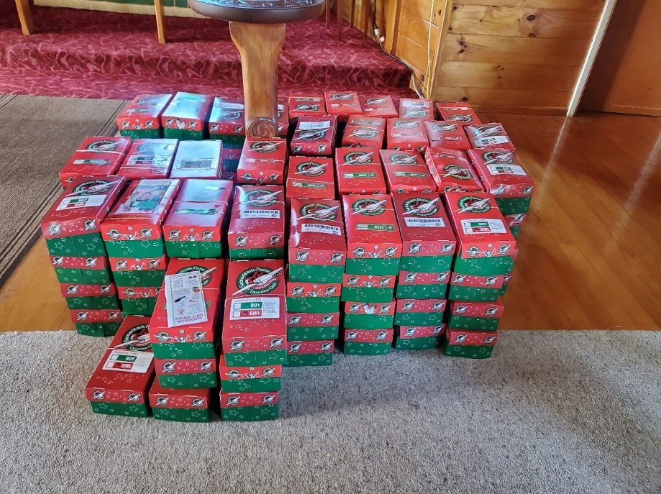
The 2023 collection of Operation Christmas Child boxes from the Whitianga churches numbered 61 at the time of printing. A great contribution to children in the South Pacific region who otherwise would not have had any Christmas presents. Many thanks to everyone who contributed to this.
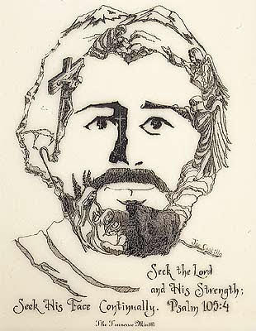
The longer you look at this picture, the more you see.
Look at the lines the artist used to draw this picture of Christ...
It is of scenes from Christ's life.

Vestry News
Remembered At Christmas Service
This year’s service will be held at 7.00pm on Tuesday December 19th This special service is to remember those who for whatever reason are not here to share Christmas with us.
Carol Service
To be held at 9am on Sunday 17th December. The service consists of carols, interspersed with ten readings. Parishioners will be given readings in advance. Parishioners will also have the opportunity to vote for their favourite carol, to be included in the service.
Christmas Eve Service at Whitianga
This service will be held on 24th December at 8pm, followed by Champagne and Christmas cake.
There will be no service at Whitianga St Peters church on Christmas Day.
Christmas Day at Hahei
This service is at 10am on 25th December in the Hahei Community Hall.
Financial report
We are tracking comfortably close to budget year to date, helped by the income from the St John’s courses being run in our Lounge, and the generosity of the knitting ladies. We are in a good position to proceed with some of the planned renovation work on the Vicarage, and also our outreach donations.
Annual Outreach Donations.
Vestry has at this stage, agreed to allocate the annual donations money as follows:
World Vision: for its work on the Hamas/Israel conflict - $750.00, and Afghanistan for its earthquake recovery work - $750.00
Red Cross: for its work on relief for the floods in Libya - $500.00, earthquakes in Morocco - $500.00, its continuing relief work in Ukraine - $500.00.
Whitianga Lions Club: the Mammogram appeal - $2,500.00, and the Whitianga Community Trust food bank - $500.00

Some Prayers for quiet reflection
God our light, you stand with us on the threshold of a new era. Through Jesus, you show us your constant desire to renew creation. As we await the fulness of your coming, give us a sense of eager expectation, that we may actively contribute to a world where hope is constantly born anew. Amen
Steadfast God, the days are surely coming when your promise of new life for all will be fulfilled. Keep us ready and alert, that we may stand with you, as your way of justice for all is born anew. Bind us together with our neighbours, that we may actively grow in mutual love. Amen
Holy God, you spoke your great commandment of love to the people of Israel. Now speak it in our midst. May we love and serve you in our gentle care for our neighbours. Help us realise that in Jesus, ‘Messiah-Anointed-One’, you are among us, showing us your way of justice and compassion. Amen
Free to a good home
A set of the four laser jet printer cartidges, hardly used, for an HP Printer that takes Cartridge model 410. We have changed our printer and these cartidges are not compatible with the new one – What a Surprise! Contact Gillian or Maxwell.
FOOD BASKET – don’t forget your donation to the Social Services Food Basket. This is a very worthy cause, as there are families in Whitianga who are really struggling.
NOVEMber Birthday Wishes
This month of November we wish a Happy Birthday to
Alan Andrews
Noel Hewlett
Robert Schibli
Vic Dalbeth
Maxwell Reid
DECEMBER BIRTHDAY WISHES
To our dear Lord Jesus Christ

Don’t Forget our Outreach and Activity Groups
Knit for a Purpose:
Meets on the first and third Friday of the month, from 10.00am to 12.00pm, for good coffee, morning tea, and fellowship, while making garments and blankets for children in the care of the Anglican Trust for Women and Children. Knitting yarn, needles and patterns supplied, along with encouragement and helpful advice if needed. New members are always welcome.

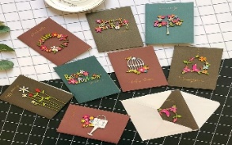
Card Making:
Meets on the second and fourth Friday of the month, from 10.00am to 12.00pm, for good coffee, morning tea, fellowship, and loads of laughs as we try to follow our teacher’s guidance to make personalized greeting cards. (There are no such things as mistakes, just creative differences, easily concealed if desired). Heaps of resources available to share. New members, skilled or unskilled, are always welcome.
Seniors Strength, Balance, and Mobility classes:
Meets every Thursday morning, 10.00am to 11.00am. For ‘seniors’ - how to exercise sitting down or leaning on a chair, without breaking out in a sweat. All levels of personal unfitness welcome! Join in any time.

Men’s gardening group:
The men’s group work in the church garden producing vegetables for Community Social Services and maintaining the church grounds. All keen (or just hopeful) gardeners welcome. Contact Maxwell on 0274 906 120.

WHO’S WHO AT ST PETERS
Clergy: Priest in Charge | Rev. Dr. Gillian Reid
Verger | Vic Dalbeth
Licensed Lay Ministers: | Sharon Short  Nicky Hewlett
 | Dr Maxwell Reid
Vestry: People’s Warden | Jill Laird
Priest’s Warden | Sharon Short
Synod Rep | Nicky Hewlett
Synod Rep & Secretary | Kaye Evans
Treasurer | Bob Schibli
Webmaster & Safety Officer  Maintenance coordinator  Vestry member | Maxwell Reid  Alan Andrews  Anna Andrews
Worship Team: | Gillian Reid
(Roster Coordinator): | Maxwell Reid
 | Dawn Schibli
 | Nicky Hewlett
Sharon Short
Jill Laird
Kaye Evans
Pastoral Care Team: | Gillian Reid
 | Dawn Schibli
 | Nicky Hewlett
 | Jill Laird
 | Sharon Short

website: wwwanglicanchurchwhitianga.org.nz
Facebook: ww.facebook.com/stpeter.thefisherman.96
Mercury Bay Mission District contact person: Jill Laird
Ph. 8660641, jilliannelaird48@gmail.com

An ode to English Plural
We'll begin with a box, and the plural is boxes,
But the plural of ox becomes oxen, not oxes.
One fowl is a goose, but two are called geese,
Yet the plural of moose should never be meese.
You may find a lone mouse or a nest full of mice,
Yet the plural of house is houses, not hice.
If the plural of man is always called men,
Why shouldn't the plural of pan be called pen?
If I speak of my foot and show you my feet,
And I give you a boot, would a pair be called beet?
If one is a tooth and a whole set are teeth,
Why shouldn't the plural of booth be called beeth?
Then one may be that, and three would be those,
Yet hat in the plural would never be hose,
And the plural of cat is cats, not cose.
We speak of a brother and also of brethren,
But though we say mother, we never say methren.
Then the masculine pronouns are he, his and him,
But imagine the feminine: she, shis and shim!
Let's face it - English is a crazy language.
There is no egg in eggplant nor ham in hamburger;
neither apple nor pine in pineapple.
English muffins weren't invented in England .
We take English for granted, but if we explore its paradoxes,
we find that quicksand can work slowly, boxing rings are square,
and a guinea pig is neither from Guinea nor is it a pig.
And why is it that writers write but fingers don't fing,
grocers don't groce and hammers don't ham?
Doesn't it seem crazy that you can make amends but not one amend.
If you have a bunch of odds and ends and
get rid of all but one of them, what do you call it?
In what other language do people recite at a play and play at a recital?
We ship by truck but send cargo by ship...
We have noses that run and feet that smell.
We park in a driveway and drive in a parkway..
And how can a slim chance and a fat chance be the same,
while a wise man and a wise guy are opposites?
You have to marvel at the unique lunacy of a language
in which your house can burn up as it burns down,
in which you fill in a form by filling it out, and
in which an alarm goes off by going on.
And in closing, if Father is Pop, how come Mother's not Mop?

