NETWORK NEWS
ST PETER’S ANGLICAN CHURCH
MERCURY BAY MISSION DISTRICT
November and December 2022

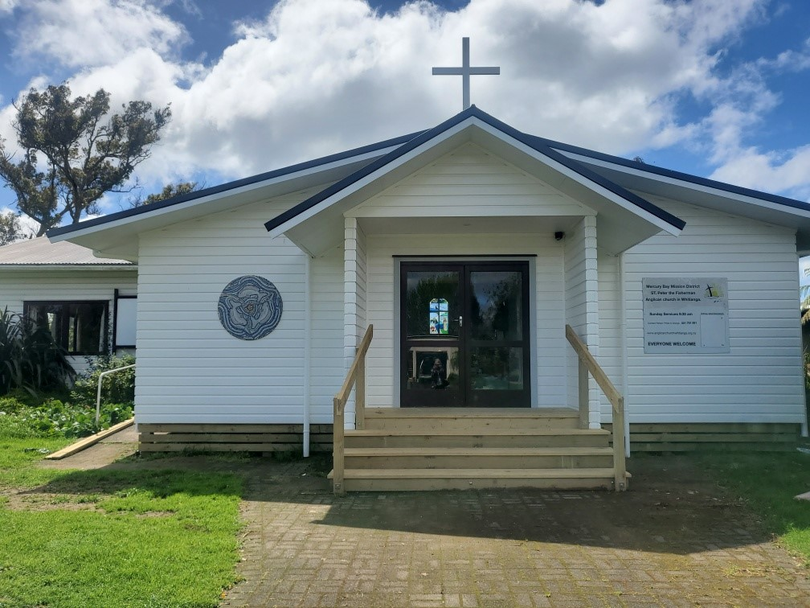

St Peters Church

OUR MISSION STATEMENT:

TO KNOW AND MAKE KNOWN THE LOVE OF GOD”

November Worship Services at St Peter’s
Sunday 6th November  Presider: Gillian Reid  Gospel and Reflection | HOLY COMMUNION 9.30am  Liturgist: Dawn Schibli  Maxwell Reid
Sunday 13th November  Presider: Gillian Reid  Gospel and Reflection | HOLY COMMUNION 9.30am  Liturgist: Nicky Hewlett  Gillian Reid
Sunday 20th November  Presider: Gillian Reid  Gospel and Reflection: | HOLY COMMUNION 9.30  Liturgist: Sharon Short  Maxwell Reid
Sunday 27th November  1st Sunday in Advent  Presider Gillian Reid  Gospel and Reflection | HOLY COMMUNION 9.30am  Liturgist: Dawn Schibli  Gillian Reid

December Worship Services at St Peter’s
Sunday 4th December  Second Sunday in Advent  Presider: Gillian Reid  Gospel and Reflection | HOLY COMMUNION 9.30am  Liturgist: Nicky Hewlett  Gillian Reid
Sunday 11th December  3rd Sunday in Advent  Presider: Gillian Reid  Gospel and Reflection | CAROL SERVICE 9.30am  Liturgist: Gillian Reid  -
Sunday 18th December  4th Sunday in Advent  Presider: Gillian Reid  Gospel and Reflection: | HOLY COMMUNION 9.30  Liturgist: Nicky Hewlett  Maxwell Reid
Saturday 24th December  Christmas Eve  Presider Gillian Reid  Gospel and Reflection | HOLY COMMUNION 8pm  At St Peter’s Whitianga  Liturgist: Sharon Short  Gillian Reid
Sunday 25th October  Christmas Day Service  Presider Gillian Reid  Gospel and Reflection | HOLY COMMUNION 10.00am  At Hahei Community Hall  Liturgist: Sharon Short  Gillian Reid
Weekly Service Roster
If you swap a duty with someone else – reading, chalice bearer, prayers etc., as well as changing it on the roster by the door please would you let the Liturgist for that Sunday know as they may not check the alterations during the week. This will make it much easier for them when putting the service together. Many thanks.

GILLIAN’S MONTHLY MUSINGS
Holding on to faith that God’s will for a world of peace, justice and love will come, can feel very challenging in this current time of conflict and oppression. Yes, there have been worse examples of man’s inhumanity to man, but we just don’t seem to have taken any effective lessons from those historical examples. The fact that so many People are suffering in Ukraine as a result of the Russian invasion of their country; the Israel-Palestine conflict seems to have been going on for ever; we’ve had decades of conflict in Afghanistan; and war after war in Ethiopia; all diminishing the quality of life for the inhabitants, doesn’t seem to have taught us anything.
Yes, we are told very clearly in Isaiah that God says “my thoughts are not your thoughts, neither are your ways my ways” when we feel our prayers are not being heard, and are also told “the wolf shall live with the lamb, the leopard shall lie down with the kid”, along with other seemingly unlikely scenarios. So, are we stuck in that same boat as the disciples when they asked Jesus to increase their faith? Are we people who although we pray actually don’t really have faith even the size of a mustard seed?
Jesus has so clearly emphasised the need for, and power of, constant prayer. In Matthew he says “whatever you ask in prayer, you will receive, if you have faith”. That doesn’t mean an immediate response as we wish it, in our ‘instant gratification’ world. It means keeping on communicating to God through Jesus, that we do want a better world, we do want the conflicts to cease, we do want God’s world of Peace, Justice and Love, and we accept that without God’s help, those things are unlikely.
There are many times that I struggle with the words of the Apostle Paul and have to remind myself that he was writing in a different context and time from our 21st Century. However, he did make some very powerful and helpful remarks to the fledgling Christian communities he was nurturing. He encourages the Thessalonians to “pray without ceasing, give thanks in all circumstances, for this is the will of God in Christ Jesus for you”. Most of all, the instructions he gave to the Romans in Chapter 12, from verse 9 onwards, (familiar and easy to extract) are my ‘go to’ goals that refocus my clouding eyes to the important things I can do as a Christian. No, I can’t directly solve the challenges of hate, conflict and prejudice in our world; that can only be fully achieved with God’s help. But I can affect my immediate environment by living as Paul encapsulated ‘the marks of the true Christian’, and “in everything by prayer and supplication with thanksgiving let [my] requests be made known to God”.
Manaakitanga, Gillian

**********************************************
LAUGHTER Really IS THE BEST MEDICINE !!!
In his earlier days of being the champ, on a flight, Muhammad Ali was asked by the flight attendant to fasten his seat belt. He replied, “Superman don’t need no seat belt.” The attendant replied,
“Superman don’t need no airplane either”!

RAF fault report to maintenance crew – NUMBER 3 ENGINE MISSING
Maintenance crew fault report signed off – NUMBER 3 ENGINE FOUND UNDER STARBOARD WING AFTER A BRIEF SEARCH
The Internet does not make you stupid. It just makes your stupidity accessible to others.

Memorable THOUGHTS ON LIFE
The problem with the world is that everyone is a few drinks behind reality – Humphrey Bogart
It should be possible to explain the laws of physics to a barmaid. Albert Einstein.
The only reason for time, is so that everything doesn’t happen at once. Albert Einstein.

It’s de ja vue all over again, and the future ain’t what it used to be. The wisdom of baseball player Yogi Beara

Life is like riding a bicycle. If you stop pedalling, eventually, you will fall off. Anon.

Nothing is impossible. The word is I’m possible – Audrey Hepburn

First, have a definite clear practical ideal, a goal, an objective. Second, have the necessary means to achieve your ends, Third, adjust your means to that end. - Aristotle

"Only a life lived for others is a life worthwhile." -Albert Einstein
Life is tough, but it is even tougher if you are stupid – John Wayne

Childhood Memories - with Edith Thompson
Edith was born in Wellington in 1936, of an English mother who had emigrated from England to arrive by ship in Lyttleton. She was a registered nurse, who had come to NZ in 1933 to marry Edith’s Father.
Edith was brought up in a family of four children, two girls and two boys, Mary, Edith, Clyde and James. As you can see, Edith was number two.
Her Father was a doctor (eye specialist) and Edith remembers that they lived in Willis St in the Wellington City Centre. The family lived above the surgery where he worked, which was quite common in the medical practice in those days. At the time, the family had a beach house in Paraparamu, and Edith remembers a wonderful childhood with many happy holidays spent there.
For one year from the age of 5 she went to Queen Margaret’s School in Wellington.
They came to Auckland for a holiday and loved the place, so they moved to Auckland while she was still school age, in 1942 at the age of six, and lived in St Andrews Road in Epsom. Consequently, the Paraparamu beach house was sold.
Her education continued at St Cuthbert’s College in Auckland, where she graduated with School Certificate and University Entrance. Many girls will remember the girl’s school uniform worn in those days - the traditional gym frock with pleats. She has very fond memories of the school and made many friends there. It was here that she became really interested and active in tennis and swimming. She learned to swim in the school pool. Her favourite Subject at school was writing essays/stories.
She used to cycle to school from St Andrews Rd, a feat which not many would try these days in Auckland traffic! She would quite often arrive at school at 8am so she could go swimming, before classes started at 9am.
Then she went to Teacher’s Training College in Epsom to become a teacher. After that she attended Christchurch Teacher’s College to study a Diploma in Speech Therapy.
Finally, to complete her education, she studied a paper in Psychology at Canterbury University. This amount of study led to her employment as a speech therapist
Edith’s interest throughout her childhood, and as an adult included swimming, tennis and Golf. As a keen tennis player, she played Lawn Tennis on grass.

She has also had a keen interest in sewing and made many of her own clothes. She also liked making baby clothes, and as her children grew up and had children, she used to be quite busy making clothes for them. She still has her original sewing machine, complete with an overlocker.
Edith’s husband Ian was born in Whanganui in 1927 and graduated from Canterbury University. He found employment as a radio announcer. They were married in Auckland in May 1957 at St Andrews Church, Epsom, and the marriage was blessed with a family of five girls.
They lived in Wellington where Ian was a ZB broadcaster, and amongst his many talents, he headed the Sunday program “Hymns of Praise” which was broadcast on all ZB stations. Finally, in retirement, Edith and Ian moved to Whitianga where she has continued to enjoy her life with golf, and an involvement and contribution to life at St Peter the Fisherman Church.

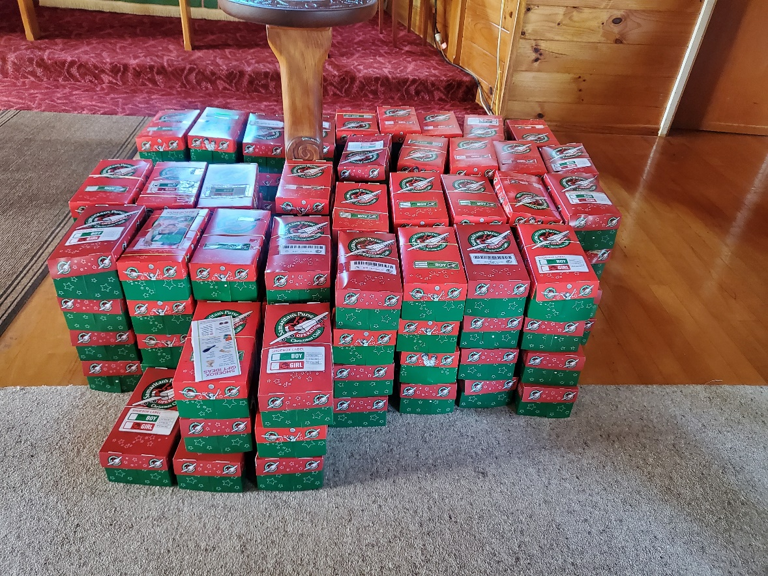

The 2022 collection of Operation Christmas Child boxes from the Whitianga churches numbered 131 at the time of printing. A really great contribution to children in the South Pacific region who otherwise would not have had any Christmas presents. Many thanks to everyone who contributed to this.

Vestry News
Remembered At Christmas Service
A service will be held at 7.00pm on Thursday December 15th This special service is to remember those who for whatever reason are not here to share Christmas with us.
Carol Service
To be held at 9.30 am on Sunday 11th December. The service consists of carols, interspersed with ten readings. Parishioners will be given readings in advance. Parishioners will also have the opportunity to vote for their favourite carol, to be included in the service.
Christmas Eve Service at Whitianga
This service will be held on 24th December at 8pm, followed by Champagne and Christmas cake.
There will be no service at Whitianga St Peters church on Christmas Day.
Christmas Day at Hahei
This service is at 10am on 25th December in the Hahei Community Hall.
Church Gardens
The vestry appreciates and thanks the parishioners who weeded and tidied the gardens before the official blessing of the building extensions.
Flooring for the kitchen and toilet/resource room area.
The best (cheapest and longest lasting) option is to tile all those floors, and Guthrie Bowron have supplied a quote for providing the tiles. We will still need to find a tiler. Offers of someone to do this are always encouraged.
Annual Outreach Donations.
The AGM agreed we would donate up to $10,000 this year to specific projects of suitable international, national, and local charities. Vestry agreed to allocate the money as follows:
World Vision for Ukraine relief work - $3,000.
Leprosy Mission NZ - $1,500 (each $1.00 matched by $4.00 from government).
The ‘What’s Up’ Youth support phone line - $1,500
St John’s Whitianga for local Paramedic training costs - $3,000.
Hot Water Beach Life Savers, for equipment - $1,000.

Some Prayers for quiet reflection
Holy Wisdom, you teach us simple ways to enjoy your love. You call us to worship you. You set your table, inviting all to share from your abundance. You feed us with the living bread of Jesu. Your rhythm of hope beats deep within our hearts. We thank you. Amen
God of many names, may we know you as ‘fire’, kindling our love. May we know you as ‘hammer’, breaking open your word to be like rocks that pave the way. May we know you as Jesus, both ‘peace-maker’ and ‘source-of-division’ from all we have known before. Baptise us into the ‘cloud of witnesses’, who make known your love today. Amen.
God our strength, yours are the arms that hold us when we fear. Yours are the words that lead us to liberating peace. Yours is the heart that loves us into service. Give us courage to follow Jesus, your bread of life, that we may be ambassadors of your hope in our time. Amen.

FOOD BASKET – don’t forget your donation to the Social Services Food Basket. This is a very worthy cause, as there are families in Whitianga who are really struggling.

NOVEMber Birthday Wishes
This month of November we wish a Happy Birthday to
Alan Andrews
Noel Hewlett
Robert Schibli
Vic Dalbeth
Maxwell Reid
DECEMBER BIRTHDAY WISHES
Our dear Lord Jesus Christ

Sign on a building

Don’t Forget our Outreach and Activity Groups
Knit for a Purpose:
Meets on the first and third Friday of the month, from 10.00am to 12.00pm, for good coffee, morning tea, and fellowship, while making garments and blankets for children in the care of the Anglican Trust for Women and Children. Knitting yarn, needles and patterns supplied, along with encouragement and helpful advice if needed. New members are always welcome.

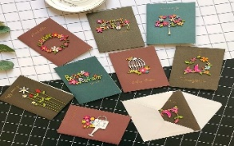
Card Making:
Meets on the second and fourth Friday of the month, from 10.00am to 12.00pm, for good coffee, morning tea, fellowship, and loads of laughs as we try to follow our teacher’s guidance to make personalized greeting cards. (There are no such things as mistakes, just creative differences, easily concealed if desired). Heaps of resources available to share. New members, skilled or unskilled, are always welcome.
Seniors Strength, Balance, and Mobility classes:
Meets every Thursday morning, 10.00am to 11.00am. For ‘seniors’ - how to exercise sitting down or leaning on a chair, without breaking out in a sweat. All levels of personal unfitness welcome! Join in any time.

Men’s gardening group:
Meets on Friday afternoon, 1.00pm for a couple of hours working in the church garden producing vegetables for Community Social Services and maintaining the church grounds. All keen (or just hopeful) gardeners welcome. Contact Maxwell on 0274 906 120.

WHO’S WHO AT ST PETERS
Clergy: Priest in Charge | Rev. Dr. Gillian Reid
Verger | Vic Dalbeth
Licensed Lay Ministers: | Sharon Short  Nicky Hewlett
 | Dr Maxwell Reid
Vestry: People’s Warden | Jill Laird
Priest’s Warden | Sharon Short
Synod Rep | Nicky Hewlett
Secretary | Kaye Evans
Treasurer | Bob Schibli
Webmaster & Safety Officer  Vestry member | Maxwell Reid  Alan Andrews
Worship Team: | Gillian Reid
(Roster Coordinator): | Maxwell Reid
 | Dawn Schibli
 | Nicky Hewlett
Sharon Short
Jill Laird
Pastoral Care Team: | Dawn Schibli
 | Gillian Reid
 | Nicky Hewlett
 | Jill Laird
 | Sharon Short

website: wwwanglicanchurchwhitianga.org.nz
Facebook: ww.facebook.com/stpeter.thefisherman.96
Mercury Bay Mission District contact person: Jill Laird
Ph. 8660641, jilliannelaird48@gmail.com

