NETWORK NEWS
ST PETER’S ANGLICAN CHURCH
MERCURY BAY MISSION DISTRICT
May June 2023

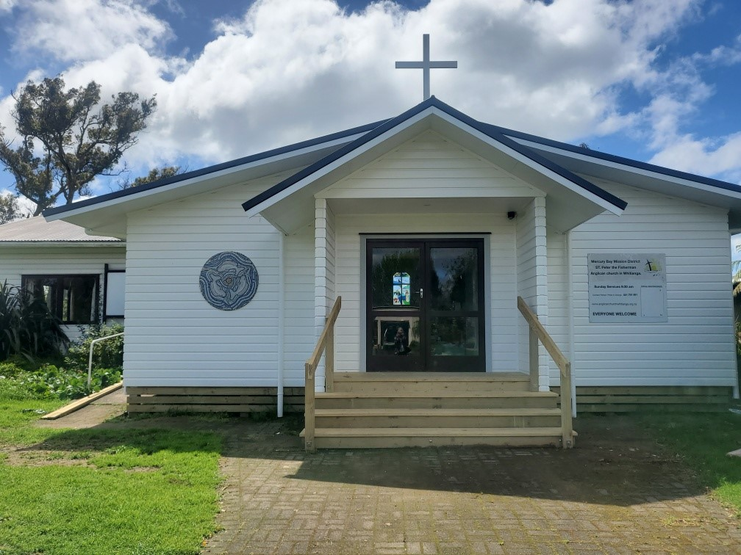

St Peters Church

OUR MISSION STATEMENT:

TO KNOW AND MAKE KNOWN THE LOVE OF GOD”

May/June 2023 Worship Services at St Peter’s
Sunday 7th May  Presider: Gillian Reid  Gospel and Reflection | HOLY COMMUNION 9.30am  Liturgist: Sharon Short  Gillian Reid
Sunday 14th May  Presider: Gillian Reid  Gospel and Reflection | HOLY COMMUNION 9.30am  Liturgist: Dawn Schibli  Maxwell Reid
Sunday 21st May  Presider: Gillian Reid  Gospel and Reflection: | HOLY COMMUNION 9.30  Liturgist: Kaye Evans  Gillian Reid
Sunday 28th May  Presider Gillian Reid  Gospel and Reflection  Sunday 4th June  Presider: Gillian Reid  Gospel and Reflection  Sunday 11th June  Presider: Gillian Reid  Gospel and Reflection  Sunday 18th June  Presider: Gillian Reid  Gospel and Reflection:  Sunday 25th June  Presider Gillian Reid  Gospel and Reflection | HOLY COMMUNION 9.30am  Liturgist: Nicky Hewlett  Maxwell Reid  HOLY COMMUNION 9.30am  Liturgist: Sharon Short  Gillian Reid  HOLY COMMUNION 9.30am  Liturgist: Kaye Evans  Maxwell Reid  HOLY COMMUNION 9.30am  Liturgist: Nicky Hewlett  Gillian Reid  HOLY COMMUNION 9.30am  Liturgist: Dawn Schibli  Maxwell Reid

GILLIAN’S MONTHLY MUSINGS
We are right in the middle of the most significant part of the Christian Year. That period from Palm Sunday to Pentecost, which for me seems to gallop through faster each year.
These nine weeks define who we are, the people who acknowledge this man Jesus of Nazareth, as the true Son of God, sent to redeem all the sins of those who believe in him. God’s plan was simple, but incredibly challenging for those who lived through its execution (quite literally) and were present for the subsequent demonstration of God’s ultimate proof of his power over death. Even though Jesus had told his followers a number of times what God’s plan was for him, it was still too much for them to believe in principle, until Jesus actually appeared to them, and they could see him as the proof of his earlier claims.
There are two things which sit in my mind, every time we move through this season. Firstly, the amazing absolute unshakeable confidence Jesus showed in what he believed God would do with him. Secondly, the challenge we face over the fact that we don’t have the luxury of the physical and visual demonstration by Jesus that God’s promise was truly delivered, which his immediate followers did have. That promise that God so loved our broken world that he was willing to prove it with the ultimate sacrifice of his only son’s life, to take in all the sins of those who believe and trust in his existence.
Each year Christians are asked to re-affirm that God did deliver. Namely that Jesus’ faith and confidence was absolutely justified. He did defeat death in his resurrection, he did ascend to heaven to be with his father, and he did send the Holy Spirit to be the guide and mentor for all who believed in him. It is a challenge to believe in someone or something where we don’t have physical evidence in front of us, but there is enough other evidence for us to accept the truth of Jesus as the crucified and resurrected Son of God.
I recently re-read the book “Person of Interest” where J. Warner Wallace a non-Christian homicide detective specializing in cold cases where there is no body, investigated Jesus as though he was an actual case on file. He goes through the historical background to Jesus’ arrival and life, checking the validity of all the recorded events written by earlier prophets and historians, plus those written by people who either knew him or were able to gather information from those who knew him – witnesses to his life in effect.
The more he studied and tested the evidence he gathered, the more he came to the conclusion that the documents and testimonies made an overwhelming case that Jesus was definitely more than human, did rise from the grave, and carried with him the kind of power only God could have or grant. Wallace came to that conclusion via his investigative experience, I came to that conclusion both by reading the documents passed down to us, and by straight out faith that the Jesus I recognise in my life is the Son of God, and my Saviour.
Manaakitanga,
Gillian
**********************************************
LAUGHTER Really IS THE BEST MEDICINE !!!

Recently, when it had finally stopped raining, a parishioner said he would get some steak out of the freezer for a BBQ. His wife said, “can you use the old stock first please”. He said, “I’ll have to get my glasses to read the expiry date”. She replied, “not necessary, just go by the prices!”
A Russian wife turned to her husband and asked, "What's this special military operation our glorious leader keeps talking about?" Her husband replied, "It's a war to stop America and NATO." "Oh, right” she says, “How's it going?" “Well,” he replied, “so far we have lost over 20 generals, 200,000 troops killed, countless injured, 3000 tanks, 300 aircraft, hundreds of helicopters, countless armoured vehicles, artillery and trucks, our flagship along with other naval ships, our army is being defeated in most areas and we have had to resort to conscription to replace our losses”. “Wow” replied the wife “what about America and NATO?” “They haven’t turned up yet”.

After the recent floods in Australia a newspaper reported 30,000 pigs flowing down the river. What the farmer actually said, “I saw 30 sows and pigs ………”

Memorable THOUGHTS ON LIFE
Tomorrow is an important thing in life. It comes into us at midnight very clean. It’s perfect when it arrives and hopes we have learned something from yesterday (John Wayne).
What’s the secret to success? Right decisions!
How do you make the right decisions? Experience!
How do you get experience? Wrong decisions! (Richard Nixon).
Don’t insult seven men when you’re only packing a six shooter (Colonel Potter, MASH)
The people who cast votes decide nothing. It’s the people counting the votes that decide everything. (Joseph Stalin).
Life is not so much about the beginning and end. It’s more about muddling through the middle. (BBC QI programme).

Some Prayers for quiet reflection
Enduring Love, in the life and death of Jesus, we experience your promise of new birth and abundant life. When we are lost, unable to identify you clearly, walk with us on our road of life. Though our eyes be sightless, warm our hearts so that we can recognise your presence, an imperishable treasure. In your beloved Son’s name we pray. Amen.
Loving God, your compassion knows no bounds. You call us, even in our ignorance of your mercy and grace. Give us wisdom to discern your living word, that we may witness to your forgiving love. Immersed in such love, we will know that we are all indeed your people, born in your image. Amen
God our Light, you pierce our darkest times with your grace. Jesus, our advocate, with your empowerment, gave his life for the healing of your world. Give us the compassion of Jesus as we touch the wounds of humanity. Empower us to live like the first disciples, always seeking the common good. In Jesus’ name we pray. Amen.
FOOD BASKET – don’t forget your donation to the Social Services Food Basket. This is a very worthy cause, as there are families in Whitianga who are really struggling.
May Birthday Wishes
This month of April we wish a Happy Birthday to
Jillianne Laird (Jill) and Bridget Mackerith.
June Birthday Wishes
None this month.

Weekly Service Roster
If you swap a duty with someone else – reading, chalice bearer, prayers etc., as well as changing it on the roster by the door please would you let the Liturgist for that Sunday know as they may not check the alterations during the week. This will make it much easier for them when putting the service together. Many thanks.
Don’t Forget our Outreach and Activity Groups
Knit for a Purpose:
Meets on the first and third Friday of the month, from 10.00am to 12.00pm, for good coffee, morning tea, and fellowship, while making garments and blankets for children in the care of the Anglican Trust for Women and Children. Knitting yarn, needles and patterns supplied, along with encouragement and helpful advice if needed. New members are always welcome.

Card Making:
Meets on the second and fourth Friday of the month, from 10.00am to 12.00pm, for good coffee, morning tea, fellowship, and loads of laughs as we try to follow our teacher’s guidance to make personalized greeting cards. (There are no such things as mistakes, just creative differences, easily concealed if desired). Heaps of resources are available to share. New members, skilled or unskilled, are always welcome.
Seniors Strength, Balance, and Mobility classes:
Meets every Thursday morning, 10.00am to 11.00am. For ‘seniors’ - how to exercise sitting down or leaning on a chair, without breaking out in a sweat. All levels of personal unfitness welcome! Join in any time.

Men’s gardening group:
Meets on Friday afternoon, 1.00pm for a couple of hours working in the church garden producing vegetables for Community Social Services and maintaining the church grounds. All keen (or just hopeful) gardeners welcome. Contact Maxwell on 0274 906 120.

WHO’S WHO AT ST PETERS
Clergy: Priest in Charge | Rev. Dr. Gillian Reid
Verger | Vic Dalbeth
Licensed Lay Ministers: | Sharon Short  Nicky Hewlett
 | Dr Maxwell Reid
Vestry: People’s Warden | Jill Laird
Priest’s Warden | Sharon Short
Synod Rep | Nicky Hewlett
Secretary and Synod Rep | Kaye Evans
Treasurer | Bob Schibli
Webmaster & Safety Officer  Maintenance coordinator  Vestry Member | Maxwell Reid  Alan Andrews  Anna Andrews
Worship Team: | Gillian Reid
(Roster Coordinator): | Maxwell Reid
 | Dawn Schibli
 | Nicky Hewlett
Sharon Short
Jill Laird
Kaye Evans
Pastoral Care Team: | Dawn Schibli
 | Gillian Reid
 | Nicky Hewlett
 | Jill Laird
 | Sharon Short

website: wwwanglicanchurchwhitianga.org.nz
Facebook: ww.facebook.com/stpeter.thefisherman.96
Mercury Bay Mission District contact person: Jill Laird
Ph. 8660641, jilliannelaird48@gmail.com

From Church Newsletters: - (not ours )
Next Thursday there will be try-outs for the choir. They need all the help they can get.
Eight new choir robes are currently needed due to the addition of several new members and to the deterioration of some older ones.
Please place your donation in the envelope along with the deceased person you want remembered.

