NETWORK NEWS
ST PETER’S ANGLICAN CHURCH
MERCURY BAY MISSION DISTRICT
May 2022
The Ascension

OUR MISSION STATEMENT:

TO KNOW AND MAKE KNOWN THE LOVE OF GOD”

MAY WORSHIP SERVICES AT ST PETER’S
Sunday 1st May  Presider: Gillian Reid  Gospel and Reflection | HOLY COMMUNION 9.30am  Liturgist: Sharon Short  Gillian Reid
Sunday 8th May  Gospel and Reflection | Morning Worship 9.30am  Liturgist: Nicky Hewlett  Maxwell Reid
Sunday 15th May  Presider: Ven. Michael Berry  Gospel and Reflection: | HOLY COMMUNION 9.30  Liturgist: Dawn Schibli  Venerable Michael Berry
Sunday 22nd May  Gospel and Reflection | Morning Worship 9.30am  Liturgist: Sharon Short  Maxwell Reid
Sunday 29th May  Sunday after Ascension  Presider:  Gospel and Reflection: | HOLY COMMUNION 9.30  Liturgist: Nicky Hewlett  Rev. Brendon Wilkinson  Rev. Brendon Wilkinson
Weekly Service Roster
If you swap a duty with someone else – reading, chalice bearer, prayers etc, as well as changing it on the roster by the door please would you let the Liturgist for that Sunday know as they may not check the alterations during the week. This will make it much easier for them when putting the service together. Many thanks.

GILLIAN’S MONTHLY MUSING

Well, we are through Easter, and heading towards Jesus’ Ascension and the arrival of the Holy Spirit at Pentecost.
These, as for Easter, are hugely significant milestones in our Liturgical year. Yes, Jesus was indeed resurrected from the dead, but God did not intend that he remain on earth with us. It must have been terribly hard for the disciples to see him go after such a short time of having him back with them. The sense of loss all over again. Most of us can identify with that kind of emotion, and so the subsequent arrival of the Holy Spirit shortly afterwards must have been extraordinary for the whole group of Jesus’ disciples. Jesus had promised a helper, and here it was.
The possibilities of a future sharing the good news of their Messiah, God’s given son, were now real, and truly exciting. Not only exciting just for a short time, (as often these changes may be) but embedded deeply within them, sustaining them for the long life journeys ahead of each person in that room when the Holy spirit descended, bringing God’s strength and grace to everyone there.
Sometimes it can be quite hard to sustain the faith we carry with us. Personally I find that celebrating the Eucharist, is the nourishment which feeds me for each next period of living out life’s challenges, supported by God’s grace and unconditional love. I can get through a lot of setbacks and over many mountains carrying that spiritual experience with me. Everyone has a different ‘faith refueling’ component in their lives, and what ever it may be, that is the ‘Personal Pentecost’ which keeps us as Christians, and God’s kingdom, alive.
I will be away from you on leave for the month of May, with your Wardens Sharon and Jill carrying the bulk of the ‘looking after’ responsibilities in my absence. Through that loss of Ascension, I will be back refreshed and ready to celebrate the glory of Pentecost. I am pretty sure a shared breakfast together is in the planning for us all.
Manaakitanga, Gillian

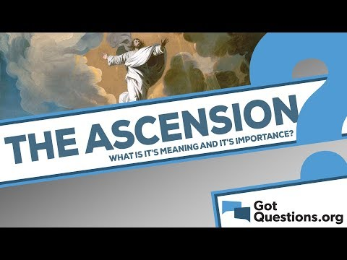

Forty days after the resurrection, Jesus and His disciples went to Mount Olivet, near Jerusalem. There, Jesus promised His followers that they would soon receive the Holy Spirit, and He instructed them to remain in Jerusalem until the Spirit had come. Then Jesus blessed them, and as He gave the blessing, He began to ascend into heaven. The account of Jesus’ ascension is found in Luke 24:50-51 and Acts 1:9-11.
It is plain from Scripture that Jesus’ ascension was a literal, bodily return to heaven. He rose from the ground gradually and visibly, observed by many intent onlookers. As the disciples strained to catch a last glimpse of Jesus, a cloud hid Him from their view, and two angels appeared and promised Christ’s return "in just the same way that you have watched Him go" (Acts 1:11).
The Ascension of Jesus Christ is meaningful for several reasons:
1) It signaled the end of His earthly ministry. God the Father had lovingly sent His Son into the world at Bethlehem, and now the Son was returning to the Father. The period of human limitation was at an end.
2) It signified success in His earthly work. All that He had come to do, He had accomplished.
3) It marked the return of His heavenly glory. Jesus’ glory had been veiled during His

sojourn on earth, with one brief exception at the Transfiguration (Matthew 17:1-9).
4) It symbolized His exaltation by the Father (Ephesians 1:20-23). The One with whom the Father is well pleased (Matthew 17:5) was received up in honor and given a name above all names (Philippians 2:9).
5) It allowed Him to prepare a place for us (John 14:2).
6) It indicated the beginning of His new work as High Priest (Hebrews 4:14-16) and Mediator of the New Covenant (Hebrews 9:15).
7) It set the pattern for His return. When Jesus comes to set up the Kingdom, He will return just as He left-literally, bodily, and visibly in the clouds (Acts 1:11; Daniel 7:13-14; Matthew 24:30; Revelation 1:7).
Currently, the Lord Jesus is in heaven. The Scriptures frequently picture Him at the right hand of the Father-a position of honor and authority (Psalm 110:1; Ephesians 1:20; Hebrews 8:1). Christ is the Head of the Church (Colossians 1:18), the giver of spiritual gifts (Ephesians 4:7-8), and the One who fills all in all (Ephesians 4:9-10).

“Yesterday is gone. Tomorrow has yet to come. We have only today left, So Let us begin.”
This quote from Mother Teresa is packed full of truth. A lot of people like to blame their past for their current situation. However, one should know that nothing is dependent on the past. What you have to do is to give your best in the present. You cannot sit idly and blame your history for all the bad things in your life. Instead of that, what you have to do is give all the efforts in the present time. It is the only way to achieve the desired success in your life. You have to understand that blaming your past will not help you in any way, as yesterday is already gone.

***********************************************
LAUGHTER Really IS THE BEST MEDICINE !!!!
A priest buys a lawn mower at a yard sale. Back home, he pulls on the starter rope a few times with no results. He storms back to the yard sale and tells the previous owner, “I can’t get the mower to start!” “That’s because you have to curse to get it started,” says the man. “I’m a man of the cloth. I don’t even remember how to curse.” “You keep pulling on that rope, and it’ll come back to you.”
How do you know that atoms are Catholic? They have mass.
In surgery for a heart attack, a middle-aged woman has a vision of God by her bedside. “Will I die?” she asks. God says, “No. You have 30 more years to live.” With 30 years to look forward to, she decides to make the best of it. So since she’s in the hospital, she gets breast implants, liposuction, a tummy tuck, hair transplants, and collagen injections in her lips. She looks great! The day she’s discharged, she exits the hospital with a swagger, crosses the street, and is immediately hit by an ambulance and killed. Up in heaven, she sees God. “You said I had 30 more years to live,” she complains. “That’s true,” says God. “So, what happened?” she asks. God shrugs, “I didn’t recognize you.”
According to the Old Testament, “Moses came down from the mount in his triumph” Was it a car or motor bike?
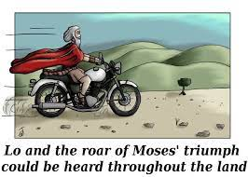

PRAYERS AND THOUGHTS
Holy One, you constantly challenge us to become aware of your presence, by offering us new possibilities and understanding. May we be open to fresh signs of resurrection, as we see things in a different light. Join us at any and every meal, and especially at your Eucharistic table. Amen

Lord God, we ask for you to be with all – especially children who are suffering as the crisis in Ukraine deteriorates. Lord, be with all those who are anxious and fearful, those who are bereaved, injured or who have lost their lives; and those who have lost loved ones.
“Yet he rescues the orphan from the sword of their mouth, the needy from the grip of the strong; so the poor have hope, and violence shuts its mouth.”
JOB 5:15-16
The Good News: God is watching over you, and will make sure that in your vulnerable moments he finds a way to protect you from things that threaten you.
Something more to smile about
THE CURRENT BANKING CRISIS EXPLAINED BY AN IRISHMAN

Young Paddy bought a donkey from a farmer for £100.

The farmer agreed to deliver the donkey the next day.
The next day he drove up and said,
'Sorry son, but I have some bad news. The donkey's died.'
Paddy replied, 'Well then just give me my money back.'
The farmer said, 'Can't do that. I've already spent it.'
Paddy said, 'OK, then, just bring me the dead donkey.'
The farmer asked, 'What are you going to do with him?'
Paddy said, 'I'm going to raffle him off.'
The farmer said, 'You can't raffle a dead donkey!'
Paddy said, 'Sure I can. Watch me. I just won't tell anybody
he's dead.'
A month later, the farmer met up with Paddy and asked,
'What happened with that dead donkey?'
Paddy said, 'I raffled him off. I sold 500 tickets at £2 each
and made a profit of £898'
The farmer said, 'Didn't anyone complain?'
Paddy said, 'Just the guy who won. So I gave him his £2 back.'

Paddy now works for the Royal Bank of Scotland .

Childhood Memories - An interview with Vic Dalbeth
By Maxwell
Vic’s family originated in Scotland his Great Grandfather came out to New Zealand in the late eighteen hundreds to live initially in Onehunga and they attended what is now the very old church there.
They then moved to Bombay. There was nothing there and the grandfather was involved as a builder in construction and development of the Bombay village. The name Bombay came from the sailing ship in which the family immigrated. Travel was difficult for all who came there because of the estuary’s that had to be crossed. There were no motorway bridges there then!
Vic remembers a few years ago, representing the Dalbeth family, along with a cousin from Rotorua who is vicar in Ngongotaha, going to the centennial service in the lovely old Bombay church. Eventually his Grand Father bought some land in the Mamaku area, followed by the further purchase of land in Ngongotaha where they established a dairy farm. They had large family, and the boys worked the farm which was accessed from the main road. (There is a Dalbeth road named after Vic’s family). He had a very scary experience there. One day, he was sitting on his mum’s lap on the front porch, looking at the road, and saw a farmer herding many bulls along the main road as one did in those days before cattle trucks. The bulls saw the open farm gate and headed towards Vic’s house with the farmer and his dog furiously rushing around, eventually turning them back, just before they charged the house.
In the late 1930s Vic’s father moved the family to Auckland, and they lived in Herne Bay. His Father worked as a jeweler and did odd jobs including making coat hangers. Vic started school at Bayfield School in Westmere. It was wartime and after a few years they shifted to a house in Point Chevalier. During this wartime period, Vic’s father served as a police officer in Newton.
Vic remembers the day he nearly killed himself with a crystal set. They used to listen to the radio and it worked well is there was only one radio station. He had a long wire reaching across the back yard and consequently received a good signal. One day a storm blew the wire across an electrical feed that ran to the shed. Vic was standing on wet grass in bare feet when he grabbed his aerial and received a severe shock from which he was lucky to survive.

He continued his schooling at Point Chevalier primary and Pasadena Intermediate, and finished at Avondale College. He either rode his bike or bused to school. He then got a job as an apprenticeship fitter and turner working with a ship builder in Freemans Bay. He was called to national service at the age of eighteen, spent 3 months in Papakura military Camp, followed by years of annual camps at Waiouru.
Like most young people, he yearned to travel, and during the Korean war he wondered if he should go and enlist. Then he thought, why should I get killed? So instead went to sea for a few years as an engineer on NZ Shipping Company ships. One day, he was working a ship, and unknown to him it was on its last voyage, and he ended up in Falmouth. He, worked in Newport for several years. At a local dance he met a Welsh girl, Norma, and walked her home afterward. Vic worked in Wales for some years and romance blossomed. After the marriage, they moved home to NZ, where they brought up three sons. Sadly, Vic’s wife died in 2010. Afterwards, Vic moved from Auckland to Christchurch to be with family, and then he moved again to Whitianga where we are delighted to have him as a valuable member of our congregation.

FOOD BASKET – don’t forget your donation to the Social Services Food Basket. This is a very worthy cause, as there are families in Whitianga who are really struggling.

Meaningful Thought for the day
“Never give up on what you want to do. The person with big dreams is more powerful than one with all the facts.”
The people with big dreams are the most motivated ones. They would do whatever it would take to make their dreams come true. Even if it seems like the odds are against them, they never give up. Just look at successful entrepreneurs. Some of them even came from humble beginnings and encountered complex challenges. Still, they endured and tackled the challenges head-on.

BOOK REVIEW FOR MAY
Searching for Charlie - written by Tom Scott
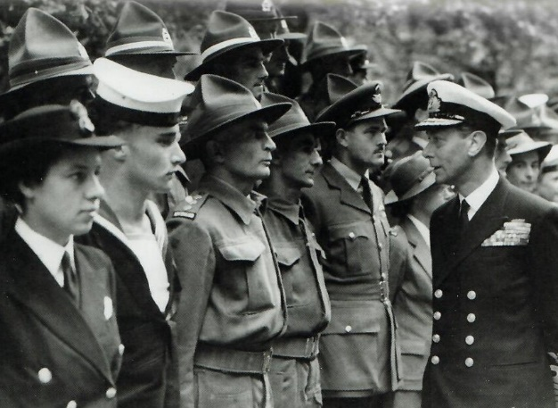
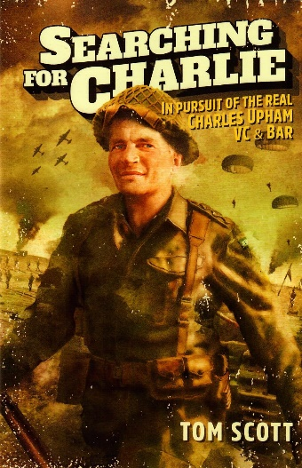
In pursuit of the real Charles Upham, VC and Bar, this book explores the mystery of how a modest farm valuer from New Zealand could be so fearless and ferocious has fascinated Tom Scott ever since. Readers might remember Tom Scott was banned from Government press conferences by the then Prime Minister, Sir Robert Muldoon. As a schoolboy, Tom read about Charles Upham – the only combat soldier to win the Victoria Cross twice. It is said that his numerous acts of bravery in the Second World War meant he probably deserved six more. When Charlie died, some of his old foes, who were from General Rommel’s famed “Afrika Corps” took the extraordinary step of placing a death notice in the Christchurch press newspaper saluting him as “one of the bravest and one of the best soldiers.”
In 2019, Scott went on a pilgrimage to Charlie’s old battlegrounds in Crete and Egypt, and his former POW camps in Germany and Italy. He also visited his childhood haunts and learnt about his saintly uncle and namesake, Doctor Charles Upham, who took his nephew on house calls to a local Leper colony. It appears that Charlie’s ethical compass, his compassion, and deep-seated sense of fair play, and abhorrence of bigotry and prejudice were sown here. An amusing story in the book relates to a time they were in a bar when a Maori soldier walked in and ordered a beer. The soldier was refused service on the basis “we don’t serve monkeys in here.” Charlie’s moral courage seemed to lend wings to physical courage. He and his fellow soldiers completely trashed the bar, and moved on to order a beer in another bar.
Working in New Zealand’s rugged high country gave him strength and stamina, made him a good shot, and gave him a feel for the terrain that served him well in battle, helping him to become a living legend within the New Zealand division. The modest Charles detested all the fuss. This book is meticulously researched and superbly written. It is a must-read story of one of New Zealand’s greatest heroes.
Enjoy the read - Maxwell

Don’t Forget our Outreach and Activity Groups
Knit for a Purpose:
Meets on the first and third Friday of the month, from 10.00am to 12.00pm, for good coffee, morning tea, and fellowship, while making garments and blankets for children in the care of the Anglican Trust for Women and Children. Knitting yarn, needles and patterns supplied, along with encouragement and helpful advice if needed. New members are always welcome.

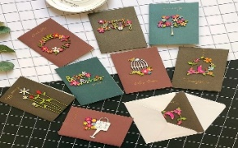
Card Making:
Meets on the second and fourth Friday of the month, from 10.00am to 12.00pm, for good coffee, morning tea, fellowship, and loads of laughs as we try to follow our teacher’s guidance to make personalized greeting cards. (There are no such things as mistakes, just creative differences, easily concealed if desired). Heaps of resources available to share. New members, skilled or unskilled, are always welcome.
Seniors Strength, Balance and mobility classes:
Meets every Thursday morning, 10.00am to 11.00am. For ‘seniors’ - how to exercise sitting down or leaning on a chair, without breaking out in a sweat. All levels of personal unfitness welcome! Join in any time.

Men’s gardening group:
Meets on Friday afternoon, 1.00pm for a couple of hours working in the church garden producing vegetables for Community Social Services and maintaining the church grounds. All keen (or just hopeful) gardeners welcome. Contact Maxwell on 027 4906120.

May Birthday Wishes
This month we wish happy birthday to
Jillianne Laird
Bridget Mackerith
WHO’S WHO AT ST PETERS
Clergy: Priest in Charge | Rev. Dr. Gillian Reid
Verger | Vic Dalbeth
Licensed Lay Ministers: | Sharon Short  Dr Maxwell Reid  Nicky Hewlett
Vestry: People’s Warden | Jill Laird
Priest’s Warden | Sharon Short
Synod Rep | Nicky Hewlett
Secretary | Kaye Evans
Treasurer | Bob Schibli
Webmaster & Safety Officer  Vestry member | Maxwell Reid  Alan Andrews
Worship Team: | Gillian Reid
(Roster Coordinator): | Maxwell Reid
 | Dawn Schibli
 | Nicky Hewlett
Sharon Short
Jill Laird
Pastoral Care Team: | Dawn Schibli
 | Gillian Reid
 | Nicky Hewlett
 | Jill Laird
 | Sharon Short

website: wwwanglicanchurchwhitianga.org.nz
Facebook: ww.facebook.com/stpeter.thefisherman.96
Mercury Bay Mission District contact person: Jill Laird
Ph. 8660641, jilliannelaird48@gmail.com

