NETWORK NEWS
ST PETER’S ANGLICAN CHURCH
MERCURY BAY MISSION DISTRICT
March/April 2023

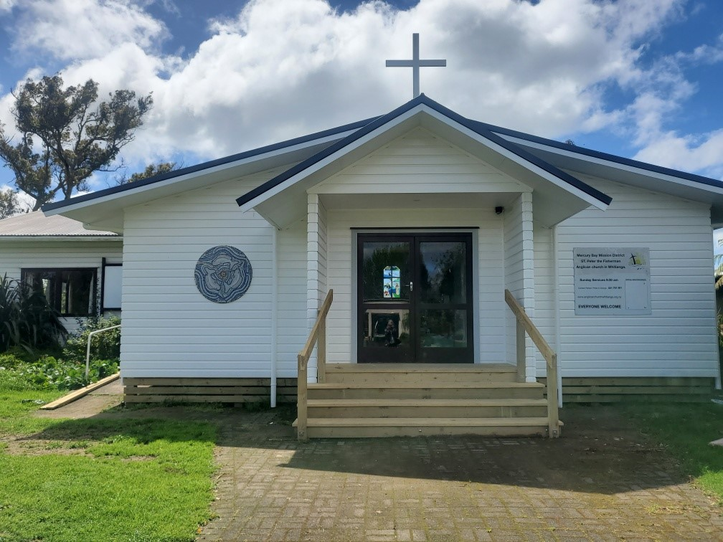

St Peters Church

OUR MISSION STATEMENT:

TO KNOW AND MAKE KNOWN THE LOVE OF GOD”

March 2023 Worship Services at St Peter’s
Sunday 5th March  Presider: Gillian Reid  Gospel and Reflection | HOLY COMMUNION 9.30am  Liturgist: Sharon Short  Gillian Reid
Sunday 12th March  Presider: Gillian Reid  Gospel and Reflection | HOLY COMMUNION 9.30am  Liturgist: Nicky Hewlett  Maxwell Reid
Sunday 19th March  Presider: Gillian Reid  Gospel and Reflection: | HOLY COMMUNION 9.30  Liturgist: Sharon Short  Gillian Reid
Sunday 26th March  Presider Gillian Reid  Gospel and Reflection | HOLY COMMUNION 9.30am  Liturgist: Dawn Schibli  Maxwell Reid
Vestry News  Notice of AGM. Sunday 2nd April after morning tea.  Please think seriously about standing for Vestry.  We meet once every 2 months. | 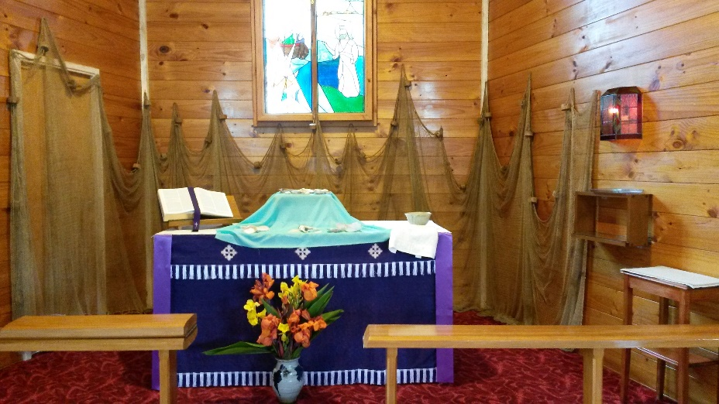
April 2023 Worship Services at St Peter’s
Sunday 2nd April  Presider: Gillian Reid  Gospel and Reflection | HOLY COMMUNION 9.30am  Liturgist: Nicky Hewlett  Gillian Reid
Friday 7th April  Good Friday  Presider: Gillian Reid  Gospel and Reflection  Sunday 9th April  Presider: Gillian Reid  Gospel and Reflection | GOOD FRIDAY 9.30am  Liturgist: Dawn Schibli  Gillian Reid  EASTER SUNDAY COMMUNION 9.30am  Liturgist: Kaye Evans  Gillian Reid
Sunday 16th April  Presider:  Gospel and Reflection: | HOLY COMMUNION 9.30am  Liturgist: Sharon Short  Maxwell Reid
Sunday 23rd April  Presider Gillian Reid  Gospel and Reflection | HOLY COMMUNION 9.30am  Liturgist: Nicky Hewlett  Gillian Reid
Sunday 30th April  Presider Gillian Reid  Gospel and Reflection | HOLY COMMUNION 9.30am  Liturgist: Kaye Evans  Maxwell Reid

GILLIAN’S MONTHLY MUSINGS
As I write this, the wind is howling around the house, and the rain is absolutely thundering down, pinning us inside for yet another day. The roads in all directions are either closed or reduced to slow, limited, use. This is an all too familiar scene we have ‘suffered’ for what sometimes feels like an early 40 days of Lenten deprivation. Yet, all this is trivial in comparison with what our families and friends in Aukland have been, and still are, facing from the devastating floods which will upend their lives for some time to come. It is trivial in comparison to the daily Russian missile attacks on their homes the people of Ukraine are suffering. It is trivial in comparison to the suffering of people in African countries from years of drought, who are quite literally starving to death for lack of food and water.
In all this, everywhere, there are people absolutely living out Christ’s example of serving others. They are helping flood-threatened families to safety, they are helping clear slips, building and road damage. They are helping take supplies to people in Ukraine who are trapped and/or homeless. They are helping many of those people get to safety. They are transporting food, water, and medical supplies to people whose lives are devastated by drought. I am so aware that in many small (and often large) ways many in our community are doing the same. The food that comes in so generously each week, for the Social Services Food Bank. The time people volunteer to the various social support groups in our town; such as Hato Hone St John, the Fire Brigade, the Coastguard, the various Op Shops whose revenue goes back out into our community, the Lions club, and all the other community groups which are organised and run by people giving up their time to help others in difficulty, or to learn skills they otherwise would never gain. The donations made to organisations world-wide who are also trying to help the lost and helpless.
As was made clear to us in the video we have been watching over January on the history of Christianity in our country of Aotearoa New Zealand, the basic Christian ethics and understanding of right and wrong, the appropriateness of helping and serving others, the difference between good and evil, are well-embedded characteristics of most people who call this country their home. As time goes on, it may well be the Christians among us who are the long term ‘guardians’ of those principles of serving others. Thus, each year, we can use that reflective time of Lent, to refuel our sense of service, and energise ourselves to go out again in our community and take that Christian message with us in all the things we do and are.
Nga manaakitanga ki a koutou katoa. Gillian

**********************************************
LAUGHTER Really IS THE BEST MEDICINE !!!

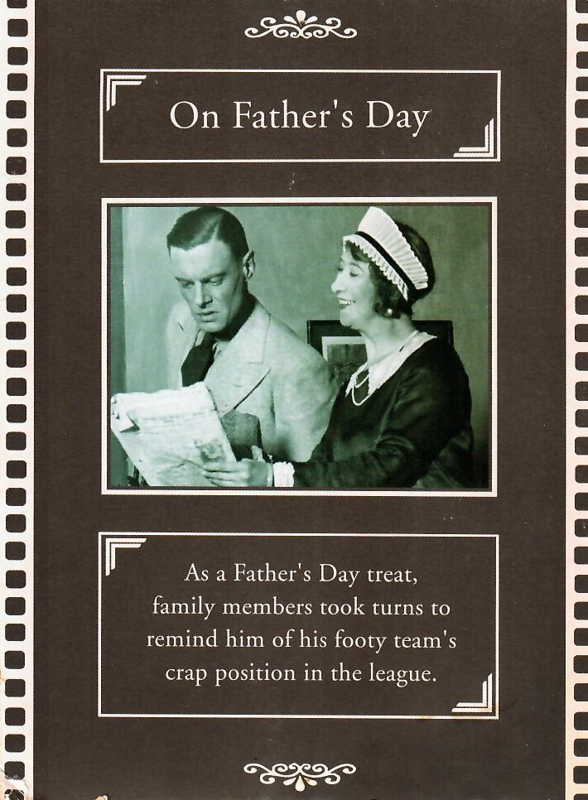 | One year a while back, the Auckland Blues were having a terrible season, so our kids gave me this Father’s Day card. Thanks a lot!

Somewhere in America there was a Dolly Parton look-like competition. Dolly tells us that the entrants were mostly transvestite men, so she walked on stage in the lineup herself. Hilariously, one of the other contestants won! (Dolly Parton)

Actually, if each day is a gift, I’d like to know where I can hand back Mondays!

Memorable THOUGHTS ON LIFE
Start the day with a smile, and get it over with (W.C. Fields).
Medical research has shown that people who have more birthdays live longer (Robert Schibli).
The definition of a gentleman. A chap who can play the bagpipes, but kindly refrains from doing so.
What lies behind us, and what lies ahead of us, are insignificant compared to what lies within us. (Ralph Emerson).
Never go in search of love. Go in search of life, and life will find you the love you seek. (Atticus).
If at first, you don’t succeed… Skydiving is not for you.
Money isn’t everything… But it sure keeps the kids in touch.
Don’t knock us oldies.
A dear old lady handed her bank card to the teller and said, I would like to withdraw $10. The teller told her “For withdrawals of less than $100, please use the ATM outside!”
The old lady wanted to to know why… The teller returned the bank card and irritably told her “These are the rules, please leave if there is no further matter. There is a line of customers behind you”. The old lady remained silent for a few seconds and then handed her card back and said “please help me withdraw all the money I have.” The teller was astonished when she checked the account balance. She nodded her head and leaned down and respectfully told her “You have $300,000 in your account but the bank doesn’t hold that much cash currently at hand. Can you make an appointment and come back again tomorrow”.
The old lady then asked how much she could withdraw immediately. The teller told her any amount up to $3000. “Well, please let me have $3000 now”. The teller kindly handed over the $3000 in a very friendly manner with a courteous smile. The old lady put $10 in her purse and asked her to deposit $2990 back into her account! The moral of the story is, don’t be difficult with old people, they spent a lifetime learning the skill!

Some Prayers for quiet reflection
Loving God, light to all who know you, strength to all who love you, unite us as we appreciate your ministry of all who walk in the Jesus way. Help us cherish what we do in your service, so that we may be bearers of your good news in all we do. Amen
Compassionate God, you lead us to repentance and new life, even as we sin and turn away from you. Call us by name, as Jesus called his disciples. Open our hearts and minds to the abundant life you offer to all creation. Amen
Lent: God of new beginnings, you meet us where we are, and stand by us in the lowest points of our lives. Help us to recognise your presence even in wasteland. Give us the clarity to know what is right, and the courage to reject tempting alternatives. Amen
Saving God, you journey with us, even in our time of wilderness. You slake our thirst with living water. May we, like the woman of Samaria, be willing to entrust yu with our innermost selves. Grace us with your Spirit, as you did Jesus, that we may be part of your harvest of love for all creation. Amen
Easter: Disturbing Spirit, you come among us to reveal resurrection hope. Rouse us from our complacency this Easter. Unbind us from all that prevents us from seeing you clearly. Help us recognise you as the one who as the one who comes to serve and revive. Transform us that we might be your light and leaven in the world. Amen
Generous God, you long to birth us into new life. You give us Jesus, pattern for this new life in you. Open the closed doors of our hearts and minds, so that we, unlike Thomas, can believe without seeing or touching, and confidently say ‘my Lord and my God’. Amen
Gracious God, you call, restore, strengthen and establish us as your disciples in our age. Help us rejoice in your call, and stand robustly together in faith, that we may be as one with you walking the way of Jesus, strengthened and inspired by your Holy Spirit. Amen

Childhood Memories – by Dawn Schibli
I was born in Brighton on the South coast of England just after the war. I have one older sister. During the war my parents were living in London, as my father was working there, when their house was bombed (fortunately they weren’t in it at the time) so they moved out of London to the coast.
After the war rationing continued for some years on various food items. When grocery shopping with my mother I was impressed with how the shop assistants held the crayon behind their ears, so it was handy to cross off the squares in the ration book. When the books were full, we used them when we were playing shops.
In the summer we spent a lot of time at the beach, so I learned to swim quite young but never mastered diving as there wasn’t anything to dive off. Brighton has a pebble beach which was normal for us. (When Robert first saw them, he called them boulders and was not impressed!)
All my family come from Yorkshire so part of our holiday each summer entailed going up there to visit everyone. The start of the holiday was the coach ride to get there, and it took all day. This was before the present motorways, so we meandered along with comfort stops from time to time. One of the highlights of the holiday was when the Fair came to the village and set up in the farmer’s field. We always liked the game aiming pingpong balls. If you got one in the right place the prize was a goldfish. We actually won one a couple of times and managed to transport them home to live in a bowl in our kitchen. I realise now how patient our mother was! Another highlight was a trip to Blackpool occasionally. There were wonderful rides at the funfair there.
For schooling we went as day students to a local convent. It was run by nuns belonging to a French order. My first teacher was a small nun called Madam Ignatius. She wore the full black and white habit which only showed her face from the eyebrows down and she had squeaky shoes! (What odd things we remember.) A happy time. We liked having longer holidays than most schools and various days off for religious festivals.
When I was 13 I transferred to a newly built co-ed grammar school – the first co-ed one in Brighton. Quite a change for me but an opportunity for a more academic education. I stayed there until I completed the equivalent of Year 13 in NZ. So, childhood over I went on to Whitelands Teacher’s College in London. It was the mid 60’s – what a time to be there!!

FOOD BASKET – don’t forget your donation to the Social Services Food Basket. This is a very worthy cause, as there are families in Whitianga who are really struggling.

March Birthday Wishes
None this month.

April Birthday Wishes
This month of April we wish a Happy Birthday to Nicola (Nicky) Hewlett

Weekly Service Roster
If you swap a duty with someone else – reading, chalice bearer, prayers etc., as well as changing it on the roster by the door please would you let the Liturgist for that Sunday know as they may not check the alterations during the week. This will make it much easier for them when putting the service together. Many thanks.

Don’t Forget our Outreach and Activity Groups
Knit for a Purpose:
Meets on the first and third Friday of the month, from 10.00am to 12.00pm, for good coffee, morning tea, and fellowship, while making garments and blankets for children in the care of the Anglican Trust for Women and Children. Knitting yarn, needles and patterns supplied, along with encouragement and helpful advice if needed. New members are always welcome.

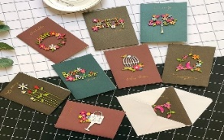
Card Making:
Meets on the second and fourth Friday of the month, from 10.00am to 12.00pm, for good coffee, morning tea, fellowship, and loads of laughs as we try to follow our teacher’s guidance to make personalized greeting cards. (There are no such things as mistakes, just creative differences, easily concealed if desired). Heaps of resources available to share. New members, skilled or unskilled, are always welcome.
Seniors Strength, Balance, and Mobility classes:
Meets every Thursday morning, 10.00am to 11.00am. For ‘seniors’ - how to exercise sitting down or leaning on a chair, without breaking out in a sweat. All levels of personal unfitness welcome! Join in any time.

Men’s gardening group:
Meets on Friday afternoon, 1.00pm for a couple of hours working in the church garden producing vegetables for Community Social Services and maintaining the church grounds. All keen (or just hopeful) gardeners welcome. Contact Maxwell on 0274 906 120.

WHO’S WHO AT ST PETERS
Clergy: Priest in Charge | Rev. Dr. Gillian Reid
Verger | Vic Dalbeth
Licensed Lay Ministers: | Sharon Short  Nicky Hewlett
 | Dr Maxwell Reid
Vestry: People’s Warden | Jill Laird
Priest’s Warden | Sharon Short
Synod Rep | Nicky Hewlett
Secretary | Kaye Evans
Treasurer | Bob Schibli
Webmaster & Safety Officer  Maintenance coordinator | Maxwell Reid  Alan Andrews
Worship Team: | Gillian Reid
(Roster Coordinator): | Maxwell Reid
 | Dawn Schibli
 | Nicky Hewlett
Sharon Short
Jill Laird
Kaye Evans
Pastoral Care Team: | Dawn Schibli
 | Gillian Reid
 | Nicky Hewlett
 | Jill Laird
 | Sharon Short

website: wwwanglicanchurchwhitianga.org.nz
Facebook: ww.facebook.com/stpeter.thefisherman.96
Mercury Bay Mission District contact person: Jill Laird
Ph. 8660641, jilliannelaird48@gmail.com

Happy Birthday Gillian!
