NETWORK NEWS
ST PETER’S ANGLICAN CHURCH
MERCURY BAY MISSION DISTRICT
June 2022
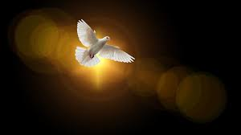

Pentecost

OUR MISSION STATEMENT:

TO KNOW AND MAKE KNOWN THE LOVE OF GOD”

JUNE WORSHIP SERVICES AT ST PETER’S
Sunday 5th June  Presider: Gillian Reid  Gospel and Reflection | HOLY COMMUNION 9.30am  Liturgist: Sharon Short  Maxwell Reid
Sunday 12th June  Presider: Gillian Reid  Gospel and Reflection | HOLY COMMUNION 9.30am  Liturgist: Dawn Schibli  Gillian Reid
Sunday 19th June  Presider: Gillian Reid  Gospel and Reflection: | HOLY COMMUNION 9.30  Liturgist: Nicky Hewlett  Gillian Reid
Sunday 26th June  Presider Gillian Reid  Gospel and Reflection | HOLY COMMUNION 9.30am  Liturgist: Dawn Schibli  Gillian Reid
Weekly Service Roster
If you swap a duty with someone else – reading, chalice bearer, prayers etc., as well as changing it on the roster by the door please would you let the Liturgist for that Sunday know as they may not check the alterations during the week. This will make it much easier for them when putting the service together. Many thanks.

GILLIAN’S MONTHLY MUSING
Gillian’s Monthly Musings:
It is not an activity which is common for most of us, but going into other churches, whether in NZ or elsewhere, can be quite a challenging exercise. I find this particularly so, when I am ‘a tourist’ in a country which is very different from mine, and far from being able to sit quietly, or engage with a service of worship, I am surrounded by people for whom this is just another building.
It feels even more challenging to ‘feel the presence of God’, when in spite of multi-language signs and instructions to respect the nature of that environment, loud conversations are carried out, and cameras are flashing all around to capture pictures which will be carried home as mementos of the few minutes spent in each place.
This was particularly so in the magnificent La Sagrada Familia in Barcelona. This is, above all, a significant Christian Basilica, which has worship services early each morning, yet as I sat there for a while gazing at the truly amazing altar area, the hubbub around me made the place feel more like a secular public building, certainly magnificent, but not a place of God.
That experience, and a couple of other forays into churches now presented as much as tourist destinations as they are places of worship, made me reflect on just how do we feel the presence of God in noisy and/or very busy places? We are encouraged, when we want to pray, to go into a quiet place, let everything go, and allow the Holy Spirit to come. For the life of me, sitting surrounded by noisy non-Christians waving cameras in all directions, making contact with the Holy Spirit felt like the top of a very high mountain reachable only by an effort almost beyond me.
I realise how important it is to me to be quiet, in all aspects of myself, in order for that food of Christ, in the entity of the Holy Spirit, to come and refresh my soul. Thus, in spite of feeling ‘short-changed’ on my expectation I would have some amazing spiritual experience being in these ‘tourist churches’, what I was reminded about was that for me, getting close to God is a lot easier when the noise and clutter of ‘daily life’ is shed, and that quiet place in myself is able to be reached.
Manaakitanga, Gillian

Altar section of La Sagrada Familia - from Gillian
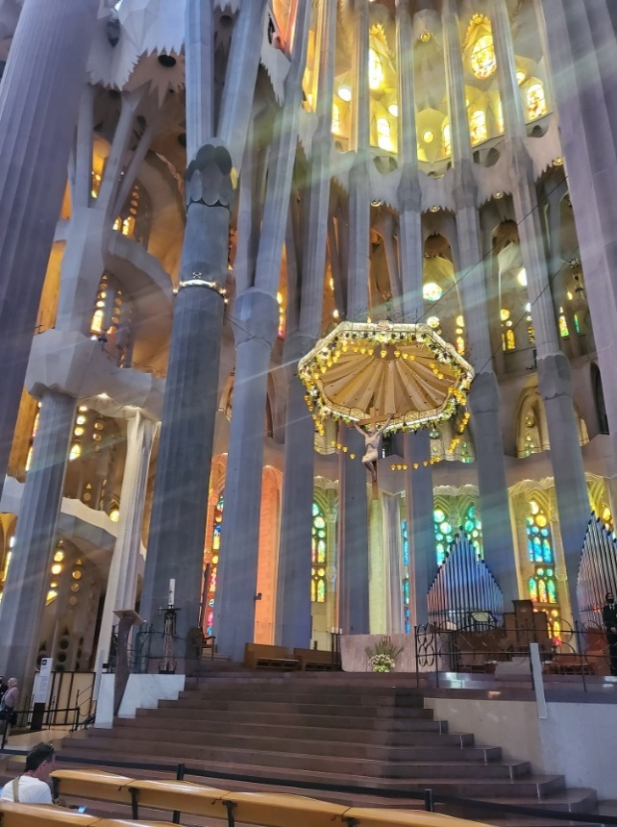
What is Trinity Sunday? - The Mystery of the Three-in-One
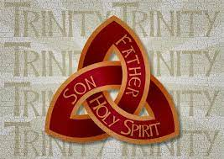
Trinity Sunday (also called Holy Trinity Sunday) is a day commemorated on the Sunday following Pentecost to emphasize the Trinity—Father, Son, and Holy Spirit. In the Western church calendar, this Sunday occurs on the eighth Sunday following Easter (since Pentecost Sunday falls on the seventh Sunday after Easter) Trinity Sunday helps the church to emphasize the proper understanding of Father, Son, and Spirit, and reminds us that God exists in both perfect oneness and community. He is perfect in every way, transcending all creation, sending Jesus to live among humanity, and empowering believers by the Spirit today. In Matthew 28:19, Jesus instructed the disciples, telling them, “Go and make disciples of all nations, baptizing them in the name of the Father, and of the Son, and of the Holy Spirit.”

PENTECOST SUNDAY

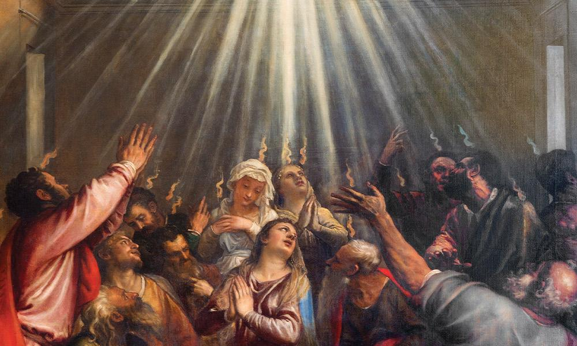
Pentecost is generally regarded as the church’s birthday, and it always comes on a Sunday. Unlike Christmas and Easter this day passes with such little fanfare that there is a good chance you will not think about it or be reminded of it. But it is the ‘when’ as well as the ‘what’ of Pentecost that shows it is a Sign, a remarkable allusion of the Gospel that deserves our full attention. However, to see this we need to understand its place in the Biblical story.
Pentecost is the day when the Holy Spirit of God came down to dwell in the followers of Jesus. This is the day that the church, the “called-out ones” of God, was born. It is recorded in Acts chapter 2. On that day, the Spirit of God descended on the 120 followers of Jesus, and they started speaking out loud in languages from around the world. This created such a commotion that thousands who were in Jerusalem at the time came out to see what was happening and in front of the gathering crowd, Peter spoke the first gospel message and ‘three thousand were added to their number that day’ (Acts 2:41).
Hence, the church was born, and the number of gospel followers has been growing continually ever since that Pentecost Sunday. This happened 50 days after Jesus’ resurrection. It was during this ‘quiet’ interval of 50 days that Jesus’ disciples became convinced that Jesus had risen from the dead. On Pentecost Sunday they went public, and history was changed. Whether you believe in the resurrection or not, your life has been affected by the events of that Pentecost Sunday.

***********************************************
LAUGHTER Really IS THE BEST MEDICINE !!!!

An obnoxious lady once said to Winston Churchill, “if you were my husband, I would poison you.”
Churchill replied “if you were my wife, I’d drink it”

Moses was leading his people through the desert for 40 years. It seems, even in Biblical times men avoided asking for directions.
One Sunday, a minister played hooky from church so he could shoot a round of golf. St. Peter, looking down from Heaven, seethed. “You’re going to let him get away with this, God?” The Lord shook his head. The minister took his first shot. The ball soared through the air 670 yards and dropped into the cup for a hole in one. St. Peter was outraged. “I thought you were going to punish him!” The Lord shrugged. “Who’s he going to tell?”
A Sunday School teacher had just concluded her lesson and wanted to make sure she had made her point regarding remorse. She said, “Can anyone tell me what you must do before you can obtain forgiveness of sin?” There was a short pause and then, from the back of the room, a small boy spoke up. "Sin?" he said.
The local council CEO explained that they were trying to cut overheads in their administration. He said in the interview “we’re looking for someone who can replace three men in our office.”
The lady applicant replied, “that’s a shame, I was hoping for a full-time job.”
The surest sign that intelligent life exists elsewhere in the Universe is that it has never tried to contact us.

It's not my age that bothers me, it's the side effects.

As I've got older, people think I have become lazy. The truth is I've just become more energy efficient.

I got nothing done today. I've been in the Produce department, trying to open this stupid plastic bag.

I want to be 18 again and ruin my life differently. I have some new ideas now.

I'm on two diets. I wasn't getting enough food on one.

God promised men that good and obedient wives would be found in all corners of the earth. Then he made the earth round, and laughed and laughed and laughed.

I put my scales in the corner of the bathroom, and that's where the little liar will stay until it apologies.

It's hard to believe I once had a phone attached to a wall, and when it rang I had no idea who was calling me.

There's no such thing as a grouchy old person. The truth is, once you get old you stop being polite and start being honest.
Memorable THOUGHTS
"If you can’t fly, then run, If you can’t run, then walk, If you can’t walk, then crawl, but whatever you do, you have to keep moving forward." – Dr Martin Luther King Jr.
Relying on God has to start all over everyday, as if nothing has yet been done." – C. S. Lewis
"The Christian life is not a constant high. I have my moments of deep discouragement. I have to go to God in prayer with tears in my eyes, and say, 'O God, forgive me,' or 'Help me.'” – Dr Billy Graham
"We gain strength, and courage, and confidence by each experience in which we really stop to look fear in the face...we must do that which we think we cannot." - Eleanor Roosevelt

Prayer for Peace—by Pope Francis
Lord God of peace, hear our prayer!
We have tried so many times and over so many years to resolve our conflicts by our own powers and by the force of our arms. How many moments of hostility and darkness have we experienced; how much blood has been shed; how many lives have been shattered; how many hopes have been buried… But our efforts have been in vain. Now, Lord, come to our aid! Grant us peace, teach us peace; guide our steps in the way of peace. Open our eyes and our hearts, and give us the courage to say: “Never again war!”; “With war everything is lost”. Instill in our hearts the courage to take concrete steps to achieve peace. Lord, God of Abraham, God of the Prophets, God of Love, you created us, and you call us to live as brothers and sisters. Give us the strength daily to be instruments of peace; enable us to see everyone who crosses our path as our brother or sister. Make us sensitive to the plea of our citizens who entreat us to turn our weapons of war into implements of peace, our trepidation into confident trust, and our quarrelling into forgiveness. Keep alive within us the flame of hope, so that with patience and perseverance we may opt for dialogue and reconciliation. In this way may peace triumph at last, and may the words “division”, “hatred” and “war” be banished from the heart of every man and woman. Lord, defuse the violence of our tongues and our hands. Renew our hearts and minds, so that the word which always brings us together will be “brother”, and our way of life will always be that of: Shalom, Peace, Salaam! Amen.

Childhood Memories – by Robert Schibli
As war raged in Europe I came into the world rather peacefully in Montreal, Canada. I’m the middle of 3 boys – ‘the forgotten child’! My mother was an American, my father Swiss – and the multi-nationalism of our wider family has continued through to today, and includes citizens of English, American, Canadian, New Zealand, Australian, Italian, and Indian descent (not to mention the Irish and German background of my grandparents)!
Montreal is my hometown. I lived there till I got married and I have very fond memories of my childhood. Life was good. I cannot remember there being any deprivations because of the war – no rationing, I think. My parents were Catholic and as such I had a Catholic education – even to being an altar boy at Sunday mass. I had to learn all the responses in Latin, the language of the Mass in those days. A highlight as an altar boy was being selected to be part of Midnight High Mass, at Christmas. Imagine – being allowed to stay up well past midnight, and then returning home to see the Christmas tree and presents – magical!
I attended the local primary school. The kids new each other well – all living within a few blocks in the community. Growing up there wasn’t much in the way of organised activities for children. We had to make our own fun. So, we played a lot of unorganised sport – mainly ice hockey, baseball and football (gridiron). Rugby and cricket were unheard of. My love of sport continues to this day.
My homelife seemed ordinary – a well-settled family of 5. Dad went to work, Mom stayed home. I had a good relationship with my brothers – we played together a lot, fought a few times, some tears – but mainly smiles. We always seemed to have a dog – in fact, my first dog (a Springer Spaniel) had been the mascot, under the care of my uncle, on one of the Canadian frigates during the war! When the war ended, my uncle passed the dog on to us – the beginning of my love affair of dogs. Annual highlights would include: summer holidays at the lake, the first snow-fall of the winter, the arrival in the post of Swiss chocolates from my Swiss relatives, listening/watching hockey games on radio/tv, going to the baseball stadium, …
Such a carefree life – and then high school began. The start of the transition from childhood to adulthood …

FOOD BASKET – don’t forget your donation to the Social Services Food Basket. This is a very worthy cause, as there are families in Whitianga who are really struggling.

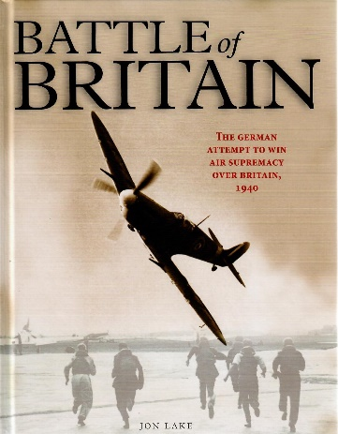
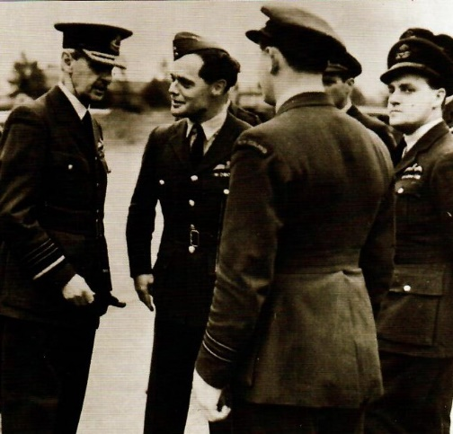
Book Review - Battle of Britain by Jon Lake
Never in the field of human conflict, was so much owed by so many to so few
I remember sitting on my Grandad’s knee listening to his memories of the Battle of Britain, and my interest has never waned since. The research that has gone into this book and the subsequent publication is the quality of Doctoral Thesis with Honours. It is a comprehensive and informative account of the greatest aerial conflict in the history of the world. It is illustrated with over three hundred photographs and art works. The book includes an extensive appendix with details of the aircraft, men and women, and units that were involved in the battle on both sides. Yes, many British women must take credit for extensive involvement behind the scenes including flying new fighters from the factories to the front line.
Each chapter, in fact almost every page, includes illustrated feature boxes on a range of topics to do with the battle including the commanders involved, the tactics and formations used. The layout is such that you can pick the book up and read any page with interest. The RAF pilots were not only British. These included 145 Poles, 127 New Zealanders, 112 Canadians, 88 Czechoslovaks, 10 Irish, 32 Australians, 28 Belgians, 25 South Africans, 13 French, 9 Americans, 3 Southern Rhodesians and individuals from Jamaica, Barbados and Newfoundland. The statistics on pilot survival were horrific. As an example, of the nine American volunteers, only one survived. Towards the end, many young pilots with few flying hours were thrown into the melee. It was equivalent to learning to drive in the family saloon car, and then going into straight a formula one racing car! Intriguingly, the Spitfire is now the symbol of the Battle of Britain, but in fact, Hurricanes were easier to build, more numerous, and accounted for eighty percent of the German aircraft destroyed. One of the myths dispelled in the account is Hitler’s daft idea of invading Britain using canal boats which were designed for still waters. The unbelievable organisation by the allied invaders of France after D-Day showed that such an exercise would be nearly impossible for the Germans to achieve. It is thought that the plans to invade Britain were a simply a bluff to bring the British to negotiations for peace which, considering the bulldog nature of Churchill, were doomed to failure. The second illustration here shows Air Chief Marshal Lord Dowding (the man who was responsible for the air defence of Great Britain) with his pilots in 1945 before the flypast on Battle of Britain Day. He is talking to the legless fighter pilot, Group Captain Sir Douglas Bader. (The honours for these two men were given at a later date). Enjoy the read. Maxwell

Don’t Forget our Outreach and Activity Groups
Knit for a Purpose:
Meets on the first and third Friday of the month, from 10.00am to 12.00pm, for good coffee, morning tea, and fellowship, while making garments and blankets for children in the care of the Anglican Trust for Women and Children. Knitting yarn, needles and patterns supplied, along with encouragement and helpful advice if needed. New members are always welcome.

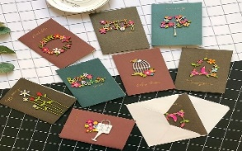
Card Making:
Meets on the second and fourth Friday of the month, from 10.00am to 12.00pm, for good coffee, morning tea, fellowship, and loads of laughs as we try to follow our teacher’s guidance to make personalized greeting cards. (There are no such things as mistakes, just creative differences, easily concealed if desired). Heaps of resources available to share. New members, skilled or unskilled, are always welcome.
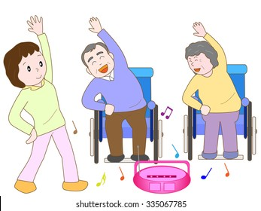
Seniors Strength, Balance, and mobility classes:
Meets every Thursday morning, 10.00am to 11.00am. For ‘seniors’ - how to exercise sitting down or leaning on a chair, without breaking out in a sweat. All levels of personal unfitness welcome! Join in any time.

Men’s gardening group:
Meets on Friday afternoon, 1.00pm for a couple of hours working in the church garden producing vegetables for Community Social Services and maintaining the church grounds. All keen (or just hopeful) gardeners welcome. Contact Maxwell on 0274 906 120.

JUNE Birthday Wishes
This month we wish happy birthday to
Kaye Evans

WHO’S WHO AT ST PETERS
Clergy: Priest in Charge | Rev. Dr. Gillian Reid
Verger | Vic Dalbeth
Licensed Lay Ministers: | Sharon Short  Nicky Hewlett
 | Dr Maxwell Reid
Vestry: People’s Warden | Jill Laird
Priest’s Warden | Sharon Short
Synod Rep | Nicky Hewlett
Secretary | Kaye Evans
Treasurer | Bob Schibli
Webmaster & Safety Officer  Vestry member | Maxwell Reid  Alan Andrews
Worship Team: | Gillian Reid
(Roster Coordinator): | Maxwell Reid
 | Dawn Schibli
 | Nicky Hewlett
Sharon Short
Jill Laird
Pastoral Care Team: | Dawn Schibli
 | Gillian Reid
 | Nicky Hewlett
 | Jill Laird
 | Sharon Short

website: wwwanglicanchurchwhitianga.org.nz
Facebook: ww.facebook.com/stpeter.thefisherman.96
Mercury Bay Mission District contact person: Jill Laird
Ph. 8660641, jilliannelaird48@gmail.com

Lunch in Sicily

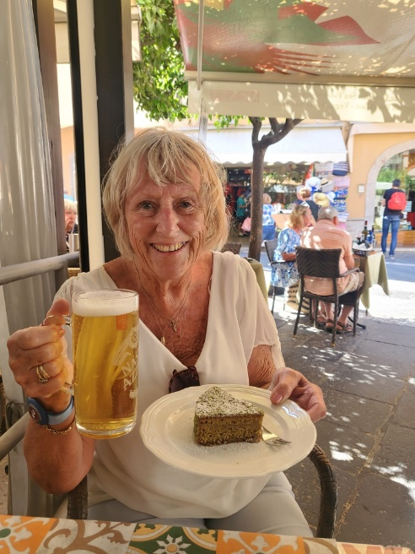

Progress on our building extension
