NETWORK NEWS
ST PETER’S ANGLICAN CHURCH
MERCURY BAY MISSION DISTRICT
July - August 2023

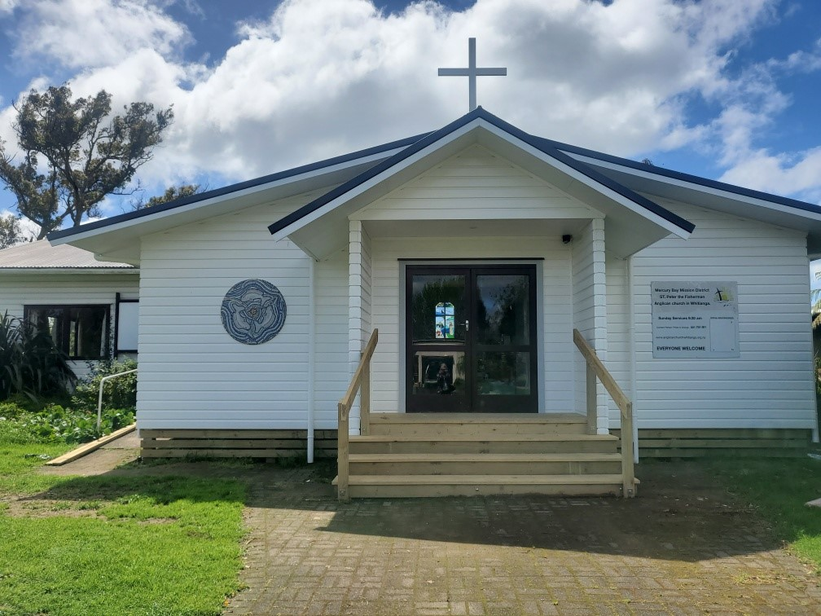

St Peters Church

OUR MISSION STATEMENT:

TO KNOW AND MAKE KNOWN THE LOVE OF GOD”

July/August 2023 Worship Services at St Peter’s
Sunday 2nd July  Presider: Gillian Reid  Gospel and Reflection | HOLY COMMUNION 9.30am  Liturgist: Kaye Evans  Guest Speaker (Social Services Sunday)
Sunday 9th July  Presider: Gillian Reid  Gospel and Reflection | HOLY COMMUNION 9.30am  Liturgist: Sharon Short  Guest Speaker (Sea Sunday)
Sunday 16th July  Presider: Gillian Reid  Gospel and Reflection: | HOLY COMMUNION 9.30  Liturgist: Dawn Schibli  Guest Speaker (Refugee Sunday)
Sunday 23rd July  Presider Gillian Reid  Gospel and Reflection  Sunday 30th July  Presider: Gillian Reid  Gospel and Reflection  Sunday 6th August  Presider: Gillian Reid  Gospel and Reflection  Sunday 13th August  Presider: Gillian Reid  Gospel and Reflection:  Sunday 20th August  Presider Gillian Reid  Gospel and Reflection  Sunday 27th August  Presider Gillian Reid  Gospel and Reflection | HOLY COMMUNION 9.30am  Liturgist: Nicky Hewlett  Gillian Reid (Bible Sunday)  HOLY COMMUNION 9.30am  Liturgist: Sharon Short  Maxwell Reid  HOLY COMMUNION 9.30am  Liturgist: Sharon Short  Gillian Reid (Transfiguration Sunday)  HOLY COMMUNION 9.30am  Liturgist: Kaye Evans  Maxwell Reid  HOLY COMMUNION 9.30am  Liturgist: Nicky Hewlett  Gillian Reid  HOLY COMMUNION 9.30am  Liturgist: Dawn Schibli  Maxwell Reid
GILLIAN’S MONTHLY MUSINGS
Tena kotou katoa,
It has been, to say the least, an interesting couple of weeks since I ‘crashed’ down on my back, and am now confined either to bed or couch. If it was God’s intention that I should spend some time in quiet reflection I can think of less painful ways of doing that.
However, here I am, with plenty of time to consider the experiences I have been through as a result of my fall. For the first time in my life I became an emergency patient. Initially, with our Hato Hone St John paramedics and an ambulance trip to Thames A&E. St Peter’s has donated what was (for us) a significant amount of money towards the cost of training that paramedics need to undertake to become fully qualified. I became a recipient of that training, and was hugely impressed by the high level of skills in the treatment I was given – right up with hospital nursing standards. I was also quite overcome by the care and attention I received from them, which made this experience of immediate triage and the long trip to Thames less awful than it might have been. We are incredibly fortunate to have this service and those kind of people here.
Where was God in this? A complete demonstration of care and faith in action. Living out in a totally practical way all the Christian philosophy behind Hato Hone St John’s reason for existence. On Sunday July 2nd, we will have the opportunity to get close to one of our Whitianga paramedics on our Social Services Sunday, and hear from her what her job entails, plus get a bit of exposure to how to use an AED (defibrillator) , since it is possible any one of us could be in the position of needing to use one.
The next three weeks are the rest of our July themes of guest speakers on Sea Sunday, Refugee Sunday, and Bible Sunday. On Sea Sunday we are hoping to have one of Thelma Clow’s sons (Thelma was once a parishioner of ours, and I took her funeral a year or so ago) to talk about his life as a commercial fisherman out of Whitianga.
The following Sunday we have a senior member of World Vision NZ coming to talk about the work he is involved in for WV in Ukraine and parts of Africa. Again, WV is a Christian faith-based organisation, and that philosophy of faith in action underpins all they do. The Ukraine refugee work by WV was also a recipient of a significant donation from us last year, and it will be interesting to hear how that money is being used. On the following Sunday, Bible Sunday, you get me (if I am mobile enough) bearing chocolate fish and other goodies, for a fun morning of Bible Bingo. Yes, all you closet Bingo fans – this is your moment! There is a Plan B if I don’t make it, but I am optimistic that I will be back.
In the meantime I am doing it hard being away from you, but am at least joining you as one of our online congregation members on Sundays anyway.
Maha nga manaakitanga,
Gillian

**********************************************
LAUGHTER Really IS THE BEST MEDICINE !!!
At a pre-election meeting
Heckler: “Tell us what you know, it won’t take long”.
Candidate: “I’ll tell you what we both know; it won’t take any longer”.

We had to cut costs, so we took a few short cuts, but no one will ever know.
City Engineer’s Report – Pisa

A young man was before the court once again, and the court appointed him a court duty solicitor. After consultation with the family, the solicitor stated to the judge that his mother explained that he is cooperative in the family environment provided that the rational for the expectation of behaviour is clearly identified and explained. However, outside the home environment, he becomes dysfunctional, and his personality becomes chameleon-like, adapting his social behaviour to the environment and company he is in.
The Judge said “I don’t believe his mother said anything of a sort. She probably said that he does as he is told at home, provided he is first kicked in the pants, but when he is out with his mates, he just gets into trouble”.

Thoughts on life
I feel sorry for those people who don’t enjoy a glass of wine, when they wake up in the morning, that’s the best they are going to feel all day! (Anon).
There is no such thing as always, well, not on earth anyway (actress Maggie Smith)

History subject was not such a mission when I was at school, because there wasn’t so much of it! (Gillian’s late Dad).

The secret of a good sermon is to have a good beginning and a good ending; and to have the two as close together as possible. (George Burns).
Be careful of reading health books. You may die of a misprint (Mark Twain).
I have never hated a man enough to give his diamonds back (Zsa Zsa Gabor).
Money can’t buy you happiness, but it does give you a more pleasant misery (Spike Milligan).
I don’t feel old, I don’t feel anything until noon, and then it’s time for my nap (Bob Hope).
Don’t worry about avoiding temptation, as you grow older, it will avoid you (Winston Churchill).
The way we were – 1950s
When we were young, my brothers and I saved seven pounds, ten shillings for a record player, and bought Elvis records (amongst other loud songs) for 7/6 each. Considering I got paid 5 shillings a week delivering groceries on a bike, this was quite a lot at the time. I remember torturing Mum and Grandma with these records and being told to PUT A SOCK IN IT! I now understand the origin of this term. Early gramophones had no volume control, and the sound output was reduced by putting a sock in the speaker.
The way we were – 1928
The flapper arrived in New Zealand, to the consternation of many. Unencumbered by masses of clinging drapery, the modern woman now wears dresses, without waistlines, that end an inch or so above the knee. But these followers of fashion are warned by a Presbyterian minister from Mt Eden that there is no permanent happiness in this new lifestyle. Also, he claims they are reportedly trying to ‘ape’ men, taking to drinking cocktails and smoking cigarettes!
After all that – Some Prayers for quiet reflection

Life-giving God, enable us to share that which you have given us with the people we meet on our journey to you. Empower us, as you did Jesus, to welcome home any who have experienced exile from you. May we all be able, finally to welcome and celebrate your reign of justice and peace in our midst. Amen

Ever-generous God, by your creative love, we are made in your image. Empower us by your Spirit, that we might be like the hem of Jesus’ cloak; as people come into contact with us may they experience your healing and hope. Remind us, that that you create us to faithfully live out your gift your gift of ever-lasting life. Amen
Gift-giving God, you throw your mantle of love over us, urging us to love and serve our neighbours. You gift us with all we need to follow your way; and yet we waver; our flesh is weak. Shake us, and help us appreciate that you walk with us, particularly when the going is difficult. Amen.

FOOD BASKET – don’t forget your donation to the Social Services Food Basket. This is a very worthy cause, as there are families in Whitianga who are really struggling.
July Birthday Wishes
This month of July we wish a Happy Birthday to
Sharon Short, Alison Goodlet, and Dawn Schibli
August Birthday Wishes
This month of August we wish a Happy Birthday to
Julie Kipling
Grinding the stumps
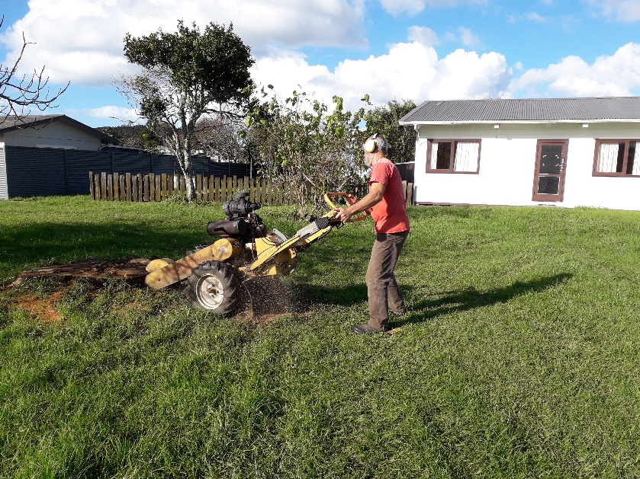
Don’t Forget our Outreach and Activity Groups
Knit for a Purpose:
Meets on the first and third Friday of the month, from 10.00am to 12.00pm, for good coffee, morning tea, and fellowship, while making garments and blankets for children in the care of the Anglican Trust for Women and Children. Knitting yarn, needles and patterns supplied, along with encouragement and helpful advice if needed. New members are always welcome.

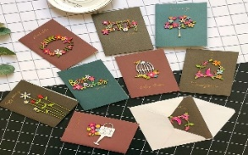
Card Making:
Meets on the second and fourth Friday of the month, from 10.00am to 12.00pm, for good coffee, morning tea, fellowship, and loads of laughs as we try to follow our teacher’s guidance to make personalized greeting cards. (There are no such things as mistakes, just creative differences, easily concealed if desired). Heaps of resources are available to share. New members, skilled or unskilled, are always welcome.
Seniors Strength, Balance, and Mobility classes:
Meets every Thursday morning, 10.00am to 11.00am. For ‘seniors’ - how to exercise sitting down or leaning on a chair, without breaking out in a sweat. All levels of personal unfitness welcome! Join in any time.

Men’s gardening group:
Meets on Friday afternoon, 1.00pm for a couple of hours working in the church garden producing vegetables for Community Social Services and maintaining the church grounds. All keen (or just hopeful) gardeners welcome. Contact Maxwell on 0274 906 120.

WHO’S WHO AT ST PETERS
Clergy: Priest in Charge | Rev. Dr. Gillian Reid
Verger | Vic Dalbeth
Licensed Lay Ministers: | Sharon Short  Nicky Hewlett
 | Dr. Maxwell Reid
Vestry: People’s Warden | Jill Laird
Priest’s Warden | Sharon Short
Synod Rep | Nicky Hewlett
Secretary and Synod Rep | Kaye Evans
Treasurer | Bob Schibli
Webmaster & Safety Officer  Maintenance coordinator  Vestry Member | Maxwell Reid  Alan Andrews  Anna Andrews
Worship Team: | Gillian Reid
(Roster Coordinator): | Maxwell Reid
 | Dawn Schibli
 | Nicky Hewlett
Sharon Short
Jill Laird
Kaye Evans
Pastoral Care Team: | Dawn Schibli
 | Gillian Reid
 | Nicky Hewlett
 | Jill Laird
 | Sharon Short

website: wwwanglicanchurchwhitianga.org.nz
Facebook: ww.facebook.com/stpeter.thefisherman.96
Mercury Bay Mission District contact person: Jill Laird
Ph. 8660641, jilliannelaird48@gmail.com

