NETWORK NEWS
ST PETER’S ANGLICAN CHURCH
MERCURY BAY MISSION DISTRICT
July 2022

OUR MISSION STATEMENT:

TO KNOW AND MAKE KNOWN THE LOVE OF GOD”

JULY WORSHIP SERVICES AT ST PETER’S
Sunday 3rd July  Presider: Gillian Reid  Gospel and Reflection | HOLY COMMUNION 9.30am  Refugee Sunday  Liturgist: Sharon Short  Gillian Reid
Sunday 10th July  Presider: Gillian Reid  Gospel and Reflection | HOLY COMMUNION 9.30am  Sea Sunday  Liturgist: Dawn Schibli  Gillian Reid
Sunday 17th July  Presider: Gillian Reid  Gospel and Reflection: | HOLY COMMUNION 9.30  National Bible Sunday  Liturgist: Nicky Hewlett  Maxwell Reid
Sunday 24th July  Presider Gillian Reid  Gospel and Reflection | HOLY COMMUNION 9.30am  Social Services Sunday  Liturgist: Dawn Schibli  Gillian Reid
Sunday 31st July  Presider Gillian Reid  Gospel and Reflection | HOLY COMMUNION 9.30am  Liturgist Dawn Schibli  Gillian Reid
Weekly Service Roster
If you swap a duty with someone else – reading, chalice bearer, prayers etc., as well as changing it on the roster by the door please would you let the Liturgist for that Sunday know as they may not check the alterations during the week. This will make it much easier for them when putting the service together. Many thanks.

GILLIAN’S MONTHLY MUSING
The month of July is definitely when we acknowledge Winter is here – although this year June gave us a pretty good rehearsal for it. We hunker down wherever we have warmth organised in our homes, find something good to read or watch, and think about the warmer days to come.
This Winter, although they are always sitting there in my consciousness, I am thinking about people like me, or who are like my family, or like my friends, for whom Winter is an absolute nightmare. Making another trip to Auckland to deliver blankets and children’s knitted garments to ATWC for distribution brings home the fact that hunkering down in a warm home, in warm clothes, wearing shoes, and feeling full after a good, healthy meal, is completely foreign to thousands of children in our country, and millions of people in other parts of our world.
Where did we go so wrong, that somehow a byproduct of our comfort becomes someone else’s utter misery? We haven’t knowingly done harm to anyone. We haven’t (too) carelessly used or misused the natural resources available to us. We know that Climate Change is bad with more extreme weather events, and probably will get worse, but ‘the government’ will deal with all that, leaving us free to complain about rising insurance premiums and increased taxes.
Child poverty, displaced refugees from natural and ‘unnatural’ climate or conflict events, infrastructural damage from floods, fires, or earthquakes, are all such big issues they can feel beyond the ability of any individual effort to avert, positively impact, or fix. Yet, for some reason I just can’t get out of my head the words Neil Armstrong is reported to say when he set foot on the moon – “one small step for man, one giant leap for mankind”. It is joined in my increasingly crowded mind with the old Chinese proverb, “a journey of a thousand miles begins with a single step”.
Both of those quotes are emphasising the fact that small things can generate big things. A tree planted; fossil energy consumption reduced; consumable goods reduced, reused, or recycled; an hour a day doing something that makes either our environment or some person’s life a little better; are all small steps that can generate big consequences if enough of us take them.
Jesus knew all about small steps leading to big things, that’s just how he put his ministry into action, starting with a call to just two men to join him, Peter and Andrew. How about finding your small steps and taking them?
Manaakitanga,
Gillian

**********************************************
LAUGHTER Really IS THE BEST MEDICINE !!!!

Things are improving, today I acually went into another room, and could remember why I went there – mind you, it was the bathroom - Anon
Never criticize someone until you've walked a mile in their shoes. That way, when
you criticize them, they won't be able to hear you from that far away. Plus, you'll
have their shoes.
So what if I don't know what "Armageddon" means? It's not the end of the world.
Recently decided to sell my vacuum cleaner as all it was doing was gathering dust.
The best thing about good old days is that we were neither good nor old.
If we shouldn’t eat at night, why do they put a light in the fridge?
Memorable THOUGHTS ON LIFE
Definition of optimism – Batsmen putting zinc on their nose before going out to face the West Indian fast bowlers - Sir Richard Hadley
Life’s tragedy is that we get old too soon and wise too late.” - Benjamin Franklin
“If you live long enough, you’ll make mistakes. But if you learn from them, you’ll
be a better person.” - Bill Clinton
“As you grow older, you will discover that you have two hands, one for helping
yourself, the other for helping others.” - Audrey Hepburn
When one door closes, another opens; but we often look so long and so
regretfully upon the closed door that we do not see the one that has opened for
us. - Alexander Graham Bell
“Never take life seriously. Nobody gets out alive anyway.” - Anonymous
“The way I see it, if you want the rainbow, you gotta put up with the rain.”
- Dolly Parton
Some men see things as they are, and ask, why? I dream things that never were
and ask, why not? Attorney General Robert Kennedy

Childhood Memories – An Interview with Noel Hewlett
Noel’s father had returned from the war, and unfortunately, his family farm had been sold. Consequently, he obtained a rehabilitation farm 20 kms out of Otorohonga. His father’s hard work included turning a swamp into a dairy farm, involving pulling out tree stumps. Noel was born in Otorohonga and was brought up in a family as the youngest of six children on that farm. They used a trailer to transport the milk cans to the gate. Bread was delivered daily with rural mail and supplies came once a week, again by Rural Mail. Fresh milk and cream of course came from the farm.
It was large family, where his sister played the piano, involving wonderful family evenings singing around the piano (one of the ways people entertained before the arrival of Television). Transport to school was by school bus into Otorohonga. A memorable treat was a family Friday night journey into town in the old Ford V8 to the cinema. There were two theatres, one for high quality movies and the other for B-Grade stuff. Quite often they would split up with some of the boys preferring the bug house with all the westerns. One of Noel’s precious family memories was his mother, whom he described as a lovely lady, who used to kneel and pray for the family every night. They also had a commitment to church life at St Brides Anglican Church in town. As a highlight to church life, on some Sundays the children in the area were rounded up and transported into town for combined Sunday School, by means of a sheep truck. Some of the memories would be familiar to many of us, like the outside loo, open fires, etc. Noel’s Father eventually retired, and the family went to live in Te Awamutu. Here Noel became heavily involved with a lively and active church group called the roundabout club. He remembers going with the group to New Plymouth where they were fortunate to see The Seekers on stage. Noel was billeted with a family who had a daughter called Nicky. Their eyes met, and the rest is history, resulting in a wonderful life together.
Noel tried a couple of years at farming with one of his brothers, but farming is not for everyone. Noel was more interested in the retail end of commerce, rather than the primary end. So, he entered the Woolworths trainee management scheme, beginning in Hamilton. He successfully rose through various management levels at Woolworths gaining a very good grounding in the retail and grocery trade. Eventually, while on a work-related advisory trip he discovered this lovely little town of Whitianga. Fortunately for Noel (and us at St Peters) Nicky liked it too, and they bought the local supermarket in the main street, and shifted here.
As a result, over the years, Noel and Nicky have made a massive contribution to the social and service community in Whitianga, and the peninsular. But that‘s another good story. Maxwell

Matariki
For many New Zealanders, 31 December means parties and celebrations to welcome the New Year. These celebrations are an important way of marking the passage of time as well as heralding new beginnings.
Depending on your religion or ethnicity, New Year can come at different times of the year and be celebrated in many ways. For example, there is Chinese New Year or Spring Festival; the Muslim month of Muharram; and Rosh Hashanah, one of the most important religious holidays in the Jewish calendar. In Hebrew, Rosh Hashanah means the ‘head of the year’.
Māori also have their own ‘New Year’, which is marked by the rise of Matariki (the group of stars also known as the Pleiades star cluster) and the sighting of the next new moon. Like Chinese New Year, and the Christian festival of Easter, its exact timing varies from year to year, but it usually occurs during the middle of winter.
Like most natural features seen around New Zealand, Matariki has many different legends behind it. The most common of these is the legend of a mother called Matariki, and her eight daughters, each of whom had a responsibility for a different part of the environment. Back in the early days, Matariki was used to predict the next harvest. The brighter the Matariki star cluster seemed, the warmer the growing season would be for a good harvest.
To find Matariki, from late-May/early-June, look to the northeast horizon just before sunrise. Find the constellation of Orion’s belt (the line of stars that looks like they are going across the waist of a dancing man). Trace a line northward from the three stars of Orion’s Belt and look for a faint sparkle of tiny dots – about the same width as Orion’s Belt is long. That is the Matariki star cluster. (You can also see Matariki during the summer months in the same location but after sunset.)

A prayer for Matariki
The new light of Matariki has risen! May it be to you a sign of resurrection and new life. May it be to you a sign of hope in times of darkness. May it be to you a sign of the wondrous mystery of Atua who loves you. May it be to you a sign that the eyes of the Eternal One are ever upon you and that the presence of the Holy One is ever with you. And may this be the cause of your rejoicing. Go in peace. Through Christ and in the perfect unity of the Holy Spirit, we pray. Amen
Children Are Quick
TEACHER: Why are you late?
STUDENT: Class started before I got here.
TEACHER: Glenn, how do you spell 'crocodile?'
GLENN: K-R-O-K-O-D-I-A-L'
TEACHER: No, that's incorrect.
GLENN: Maybe it's wrong, but you asked me how I spell it.
TEACHER: Donald, what is the chemical formula for water?
DONALD: H I J K L M N O.
TEACHER: What are you talking about?
DONALD: Well, yesterday you said the formula was H to O.
TEACHER: Jennifer, name one important thing we have today
that we didn't have ten years ago.
JENNIFER: Me!
TEACHER: Billy, why do you always get so dirty?
BILLY: Well, I'm a lot closer to the ground than you are.
TEACHER: George Washington not only chopped down his father's cherry tree,
but also admitted it. Now, Louie, do you know why his father didn't punish him?
LOUIS: Because George still had the axe in his hand.
FOOD BASKET – don’t forget your donation to the Social Services Food Basket. This is a very worthy cause, as there are families in Whitianga who are really struggling.

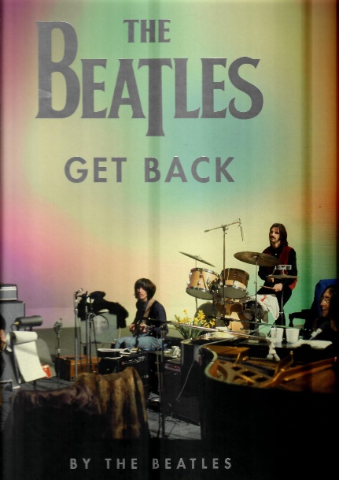
July Book Review - The Beatles: Get Back
Being a child in the post-war early 1950’s, the pop music was rather bland, like Doris Day and the Andrews Sisters. Then in the mid-fifties Rock and Roll hit the American scene. Our age-group loved it, although my family elders did not! The early prime movers like Bill Haley, Elvis and Chuck Berry hammered out Rock and Roll, although there were more sanitised versions on the American scene by singers such as Pat Boon. In England, Cliff Richard and the Shadows made an impression, but it was not until 1963 that suddenly, it really arrived, like a tsunami. Britain, having begun to recover from the war, was being reborn. These were young faces – the Beatles (and others) – with strange and fascinating hair on television, in the newspapers and magazines, and on the radio. It was all happening in London. Suddenly, there was social mobility, the possibility to escape drudgery with a brighter, fuller future. It was not one of Britain’s great public schools or universities that produced these revolutionary boys. They came from one of the war-ravaged northern cities – Liverpudlians! The Beatles were judged by far the best of all the talent around at the time, and they were certainly going somewhere.
This book is the band’s authorised account, in their own words, of the creation of the 1970 album Let It Be. The book transcribes conversations from over 120 hours of original recordings, along with superb candid photographs of the sessions by Ethan Russell and Linda McCartney. Here, both in the Peter Jackson film recently released, and in this book, we are given a fly-on-the-wall-opportunity to witness the only time in their career that the Beatles were filmed at such length, during their creation of music, while in the studio. It is a privilege and an opportunity to see them chatting and improvising, in close-up, in their everydayness selves. These were young people, in their mid to late twenties at the time, three of them who had known each other since school, and who had made music collectively most days since, until they broke up after this album. At the time I thought we would never see another phenomenon like this, but eventually, I think we did, with the more recent works of J K Rowling. Maxwell

Update on our Church Renovation Project
There have been times when it looked as though nothing was progressing on our renovation and extension project. We, like just about everyone involved in construction work have been at the mercy of Council compliance requirements, (some of which we have challenged, with a mix of wins and losses), weather, and supplies.
However, as we can see, progress has been made, and now we have the extension just about ready for the exterior cladding, with all the internal framing in place. It is great to see the shape of the new rooms. The new storeroom and kitchen extension are the most dramatic changes.
At the end of this week, just before our Patronal Festival celebration (breakfast together) the kitchen will be taken out. We have been able to sell our old kitchen, thanks to Kaye’s efforts, so that’s a bit more money which is coming in to help the funds. We have also been receiving money from the Knit for a Purpose Group, along with funds from the sale of our greeting cards and candles. All of this is making it easier to fund items like the dishwasher and new toilet fittings etc.
We have the plan for continuing worship and morning teas during the time we are without a kitchen. If we don’t have any more holdups, the interior will be ready for installation of the gib board linings by the end of June. That is expected to take about a week, with the following week having the plastering done, ready for painting. The painting will be done by those of us who Maxwell agrees are safe with a paintbrush and paint, and that is ‘planned’ to start by mid-July. Maxwell is looking for volunteers to be part of that exercise, which when finished will have us back with a new kitchen and toilets, plus a storeroom which takes a huge amount of pressure away from our present hugely overcrowded facility. At the moment, one of the most striking changes is the view from the new front door area into the church. It is a real treat in waiting for everyone when the new interior is finished. Another stunner is the mosaic design crafted by our own Julie Kipling which will be fixed to one of the front walls. It is quite beautiful, and really eye-catching.
Gillian

Don’t Forget our Outreach and Activity Groups
Knit for a Purpose:
Meets on the first and third Friday of the month, from 10.00am to 12.00pm, for good coffee, morning tea, and fellowship, while making garments and blankets for children in the care of the Anglican Trust for Women and Children. Knitting yarn, needles and patterns supplied, along with encouragement and helpful advice if needed. New members are always welcome.

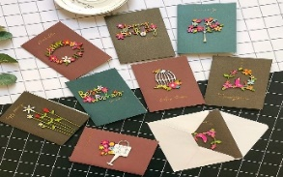
Card Making:
Meets on the second and fourth Friday of the month, from 10.00am to 12.00pm, for good coffee, morning tea, fellowship, and loads of laughs as we try to follow our teacher’s guidance to make personalized greeting cards. (There are no such things as mistakes, just creative differences, easily concealed if desired). Heaps of resources available to share. New members, skilled or unskilled, are always welcome.
Seniors Strength, Balance, and mobility classes:
Meets every Thursday morning, 10.00am to 11.00am. For ‘seniors’ - how to exercise sitting down or leaning on a chair, without breaking out in a sweat. All levels of personal unfitness welcome! Join in any time.

Men’s gardening group:
Meets on Friday afternoon, 1.00pm for a couple of hours working in the church garden producing vegetables for Community Social Services and maintaining the church grounds. All keen (or just hopeful) gardeners welcome. Contact Maxwell on 0274 906 120.

JULY Birthday Wishes
This month we wish happy birthday to
Sharon Short, Poppy Colins, and Alison Goodlet

WHO’S WHO AT ST PETERS
Clergy: Priest in Charge | Rev. Dr. Gillian Reid
Verger | Vic Dalbeth
Licensed Lay Ministers: | Sharon Short  Nicky Hewlett
 | Dr Maxwell Reid
Vestry: People’s Warden | Jill Laird
Priest’s Warden | Sharon Short
Synod Rep | Nicky Hewlett
Secretary | Kaye Evans
Treasurer | Bob Schibli
Webmaster & Safety Officer  Vestry member | Maxwell Reid  Alan Andrews
Worship Team: | Gillian Reid
(Roster Coordinator): | Maxwell Reid
 | Dawn Schibli
 | Nicky Hewlett
Sharon Short
Jill Laird
Pastoral Care Team: | Dawn Schibli
 | Gillian Reid
 | Nicky Hewlett
 | Jill Laird
 | Sharon Short

website: wwwanglicanchurchwhitianga.org.nz
Facebook: ww.facebook.com/stpeter.thefisherman.96
Mercury Bay Mission District contact person: Jill Laird
Ph. 8660641, jilliannelaird48@gmail.com

Cutting the Pentecost Church Birthday Cake
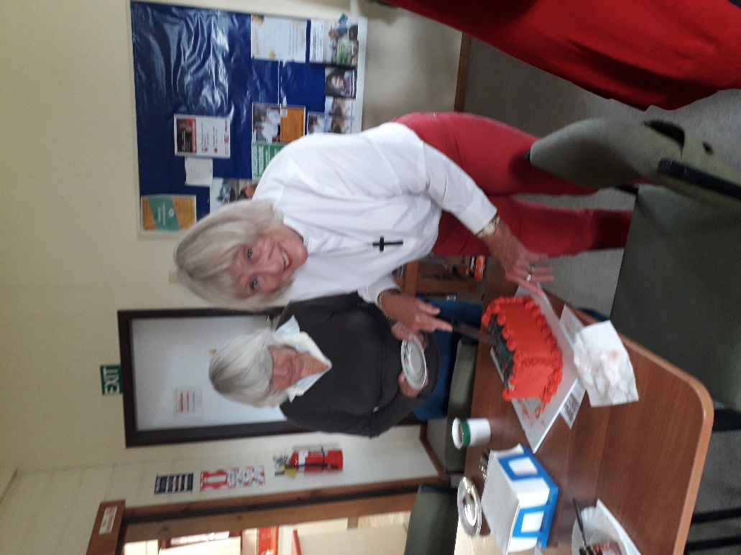

Progress on our building extension

