NETWORK NEWS
ST PETER’S ANGLICAN CHURCH
MERCURY BAY MISSION DISTRICT
January February 2024

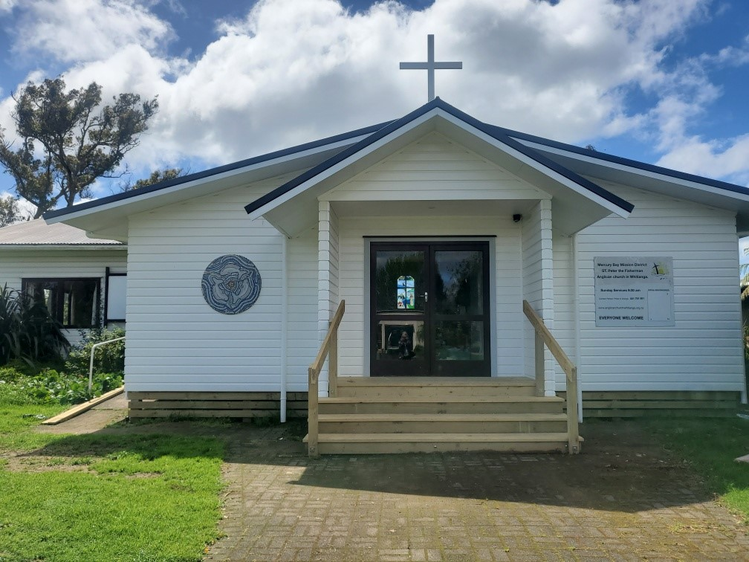

St Peters Church

OUR MISSION STATEMENT:

TO KNOW AND MAKE KNOWN THE LOVE OF GOD”

May/June 2023 Worship Services at St Peter’s
Sunday 7th January  Presider: Gillian Reid  Gospel and Reflection | HOLY COMMUNION 9am  Liturgist: Kaye Evans  Gillian Reid
Sunday 14th January  Presider: Gillian Reid  Gospel and Reflection | HOLY COMMUNION 9am  Liturgist: Nicky Hewlett  Gillian Reid
Sunday 21st January  Presider: Gillian Reid  Gospel and Reflection: | HOLY COMMUNION 9am  Liturgist: Sharon Short  Gillian Reid
Sunday 28th January  Presider Gillian Reid  Gospel and Reflection  Sunday 4th February  Presider: Gillian Reid  Gospel and Reflection  Sunday 11th February  Presider: Gillian Reid  Gospel and Reflection  Wednesday 14th February  Presider: Gillian Reid  Gospel and Reflection  Sunday 18th February  Prayer Service  Gospel and Reflection:  Sunday 25th February  Presider Gillian Reid  Gospel and Reflection | HOLY COMMUNION 9am  Liturgist: Dawn Schibli  Gillian Reid  HOLY COMMUNION 9am  Liturgist: Sharon Short  Maxwell Reid  HOLY COMMUNION 9am  Liturgist: Dawn Schibli  Gillian Reid  Ash Wednesday 9am  Liturgist: Sharon Short  Gillian Reid  HOLY COMMUNION 9am  Liturgist: Kaye Evans  Video  HOLY COMMUNION 9am  Liturgist: Nicky Hewlett  Gillian Reid
GILLIAN’S MONTHLY MUSINGS
Our world today can present us with many reasons to lose hope with opportunities, attractions, and distractions that make it easy to miss the true meaning of the Christmas season. But in fact, this is the season of light, whether from the lights of the Christmas tree, the glow of the Advent wreath candles, or perhaps simply the sky on a day of sunshine in a New Zealand December. All of these can remind us of the presence of God and the promise of hope that is fulfilled in this holy season.
This Christmas I lost a dear friend, mentor and colleague. Bishop Bruce Gilberd. I feel utterly privileged that I was fortunate enough to have had those years of the benefit of his wisdom. When I was with him I always felt God was also there, and in a funny way, the timing of his departure from this life right at the time of the arrival of our Christ had its own message, straight out of Matthew 28:20 – “obey everything I have commanded you, and surely I am with you always, to the very end of the age.” Jesus came to us as a baby and left us as a man who had dedicated his life to God’s work. Bruce lived a longer life but one that also was dedicated to God’s work. Each of us in our own way can live out the life God wants for us, turning away from those things that get in the way of being able to fulfil the promise of hope that each of us is granted.
We are living in a time of increasing conflict, increasing punishment for the damage we have done to our environment, increasing gaps between the haves and the have nots, increasing challenges to being able to live safe lives. But still, behind all these challenges and other distractions, is the radiance that is our God. Constantly seek hope in the faces of the people around you. Look for it in the faces of your family and friends and coworkers. Seek it in your own face when you look in the mirror. Doing this will allow each of us to welcome Jesus into our lives, the way that Mary and Joseph so willingly welcomed him into their lives and know that God so lovingly welcomes us into His.
We are in the Christmas season until Pentecost, and these weeks give us an opportunity to slow down, to reflect on God’s work in our lives, and on our relationship with Him. It’s a time to reflect on what God has been up to in our lives all year long. If we scamper about frenetically this season in a flurry of activity, even if it does result in a fun holiday, and fail to use this time of reflection to the fullest, we will be poorer for it—less resilient, less joyful, less grateful, and less ready for the new year. We were made for so much more.
Manaakitanga, Gillian
**********************************************
LAUGHTER Really IS THE BEST MEDICINE !!!

SENIOR CITIZEN JOKES
A little silver-haired lady calls her neighbour and says, "Please come over here and help me. I have a killer jigsaw puzzle, and I can't figure out how to get started."
Her neighbour asks, "What is it supposed to be when it's finished?"
The little silver haired lady says, "According to the picture on the box, it's a rooster."
Her neighbour decides to go over and help with the puzzle.
She lets him in and shows him where she has the puzzle spread all over the table.
He studies the pieces for a moment, then looks at the box, then turns to her and says,
"First of all, no matter what we do, we're not going to be able to assemble these pieces into anything resembling a rooster."
He takes her hand and says, "Secondly, I want you to relax. Let's have a nice cup of tea, and then," he said with a deep sigh ............
"Let's put all the Corn Flakes back in the box."

A lawyer and a senior citizen are sitting next to each other on a long flight.
The lawyer is thinking that seniors are so dumb that he could get one over on them easily.
So, the lawyer asks if the senior would like to play a fun game.
The senior is tired and just wants to take a nap, so he politely declines and tries to catch a few winks..
The lawyer persists, saying that the game is a lot of fun...."I ask you a question, and if you don't know the answer, you pay me only $5.00. Then you ask me one, and if I don't know the answer, I will pay you $500.00," he says.
This catches the senior's attention and, to keep the lawyer quiet, he agrees to play the game.
The lawyer asks the first question. "What's the distance from the Earth to the Moon?"
The senior doesn't say a word, but reaches into his pocket, pulls out a five-dollar bill, and hands it to the lawyer.
Now, it's the senior's turn. He asks the lawyer, "What goes up a hill with three legs, and comes down with four?"
The lawyer uses his laptop to search all references he can find on the Net.
He sends E-mails to all the smart friends he knows; all to no avail. After an hour of searching, he finally gives up.
He wakes the senior and hands him $500.00. The senior pockets the $500.00 and goes right back to sleep.
The lawyer is going nuts not knowing the answer. He wakes the senior up and asks, "Well, so what goes up a hill with three legs and comes down with four?"
The senior reaches into his pocket, hands the lawyer $5.00, and goes back to sleep.
EXERCISES FOR SENIORS
You know how important exercise is, as we grow older. Here are a few suggestions. I start by standing outside behind the house and, with a five-pound potato sack in each hand, extend my arms straight out to my sides and hold them there as long as I can.
After a few weeks, I moved up to 10-pound potato sacks, then 50-pound potato sacks and finally I got to where I could lift a 100-pound potato sack in each hand and hold my arms straight out for more than a full minute!
Next, I started putting a few potatoes IN the sacks, but I would caution you not to overdo it at this level.

LOOKING GOOD
My face in the mirror isn’t wrinkled or drawn. My house isn’t dirty. The cobwebs are gone.
My garden looks lovely and so does my lawn. I think I might never put my glasses back on.
Memorable THOUGHTS ON LIFE
TWELVE COMMANDMENTS
- Make up your mind to be happy. Learn to find pleasure in simple things.
- Make the best of your circumstances. No-one has everything and everyone has something of sorrow intermingled with gladness of life. The trick is to make the laughter outweigh the tears.
- Don’t take yourself too seriously and don’t think you should be protected from misfortune that befalls other people.
- You can’t please everybody so don’t let criticism worry you.
- Don’t let your neighbour set your standards. Be yourself.
- Do the things you enjoy doing but stay out of debt.
- Never foreshadow trouble. Imaginary things are harder to bear than real ones.
- Since hate poisons the soul, do not cherish jealousy. Avoid people who make you unhappy.
- Have many interests. If you can’t travel, read about new places.
- Don’t spend your time brooding over sorrows or mistakes. Don’t be one who never gets over things.
- Do what you can for those less fortunate than yourself.
- Keep busy at something. A busy person never has time to be unhappy.

Finally - don’t forget always to be thankful and thank God for today.

Some Prayers for quiet reflection
Saviour God, you gave us Jesus, our brother, who pioneered the way for us through suffering and death to new life. Give us his courage, and that of his family, to follow wherever you call, knowing that we are safe and secure in the mercy of your love. Amen
Life-giving God, you have sent wise prophets to show us a way to your heart. In Jesus your promise becomes flesh, to live amongst us, bringing the fullness of your grace and truth. Open our hearts that we may meet you in your Son and journey deep into your centre. Amen.
God-with-us, Emmanuel, you come amongst us like a bright star, leading us to a simple vision of love. Open our eyes to see your angels in our midst. Open our ears to hear your song of hope and grace for all humanity. Amen
True light, anoint us afresh with your Spirit that we may know that we belong to you. Speak your word of life in our midst, that we may redirect our footsteps on your way. Fill us with your grace and truth so that we may proclaim your love throughout the world. Amen.
FOOD BASKET – don’t forget your donation to the Social Services Food Basket. This is a very worthy cause, as there are families in Whitianga who are really struggling.

January Birthday Wishes
This month we wish a Happy Birthday to
Gillian Reid

February Birthday Wishes
None this month.

Don’t Forget our Outreach and Activity Groups
Knit for a Purpose:
Meets on the first and third Friday of the month, from 10.00am to 12.00pm, for good coffee, morning tea, and fellowship, while making garments and blankets for children in the care of the Anglican Trust for Women and Children. Knitting yarn, needles and patterns supplied, along with encouragement and helpful advice if needed. New members are always welcome.

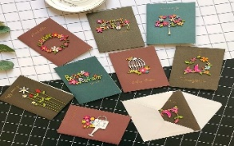
Card Making:
Meets on the second and fourth Friday of the month, from 10.00am to 12.00pm, for good coffee, morning tea, fellowship, and loads of laughs as we try to follow our teacher’s guidance to make personalized greeting cards. (There are no such things as mistakes, just creative differences, easily concealed if desired). Heaps of resources available to share. New members, skilled or unskilled, are always welcome.
Seniors Strength, Balance, and Mobility classes:
Meets every Thursday morning, 10.00am to 11.00am. For ‘seniors’ - how to exercise sitting down or leaning on a chair, without breaking out in a sweat. All levels of personal unfitness welcome! Join in any time.

Men’s gardening group:
Meets on Friday afternoon, 1.00pm for a couple of hours working in the church garden producing vegetables for Community Social Services and maintaining the church grounds. All keen (or just hopeful) gardeners welcome. Contact Maxwell on 0274 906 120.

WHO’S WHO AT ST PETERS
Clergy: Priest in Charge | Rev. Dr. Gillian Reid
Verger | Vic Dalbeth
Licensed Lay Ministers: | Sharon Short  Nicky Hewlett
 | Dr Maxwell Reid
Vestry: People’s Warden | Jill Laird
Priest’s Warden | Sharon Short
Synod Rep | Nicky Hewlett
Secretary and Synod Rep | Kaye Evans
Treasurer | Bob Schibli
Webmaster  Maintenance coordinator  Vestry Member | Maxwell Reid  Alan Andrews  Anna Andrews
Worship Team: | Gillian Reid
(Roster Coordinator): | Maxwell Reid
 | Dawn Schibli
 | Nicky Hewlett
Sharon Short
Jill Laird
Kaye Evans
Pastoral Care Team: | Dawn Schibli
 | Gillian Reid
 | Nicky Hewlett
 | Jill Laird
 | Sharon Short

website: wwwanglicanchurchwhitianga.org.nz
Facebook: ww.facebook.com/stpeter.thefisherman.96
Mercury Bay Mission District contact person: Jill Laird
Ph. 8660641, jilliannelaird48@gmail.com

