NETWORK NEWS
ST PETER’S ANGLICAN CHURCH
MERCURY BAY MISSION DISTRICT
January/February 2023

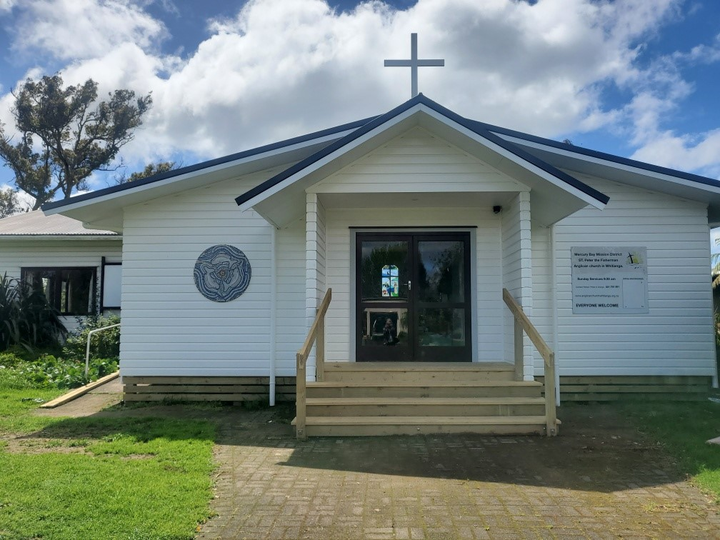

St Peters Church

OUR MISSION STATEMENT:

TO KNOW AND MAKE KNOWN THE LOVE OF GOD”

January 2023 Worship Services at St Peter’s
Sunday 1st January  Presider: Gillian Reid  Gospel and Reflection | HOLY COMMUNION 9.30am  Liturgist: Sharon Short  Gillian Reid
Sunday 8th January  Presider: Gillian Reid  Gospel and Reflection | HOLY COMMUNION 9.30am  Liturgist: Kaye Evans  Gillian Reid
Sunday 15th January  Presider: Gillian Reid  Gospel and Reflection: | HOLY COMMUNION 9.30  Liturgist: Nicky Hewlett  Gillian Reid
Sunday 22nd January  Presider Gillian Reid  Gospel and Reflection  Sunday 29th January  Presider Gillian Reid  Gospel and Reflection | HOLY COMMUNION 9.30am  Liturgist: Dawn Schibli  Gillian Reid  HOLY COMMUNION 9.30am  Liturgist: Sharon Short  Gillian Reid

February 2023 Worship Services at St Peter’s
Sunday 5th February  Presider: Gillian Reid  Gospel and Reflection | HOLY COMMUNION 9.30am  Liturgist: Sharon Short  Gillian Reid
Sunday 12th February  Presider: Gillian Reid  Gospel and Reflection | HOLY COMMUNION 9.30 am  Liturgist: Dawn Schibli  Maxwell Reid
Sunday 19th February  Presider:  Gospel and Reflection: | MORNING WORSHIP 9.30 am  Liturgist: Sharon Short
Wednesday 22nd February  Ash Wednesday  Presider Gillian Reid  Gospel and Reflection | HOLY COMMUNION 9.30 am  Liturgist: Kaye Evans  Gillian Reid
Sunday 26th February  Lent 1  Presider Gillian Reid  Gospel and Reflection | HOLY COMMUNION 9.30 am  Liturgist: Nicky Hewlett  Maxwell Reid
Weekly Service Roster
If you swap a duty with someone else – reading, chalice bearer, prayers etc., as well as changing it on the roster by the door please would you let the Liturgist for that Sunday know as they may not check the alterations during the week. This will make it much easier for them when putting the service together. Many thanks.

GILLIAN’S MONTHLY MUSINGS

Christmas in the Summer is strange for people who travel here from European or North American Winters. All the embedded Christmas traditions reflect a time and space which are unfamiliar to us in the Southern Hemisphere, and certainly don’t reflect the likely reality of when Christ was actually born. All the same, the key tradition that is fixed for all Christians is the celebration of receiving the one gift that outshines all other Christmas gifts – God’s gift of his Son to us.
If we are fortunate enough to be with people we love, sharing the joys and benefits of this time, we are blessed indeed. However, we are also painfully aware that for many Christians near us or around the world, this is actually far from being a joyful time. That good news message struggles to be heard over the sound of bombs dropping, guns firing, or the sight of family members or friends being dragged off to prison because they protested injustice and oppression in their country. It struggles to be heard over the sounds of grief in a family dealing with a death – on the road, in the water, in a hospital, or following a sudden medical collapse. These are the sights and sounds of a not-so-merry Christmas.
Thus, it is just as important to pray for God’s grace, comfort and blessing, on those unable to feel the season is worth celebrating, as it is to give thanks for the good times the rest of us are experiencing. Life is finite, a temporary state, ‘the present’ we need to appreciate every day. With that appreciation, it feels more than usually important that in our gratitude for the loving grace poured down on us from God, we also pass on active examples of that grace on to those with whom we come into contact over both this Christmas season and on into the rest of the year.
A smile, a greeting, a small helping action, can be like a pebble thrown into a pool, its effect spreading out in circles touching more that the place it initially lands. Thus, the gift we receive at Christmas can, without much effort, bring moments of relief, gratitude and pleasure, to more than those immediately around us. May your Christmas season include the satisfaction gained from passing on elements of the gift you have received.
Nga manaakitanga me te Kirihimete hari ki a koutou katoa. Gillian
(Blessings and Merry Christmas to you all).

**********************************************
LAUGHTER Really IS THE BEST MEDICINE !!!
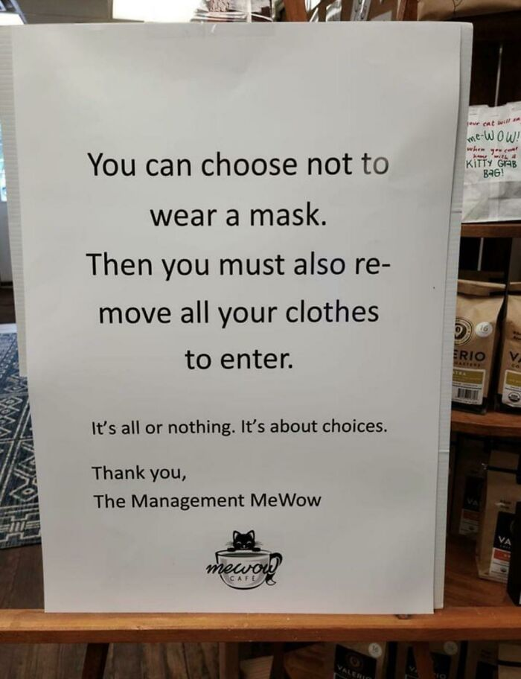

A Texas Govenor running for reelection presented a ten-point plan to eliminate poor levels of innumeracy and illiteracy in their schools. A lady said, but Governor, you have only presented nine points. He replied, Lady, you’ve just defined the problem.

Memorable THOUGHTS ON LIFE
Don’t let your past dictate who you are, but let it become part of who you will become (Reply from Dear Abbey).

Some Prayers for quiet reflection
Life-giving God, you have sent wise prophets to show us a way to your heart. In Jesus, your promise becomes flesh, to live amongst us, bringing the fulness of your grace and truth. Open our hearts that we may meet you in your Son and journey deep into your centre.
Amen.
Creator God, in your creation you show us both your beauty and your nurture. You come amongst us in Jesus, small and vulnerable, yet instantly recognised by the most marginalised and poor. Help us to know both your name and your way as ours.
Amen
God of the Universe, we have seen the star of your glory rising in splendour. May the brightness of your incarnate Word pierce the night that covers the earth, and signal the dawn of your reign of justice and peace. May all nations walk as one in your light.
Amen
Childhood Memories – by Kaye Evans
Childhood Memories by Kaye Evans
Kaye was born in Martin, in the Taranaki region, she was the youngest of 5 children and her father Alan was the manager of a garage there. She remembers childhood fun at an early age with the fun included their horse called trigger, in which they all used to get onto him.
Her father got a new job managing the Dairy Company garage in Inglewood, so the family moved to Inglewood. At this time Kaye turned five and started school in Inglewood, and her mother worked in the Inglewood telephone exchange until they moved to New Plymouth when Kaye was twelve.
There was quite an age spread between the children, with the eldest son being eight years older than Kaye who was the youngest, and although they were close, the family dissipated as the older ones found work and moved away, leaving Kaye and brother Mark who was three years older at home. Consequently, they were quite close as brother and sister because they were the only children at home most of the time.

Her father was friendly with Nick Wells who also worked at the Dairy Company and together with Trevor Jackson, the three of them built a boat. Then Alan and his friend Nick gave up working as Dairy Company engineers, to became commercial fishermen working the boat out of New Plymouth. Consequently, by the time Kaye began High School, the family had shifted to New Plymouth.
Kaye said that she remembers living a normal childhood in an average family where nothing stood out as significant to relate in this account of her childhood. She remembers her mother doing a family roast on Sundays and mother’s big puddings. She was very active in sports and was very keen and successful with netball. She remembers wearing the short Gym frock that girls wore in those days, in the very cold winters living by Mount Taranaki. It was a traditional childhood and life in those days also involved membership of the Brownies and Girl Guides which involved all the camp activities.
She remembers great summers and their holidays at Tangimoana where they camped in canvas tents. The tent was the traditional circular bell design with a centre pole. She remembers the back seat of the car being replaced with a mattress and all the children piling into the back.
The family always had a strong faith and were involved with the Anglican church in Inglewood and Kaye remembers going on Christian camps at that time. Because she had gone to High School in Inglewood, the parting of friendships one has with school friends was sad when they moved to New Plymouth with a change of high schools, but she became involved with the Anglican New Plymouth youth group, which was a help in meeting new people of her age and included a fun time with activities on Friday nights.
Things were to change. By the time she was fourteen, her father Alan and his friend Nick came to Whitianga to fish for scallops. They used to stay at a motel in Simpson’s Beach and they travelled back and forth to their families in New Plymouth during the weekends. It was a big boat, about forty feet, and they removed the trawling equipment and replaced it with scallop dredging equipment. (Interestingly, the boat is still operational, and the current owners are working out of Whangamata).
If any of you remember the state of the roads in those days, the journey from New Plymouth took about eight hours, so eventually, the family moved to Whitianga, a place Kaye had never heard of! She asked her father if this was a suburb, “no” he said, “this was the whole town!” (At the time it was quite small). Kaye finished her schooling at Mercury Bay Area School, and it was a struggle adapting to new circumstances in yet another school. The family lived in Mercury Street, and after marriage Kaye and her husband also built a home in Mercury Street. The marriage was blessed with three children. The family had attended St Peter’s from the time they moved to Whitianga, and as a result of successive priests leaving, eventually, the vicarage became available

for renting and was offered to parishioners. Consequently, Kaye’s Mum and Dad moved into the house and lived there for many years.
Editor’s note
[The difficulty of replacing the priest was eventually solved by the Reverend David Balfour of Auckland, who used the Reid’s beach house at Rings Beach as his headquarters for a training scheme, a new idea called the Coromandel Experiment to train non-stipendiary ministers, chosen by the congregation and working solely with that congregation. This successful format eventually became the “Local Shared Ministry” format we have today in some churches.]
During the high school era, Kaye had an after-school job cleaning out the then medical centre which is where the skate park is now. At the age of seventeen, they had a doctor who was also a dentist and anesthetist who wanted to turn the place into a full-time dental centre. (They used to have a dentist fly over from Hamilton once a week). He asked Kaye if she would like to train as a chairside dental assistant which she did successfully. After being a mother to her children, some twenty-five years ago she took up her current position in the dental centre as a receptionist/administrator an occupation she continues to enjoy to this day! It is worth noting that Kaye’s father donated the stained-glass window and the fishing net in the St Peter’s sanctuary.
Subject: Interesting True Story of a13 or 14 years old Girl

Once a Train Ticket Examiner who was on duty on a Bangalore bound train from Mumbai caught a girl who was hiding under a seat. She was about 13 or 14 years old. The TTE asked the girl to produce her ticket. The girl hesitantly replied that she had no ticket. The TTE told the girl to get off the train immediately.

Suddenly, a voice from behind said, "I will pay for her." That was the voice of Mrs. Usha Bhattacharya, who was a college lecturer by profession. Mrs. Bhattacharya paid for the girl's ticket and requested her to sit near her. She asked her what her name was.
"Chitra", the girl replied.
"Where you are going?"
"I have nowhere to go," the girl said.
"Then come with me." Mrs. Bhattacharya told her.
After reaching Bangalore, Mrs. Bhattacharya handed over the girl to an NGO, to be taken care of. Later Mrs. Bhattacharya moved to New Delhi and the two lost contact with each other. About 20 years later, Mrs. Bhattacharya was invited to San Francisco, USA to deliver a lecture in a college there. After having a meal in a restaurant, she asked for the bill, but was told that her bill was already paid for. When she turned back, she saw a woman with her husband smiling at her.
Mrs. Bhattacharya asked the couple: "Why did you pay my bill?" The young woman replied: "Ma'am, the bill I paid is extremely little, compared to the fare you paid for me for that train journey from Mumbai to Bangalore.
Tears rolled down from the eyes of both women. "Oh Chitra... It's you...!!!" Mrs. Bhattacharya said happily astonished. While hugging each other, the young lady said: "Ma'am my name is not Chitra now. I am Sudha Murthy. And this is my husband... Narayan Murthy."
Yes, the little help you extend to others can change their whole lives. Please do not withhold doing good to those in distress, especially when it is in your power to do so"!

EPILOGUE

Don't be astonished. You are reading the true story of Mrs. Sudha Murty, the chairman of Infosys Ltd, and Mr. Narayan Murty, the man who established the multi-million INFOSYS software company............. and Akshata Murthy is the daughter of this couple, married to RISHI SUNAK, the Prime Minister of U.K.

Vestry News
Remembered At Christmas Service
A service held at 7.00pm on Thursday December 15th was a special service is to remember those who for whatever reason are not here to share Christmas with us. The service was appreciated by those who attended.
Carol Service Our Carol Service was held at 9.30 am on Sunday 11th December. The service consisted of carols, chosen from the votes of Parishioners interspersed with nine readings, by nine Parishioners.
Christmas Eve Service at Whitianga
This service was be held on 24th December at 8pm. It was well attended with many visitors who happily joined in with the post service time of Champagne and Christmas cake.
Christmas Day at Hahei
This service was at 10am on 25th December in the Hahei Community Hall and was attended by 48 people.
Flooring for the kitchen and toilet/resource room area.
The kitchen has been tiled, and the remainder should be finished in the new year.

FOOD BASKET – don’t forget your donation to the Social Services Food Basket. This is a very worthy cause, as there are families in Whitianga who are really struggling.

January Birthday Wishes
This month of January we wish a Happy Birthday to
Gillian Reid
Edith Thompson
February Birthday Wishes
None this month

Don’t Forget our Outreach and Activity Groups
Knit for a Purpose:
Meets on the first and third Friday of the month, from 10.00am to 12.00pm, for good coffee, morning tea, and fellowship, while making garments and blankets for children in the care of the Anglican Trust for Women and Children. Knitting yarn, needles and patterns supplied, along with encouragement and helpful advice if needed. New members are always welcome.

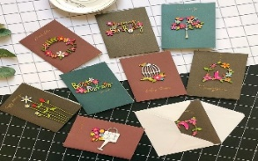
Card Making:
Meets on the second and fourth Friday of the month, from 10.00am to 12.00pm, for good coffee, morning tea, fellowship, and loads of laughs as we try to follow our teacher’s guidance to make personalized greeting cards. (There are no such things as mistakes, just creative differences, easily concealed if desired). Heaps of resources available to share. New members, skilled or unskilled, are always welcome.
Seniors Strength, Balance, and Mobility classes:
Meets every Thursday morning, 10.00am to 11.00am. For ‘seniors’ - how to exercise sitting down or leaning on a chair, without breaking out in a sweat. All levels of personal unfitness welcome! Join in any time.

Men’s gardening group:
Meets on Friday afternoon, 1.00pm for a couple of hours working in the church garden producing vegetables for Community Social Services and maintaining the church grounds. All keen (or just hopeful) gardeners welcome. Contact Maxwell on 0274 906 120.

WHO’S WHO AT ST PETERS
Clergy: Priest in Charge | Rev. Dr. Gillian Reid
Verger | Vic Dalbeth
Licensed Lay Ministers: | Sharon Short  Nicky Hewlett
 | Dr Maxwell Reid
Vestry: People’s Warden | Jill Laird
Priest’s Warden | Sharon Short
Synod Rep | Nicky Hewlett
Secretary | Kaye Evans
Treasurer | Bob Schibli
Webmaster & Safety Officer  Maintenance coordinator | Maxwell Reid  Alan Andrews
Worship Team: | Gillian Reid
(Roster Coordinator): | Maxwell Reid
 | Dawn Schibli
 | Nicky Hewlett
Sharon Short
Jill Laird
Pastoral Care Team: | Dawn Schibli
 | Gillian Reid
 | Nicky Hewlett
 | Jill Laird
 | Sharon Short

website: wwwanglicanchurchwhitianga.org.nz
Facebook: ww.facebook.com/stpeter.thefisherman.96
Mercury Bay Mission District contact person: Jill Laird
Ph. 8660641, jilliannelaird48@gmail.com

