NETWORK NEWS
ST PETER’S ANGLICAN CHURCH
MERCURY BAY MISSION DISTRICT
August 2022

OUR MISSION STATEMENT:

TO KNOW AND MAKE KNOWN THE LOVE OF GOD”

AUGUST WORSHIP SERVICES AT ST PETER’S
Sunday 7th August  Presider: Gillian Reid  Gospel and Reflection | HOLY COMMUNION 9.30am  Liturgist: Dawn Schibli  Maxwell Reid
Sunday 14TH August  Presider: Gillian Reid  Gospel and Reflection | HOLY COMMUNION 9.30am  Liturgist: Sharon Short  Gillian Reid
Sunday 21st August  Presider: Gillian Reid  Gospel and Reflection: | HOLY COMMUNION 9.30  Liturgist: Nicky Hewlett  Maxwell Reid
Sunday 28th August  Presider Gillian Reid  Gospel and Reflection | HOLY COMMUNION 9.30am  Liturgist: Sharon Short  Gillian Reid
Weekly Service Roster
If you swap a duty with someone else – reading, chalice bearer, prayers etc., as well as changing it on the roster by the door please would you let the Liturgist for that Sunday know as they may not check the alterations during the week. This will make it much easier for them when putting the service together. Many thanks.

GILLIAN’S MONTHLY MUSING
I recently watched the award-winning documentary by Sir David Attenborough “A Life on this Planet”. I had resisted what I thought would be a doom and gloom experience ever since it had been released. Having just talked about climate change on Sea Sunday, I finally was in a suitable frame of mind to sit through it. Yes, it clearly showed the willful, selfish, and stunningly ignorant behaviour carried out by humans which has definitely contributed to the current fragile state of our planet, but it also presented easy opportunities for slowing down, (and possibly even halting) this march towards our own destruction we seem to be taking.
I don’t want to see the legacy we leave our children and grandchildren to be one like the Israelites were given, after their hopelessly disobedient behaviour towards the God who had cared for them, rescued them from slavery, provided enough food to sustain them without any waste left over, and kept them safe. God effectively washed his hands of them, leaving them with the consequences of their behaviour for forty years. Moses and all the other prophets had constantly warned them, but their words were ignored or rubbished.
Are we repeating that behaviour in the way we carelessly treat our natural environment, promising to do better, but sliding back into our bad habits when being better is inconvenient? I want to believe God cares enough about the creation of our Universe not to allow it to be destroyed, but how bad will it get before we really listen to our modern-day prophets in the forms of scientists, and finally start acting like God always hoped we would.
I offered up a challenge on Sea Sunday, to choose one thing that each of us could truly make an effort to carry out – all the time – not just when it is convenient, but especially when it is inconvenient. I have a reputation for not turning out lights in rooms not being used. That’s the challenge I have given myself – ALWAYS remember to turn out the unused lights! It’s still a work in progress, but is helping reduce electrical use, and ultimately natural resource use and positively impacting on environmental health and well being.
Gen. 1:26 “Let us make humankind in our own image, … and let them have dominion over the fish of the sea, and over the birds of the air and over the cattle, and over all the wild animals of the earth, and over every creeping thing that moves upon the earth”.
I’m pretty sure ‘dominion’ does not mean careless destruction and death.
Manaakitanga,
Gillian

**********************************************
LAUGHTER Really IS THE BEST MEDICINE !!!!

A man is angry because he has it in his head that someone stole his wallet. He walks into a church to steal someone else's wallet, but he has a change of heart during the service. He confesses to the priest afterwards about what his intentions had initially been. The priest asks, "What made you change your mind?" The man says, "In your sermon on the Ten Commandments when you got to 'Thou shall not commit adultery,' I remembered where I left my wallet!"

Memorable THOUGHTS ON LIFE
He who has the most toys, wins – Frank Sinatra
He who dies with the most toys, still dies – Anon
Life is like riding a bicycle. To keep your balance, you must keep moving. — Albert Einstein
You never really learn much from hearing yourself speak. ― George Clooney
Spread love everywhere you go. Let no one ever come to you without leaving happier. – Mother Teresa
Life is really simple, but men insist on making it complicated. — Confucius
Whoever is happy, will make others happy too. – Anne Frank

Childhood Memories – by Anthea Austin
I was born at the end of WW2 in the south of England. The first of the 5th generation of the family in the same village, and the 3rd on my father’s side. Mother said she was quite upset when I was born as it was lunchtime and she missed out on a roast chicken lunch – a luxury! My father was in the British Army and was in Germany. A friend came up to him with a bottle of champagne and father asked him what it was for. He was told that it was up on the notice board that he had a daughter.
Being an army family, we travelled a lot, I was too young to remember my first stay in Germany. The first posting I remembered was Egypt where we lived in a compound that was surrounded by barbed wire and we had our meals in a communal dining room. We returned to England by boat and the only recollection of that boat trip was the boy in the next bunk who could suck his big toe. No matter how I tried my toe would not reach my mouth.
There were various postings in England, and then Dusseldorf in Germany where I learned to swim. As the pool was too deep for father to stand in, he had a large pole attached to a belt around my waist. One day I was told that I could swim as the belt had broken, but father kept pace, and told me after that the belt had broken on the way around the pool. The only posting we did not join father was in Korea but met up with him in Hong Kong. We travelled by troopship, which included schooling. All I can remember was the teacher could waggle his ears, and we had Sunday School, a welcome break for mother. We had a bath steward who delivered fresh water to rinse off the soap, as we had to bath in salt water. The highlight of the trip was the Gully Gully man who entertained us on the Suez Canal who produced live chicks from his arms and hat etc. We stayed in a flat along a busy road but enjoyed the weekends going over on the Hog Kong ferry for various walks and up the Peak Railway. We met an Army family from our same English village, and we travelled by train to them at weekends. We were to have Army quarters next to them, but we were sent to Malaya instead.
I had my 9th birthday in Hong Kong and went to two schools, as there were too many army children so we could only go in the morning or the afternoon. We sailed to Malaya and took an overnight train to Ipoh, where we stayed in a hotel. We used to see lunch being delivered by trishaw – a live chicken or duck! After three months we moved to Taiping and had an army quarter built amongst a rubber plantation. The powers that be decided that it was too hot to have a full days schooling – for us or

the teachers? So, we had four hours in the morning only, and we had chocolate or strawberry milk for our play time break. On our return from school, we had to walk
up the hill in the full midday sun and mother said she could hear my brother and I arguing so it was time then to make our fresh juices. Our father would take us to school by jeep which was not so ideal as we were often late because of being caught up in army convoys, so an army truck would collect and return us. The soldier on the truck duty did not have to wear a beret as we all thought it was great fun to remove it off his head and throw it off the truck. In the afternoons we had French one day each week – obviously mother tried to give us more education, - Brownies, and sports, but the other afternoons we played amongst the rubber trees and there was always a good group of children to play with. (I am still in contact with an Australian friend who also lived on the hill, and we have stayed with each other). Both parents were good at tennis and one day we went over to Ipoh and on the way back we heard gun shots. Father took his gun out of the glove box and had it handy.
We also went to church/Sunday School wherever we went. In Hong Kong we would sing I Am H A P P Y, in Taiping we were given stamps for attendance, but we lost them if we kept talking.
The highlight of Sundays was going to the swimming pool, which was a series of rock pools, and having curry puffs for lunch there. Sometimes at the weekends we would go up to Maxwell Hill – but would have to travel in convoys, and mother discovered she could by fresh milk – indeed a treat, until she discovered that they washed the bottles in the dirt there, not that we minded. For a change we would go to Penang for a week, watching the fisher men bring in their fish, chanting as they pulled in their nets. On Saturdays we would go to the market and buy wonderful fruit and the shopkeepers would save me their stamps.
All good schooling comes to an end, and after we sat the 11+ school exam – we cannot have done too well, as we were sent off to England. We stayed at various places on the way down to Singapore, one of the rest houses had a barrel as a bath, in Singapore we stayed at the Raffles hotel, but I expect the army had an annex there. I do remember we had a telephone in our room and when it rang in the morning, my brother and I were too scared to answer it!!
My recollections of that flight back to England include my brother and I, and another boy from Taiping sitting at the back. It was a long flight back as the plane broke down, being given coca cola at every airport, and going into the cockpit and the captain explaining the clouds etc, and a tour of Rome by coach. They obviously didn’t know what to do with us in between flights! We were given a picnic lunch of a bottle

of Chianti and fruit cake, neither of which I liked. I remember everyone laughing when we arrived at Heathrow clutching our bottles of wine and Hong Kong baskets –
which we still both have – and also probably looking rather dirty and unkempt by then.
As a result of father being in Malaya, we went to Buckingham Palace to see him receive his medal, which was rather exciting with a couple of days off school, and seeing the Queen whom I remember speaking to every recipient at length.
I went to prep school where I boarded, and on Sundays we collected our 1d collection and with our boaters on in the summer we walked to church. The Vicar was so boring and old – at least 40 – and I was always in trouble for talking, but my lovely Aunt taught me a couple of games to play during the sermon. Then I went to my mother’s old school where we played lacrosse, tennis, and cricket. As I was in the school swimming team, we went to other schools to swim against on Saturdays. My favorite was a Catholic school and we really enjoyed going there as the nuns made wonderful cakes for the team afterwards – a real treat! I also used to faint during the early Communion Service, so in eventually the school provided a cup of tea and two Jacob cream crackers.
After two years my parents were back in England and I decided I really wanted to live with them, so my final and 16th school was in Peterborough. After the Peterborough posting, Father left the Army, so we went to live in the family house in the south of England as Granny had died. We had actually been going back and forth for holiday, staying with both sets of Grandparents.
I remember one Christmas when we were quite small, we were told we could open our stocking when we heard the church bells – the house being opposite the church. We both duly did and ate our sweets and mandarin to discover when mother came in, that she had forgotten about the bells for the Midnight service. It was a disappointing Christmas morning with no stocking to open. When we were older and confirmed, my brother and I would have our clothes laid out in order, toothpaste on our brush, and when we heard the five-minute church bell we jumped out of bed – we were so organised and slipped through the church side door into the pew that everybody knew was “ours”. Mother would hiss – you have not brushed the back of your hair.
Looking back, I had a good childhood, certainly not boring. I was loved and certainly it would be very different in this day and age.

August Book Review – Willie Nelson
Author - Joe Nick Patoski
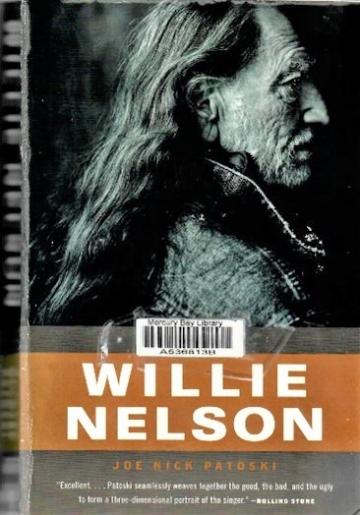
I realise that Willie Nelson is not to everyone’s taste, but he lived an interesting life that begs telling. He has done it all. He’s been a music maker, door to door vacuum salesman, movie star, disc jockey, honky tonk king, wizened philosopher, articulate poet, unrepentant hippie, committed roadie and champion of the common man.
This book is not just another glossy name-drop celebration, but a look at the truths and experiences, truly capturing the essence of his grace, his gifts, and his ability to roll seamlessly through mishaps, adventures and culturally defining moments. As an expansive, engrossing, and epic look at the life of a true American icon, this substantive account is closer to the treatment given to a historical world figure than a laid-back guitar picker.
Nelson fans will have their blue eyes crying in the rain – with joy – with this richly report biography. There are scores of amusing first-hand stories in this account of how a ramshackle hillbilly career involving honky tonk, long nights on the road, whiskey, womanising and weed, evolved into a talented, determined man who became an unlikely icon and a fascinating Texas legend.
This book weaves together the good, the bad, and the ugly to form a three-dimensional portrait of the singer. For Willie Nelson, his 1980 hit single “On The Road Again” isn’t just a silly song he wrote for the movie “Honeysuckle Rose”, it’s literally the story of his life. Joe Patoski has fleshed out and written his story beautifully, showing how over time, Willie’s curious nature was growing in spirituality, culminating in the mellow Willie of today.
Maxwell

A Prayer for Ukraine: Archbishop Justin Welby, Archbishop Stephen Cottrell
God of peace and justice, we pray for the people of Ukraine today. We pray for peace and the laying down of weapons. We pray for all those who fear for tomorrow, that your Spirit of comfort would draw near to them. We pray for those with power over war or peace, for wisdom, discernment and compassion to guide their decisions.
Above all, we pray for all your precious children, at risk and in fear, that you would hold and protect them. We pray in the name of Jesus, the Prince of Peace.
Amen
Don’t Forget our Outreach and Activity Groups
Knit for a Purpose:
Meets on the first and third Friday of the month, from 10.00am to 12.00pm, for good coffee, morning tea, and fellowship, while making garments and blankets for children in the care of the Anglican Trust for Women and Children. Knitting yarn, needles and patterns supplied, along with encouragement and helpful advice if needed. New members are always welcome.

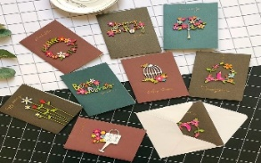
Card Making:
Meets on the second and fourth Friday of the month, from 10.00am to 12.00pm, for good coffee, morning tea, fellowship, and loads of laughs as we try to follow our teacher’s guidance to make personalized greeting cards. (There are no such things as mistakes, just creative differences, easily concealed if desired). Heaps of resources available to share. New members, skilled or unskilled, are always welcome.
Seniors Strength, Balance, and mobility classes:
Meets every Thursday morning, 10.00am to 11.00am. For ‘seniors’ - how to exercise sitting down or leaning on a chair, without breaking out in a sweat. All levels of personal unfitness welcome! Join in any time.

Men’s gardening group:
Meets on Friday afternoon, 1.00pm for a couple of hours working in the church garden producing vegetables for Community Social Services and maintaining the church grounds. All keen (or just hopeful) gardeners welcome. Contact Maxwell on 0274 906 120.

A prayer
Holy God, you never cease to call us, even though we tremble at the rumour of your presence. Like Paul, may we faithfully witness to your everlasting life, experienced in the person of Jesus. Send us out into the deep places of our world, that we may humbly share your abundant grace with all. Amen

FOOD BASKET – don’t forget your donation to the Social Services Food Basket. This is a very worthy cause, as there are families in Whitianga who are really struggling.
JULY Birthday Wishes
This month we wish happy birthday to
Suzanne McWha
Julie Kipling

WHO’S WHO AT ST PETERS
Clergy: Priest in Charge | Rev. Dr. Gillian Reid
Verger | Vic Dalbeth
Licensed Lay Ministers: | Sharon Short  Nicky Hewlett
 | Dr Maxwell Reid
Vestry: People’s Warden | Jill Laird
Priest’s Warden | Sharon Short
Synod Rep | Nicky Hewlett
Secretary | Kaye Evans
Treasurer | Bob Schibli
Webmaster & Safety Officer  Vestry member | Maxwell Reid  Alan Andrews
Worship Team: | Gillian Reid
(Roster Coordinator): | Maxwell Reid
 | Dawn Schibli
 | Nicky Hewlett
Sharon Short
Jill Laird
Pastoral Care Team: | Dawn Schibli
 | Gillian Reid
 | Nicky Hewlett
 | Jill Laird
 | Sharon Short

website: wwwanglicanchurchwhitianga.org.nz
Facebook: ww.facebook.com/stpeter.thefisherman.96
Mercury Bay Mission District contact person: Jill Laird
Ph. 8660641, jilliannelaird48@gmail.com

Progress on our building extension

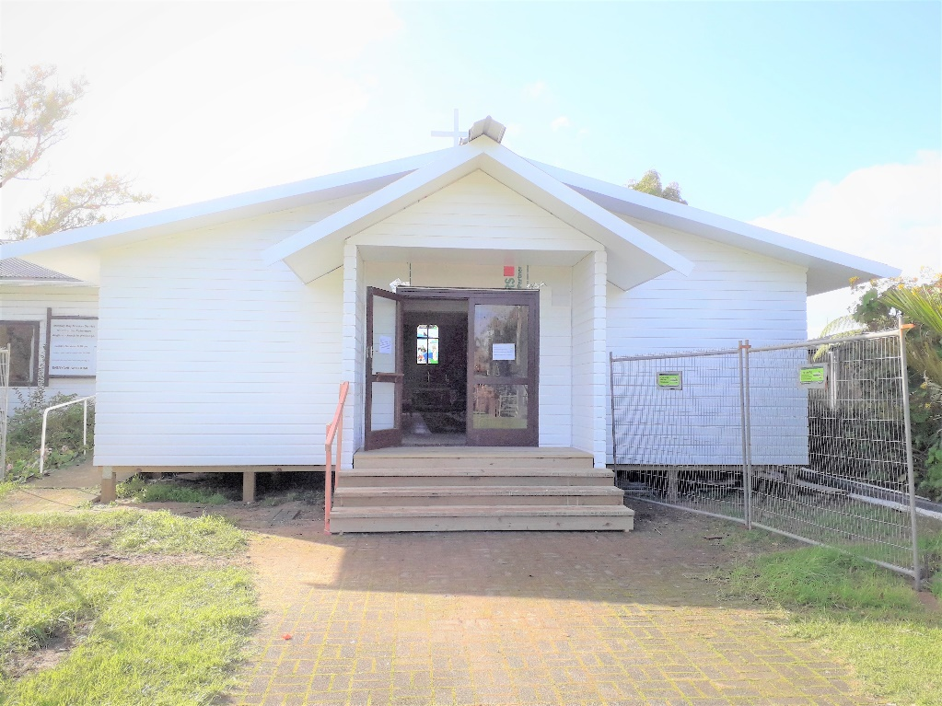

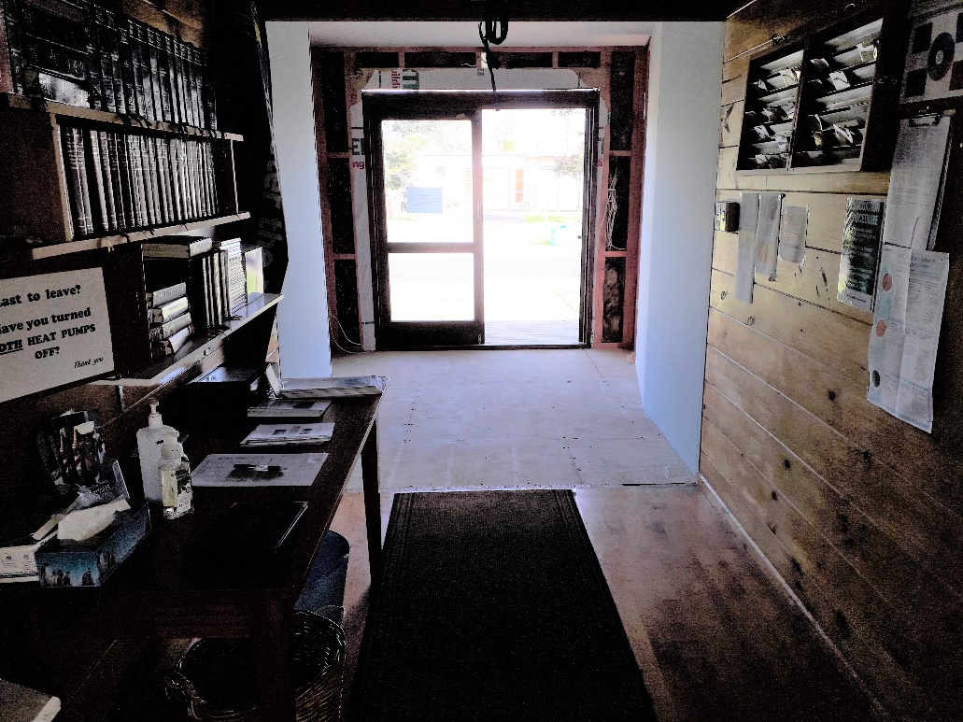

Farewell to Poppy Collins

