NETWORK NEWS
ST PETER’S ANGLICAN CHURCH
MERCURY BAY MISSION DISTRICT
April 2022
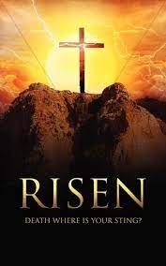

OUR MISSION STATEMENT:

TO KNOW AND MAKE KNOWN THE LOVE OF GOD”

APRIL WORSHIP SERVICES AT ST PETER’S
Sunday 3rd April  Presider: Gillian Reid  Gospel and Reflection | HOLY COMMUNION 9.30am  Liturgist: Sharon Short  Gillian Reid
Palm Sunday 10th April  Presider: Gillian Reid  Gospel and Reflection | HOLY COMMUNION 9.30am  Liturgist: Sharon Short  Gillian Reid
Good Friday 15th April  Presider: Gillian Reid  Gospel and Reflection: | HOLY COMMUNION 9.30  Liturgist: Nicky Hewlett  Maxwell Reid
Easter Sunday 17th April  Presider: Gillian Reid  Gospel and Reflection | HOLY COMMUNION 9.30am  Liturgist: Dawn Schibli  Gillian Reid
Sunday 24th April  Presider: Gillian Reid  Gospel and Reflection: | HOLY COMMUNION 9.30  Liturgist: Sharon Short  Maxwell Reid

Weekly Service Roster
If you swap a duty with someone else – reading, chalice bearer, prayers etc, as well as changing it on the roster by the door please would you let the Liturgist for that Sunday know as they may not check the alterations during the week. This will make it much easier for them when putting the service together. Many thanks.

GILLIAN’S MONTHLY MUSING
There is a great deal going on in all our lives, at the moment – good and bad. Life tends to dish up rather a lot of that. Right now, we know many NZ families are celebrating the fact that overseas family members and friends can come here without periods in MIQ, and we can actually leave NZ for overseas trips. It has felt a long time since we could have those things happen, often I sense because we are fighting a war (not over yet) where we cannot actually see the enemy. It has been a hard one to live through, but we can see a brighter future. There will be more bumps in the road, I am sure, but I do believe, we are moving forward, and generally speaking have been totally awesome in the way as a nation we have dealt with this Covid pandemic.
However, on the bad side, we have a war that is only too visible and painful for us to see. The invasion of Russian troops into Ukraine, also affects many NZ families who have friends and family throughout that country, and quite unthinkable images are pouring on to our TV and computer screens on a daily basis. I have no idea how or when this particular war will end but the civilians I see are just regular people like us, living regular lives like us, coping with Covid like us, and now spending their nights, not comfortably in their homes, but in underground bunkers, cold and frightened beyond belief at the bombs and missiles landing around them.
Then I look across the Tasman and see “the sunshine state” of Queensland inundated by rain and floods, with hundreds of people missing, and evacuation orders being issued by their government as apparently worse is still to come. Plus, this storm is heading down the coast and Sydney is in its path.
For those of you who remember him, our comedian John Clark totally nailed it when he sang “We Don’t Know How Lucky We Are”.
(Here’s a link for anyone who would like to relive that classic. https://www.youtube.com/watch?v=AYvMeT2GC14)
So – how do we cope with so much going on in our world that seems quite out of our control to influence? We do the best we can with the best we have. In small ways we can contribute to relief funds. We can pray that willful despots will be brought down. We can both pray and act as a human race that we will genuinely change our behaviour and stop messing up our world (the only one we have – there is no Planet B), and slow down or halt the chaos that nature is wreaking on us because we have so abused our environment for so long.
These forty days of Lent, remembering Jesus taking himself off into the wilderness to reflect on his life and how he would live the remainder of it, could equally be an opportunity for us to commit ourselves to making changes that will bring a better life to so many people today, and in the future, people we may even not know – just as Jesus did.
Manaakitanga, Gillian
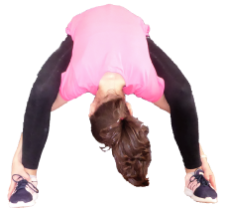
A good course to get stuck into
60’s plus Strength, Balance and Mobility Classes run by LISA JURY
on Thursday weekly from 10am to 11.00am held at St Peter’s Anglican Church in the lounge. Come and join in any time!

See you there!
***********************************************
LAUGHTER Really IS THE BEST MEDICINE !!!!
A lawyer runs a stop sign and gets pulled over by a sheriff. He thinks he's smarter being a big shot lawyer from New York and has a better education than a sheriff from West Virginia. The sheriff asks for license and registration. The lawyer asks, "What for?" The sheriff responds, "You didn't come to a complete stop at the stop sign." The lawyer says, "I slowed down and no one was coming." "You still didn't come to a complete stop. License and registration please," say the sheriff impatiently. The lawyer says, "If you can show me the legal difference between slow down and stop, I'll give you my license and registration and you can give me the ticket. If not, you let me go and don't give me the ticket." The sheriff says, "That sounds fair, please exit your vehicle." The lawyer steps out and the sheriff takes out his nightstick and starts beating the lawyer with it. The sheriff says, "Do you want me to stop or just slow down?"
Two factory workers are talking. The woman says, "I can make the boss give me the day off." The man replies, "And how would you do that?" The woman says, "Just wait and see." She then hangs upside down from the ceiling. The boss comes in and says, "What are you doing?" The woman replies, "I'm a light bulb." The boss then says, "You've been working so much that you've gone crazy. I think you need to take the day off." The man starts to follow her and the boss says, "Where are you going?" The man says, "I'm going home, too. I can't work in the dark."
It's game 7 of the NBA finals and a man makes his way to his seat at center court. He sits down and notices that the seat next to him is empty. He leans over and asks his neighbor if someone is sitting there. He responds, "No, the seat's empty." "The first man exclaims, "What?!? Who in their right mind would have a seat like this for the NBA finals and not use it?" The neighbor responds, "Well the seat is mine, but my wife passed away and this is the first NBA finals we haven't been together." The first man responds," I'm sorry to hear that. Wasn't there anyone else, a friend or relative, that could've taken that seat?" The neighbor responds, "No, they're all at the funeral."

Childhood memories – FROM NICKY
I am an only child, born in Altrincham, Cheshire (England) just after the end of the war. There was a quote from my father “the war is over but our peace has been shattered”! He worked for the British Civil Service and was prepared to move anywhere for his career – so my first move was at the age of 3 weeks and this continued throughout our time in the UK. The three of us were very close knit unit and I was very privileged to grow up in such a loving atmosphere.
We came to New Zealand when I was 16 – part of a 6th month world trip to mark my father’s retirement. My parents fell in love with the country and wrote home to have all our belongings shipped down to the antipodes. So it was yet another school for me – 6th form at New Plymouth Girl’s High School. New Plymouth was the first place we lived in NZ as we had some family there. On leaving school I worked in travel related positions – a travel agency, an airline company (SPANZ) and Trans Coach Tours both in New Plymouth and Auckland.
Back in New Plymouth I met Noel through a visiting church youth group. We were married there at St. Mary’s Church (now Pro-Cathedral) in 1967.
It is interesting, with hindsight, to understand how one’s early years has such an influence on your life over the ensuing years.
PRAYERS AND THOUGHTS
There is no easy shortcut to recovery. As much as we would like to see ourselves immediately healed completely, it all takes time. It takes doing it one step at a time. And we can only recover one day at a time. Each day we are guided in our recovery from exactly where we are to where we need to go in this day. If we can keep it this simple, we can enjoy this day…. Knowing it is the only day that we have.

Each step I take today makes me feel better and better. Today I know I have all that I need to do exactly what must be done and go exactly where I need to go.

Here is something to think about, especially if you have been worrying about turning over that new leaf. The friend who passed it on to me says that it is well worth remembering, and I agree. It comes, I’m told, from an old Jewish proverb:
“Bad habits are easier to abandon if you tackle them today rather than tomorrow.”
I got the blues thinking of the future so I left off and made some marmalade. It’s amazing how it cheers one up to shred oranges and scrub the floor.
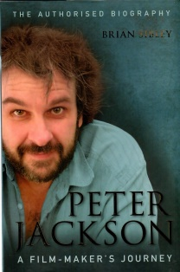
BOOK REVIEW FOR FEBRUARY BY MAXWELL
I continue this month with books that are best sellers.
Peter Jackson – A Film-maker’s Journey, by Brian Sibley
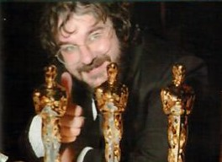
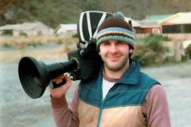
In this authorised biography, the boy from Wellington’s Pukerua Bay reveals how he beat Hollywood at its own game. Apparently, never before has Sir Peter revealed so much about himself and his work. It is a story of his passion, relentless single-minded determination, and above all, an artistic vision, and a sense of dramatic scale.
Through Jackson’s eyes and own words, as well as re-tellings and memories of friends, family and associates, we are shown the director’s early life – with its obsessively pursued hobbies and first childhood attempts at filmmaking. Attempts, which in hindsight are now viewed as effectively one big audition for The Lord of the Rings and King Kong.
The book includes the exploration of Sir Peter’s early years leading to the Academy Award winning success of Heavenly Creatures, the first abandoned remake of King Kong, then the triumphant filming of The Lord of the Rings – a project that was abandoned two years into pre-production, rejected by most studios and then picked up by New Line Cinema in the biggest gamble in film-making history.
Sir Peter has gone on to produce Crossing the Line, The Lovely Bones, TinTin (directed by Stephen Spielberg), The Hobbit, They Shall Not Grow Old, Mortal Engines and the recent TV Series The Beatles: Get Back. He also contributed the forward for the book The Beatles: Get Back (which I gave Gillian for Christmas).
The story of Sir Peter Jackson will inspire everyone who admires creativity and courage, who loves cinema, or is proud of this clever filmmaker from this small country of ours who can show the giants of the movie world that vision and passion can succeed.
Brian Sibley, the man Sir Peter chose to work with on this biography, is a writer and broadcaster with a lifelong interest in fantasy books and cinema. His fascination with J.R.R. Tolkien led to his critically acclaimed BBC radio dramatization of The Lord of the Rings. He is also author of The Lord of the Rings – The Making of the Movie Trilogy.

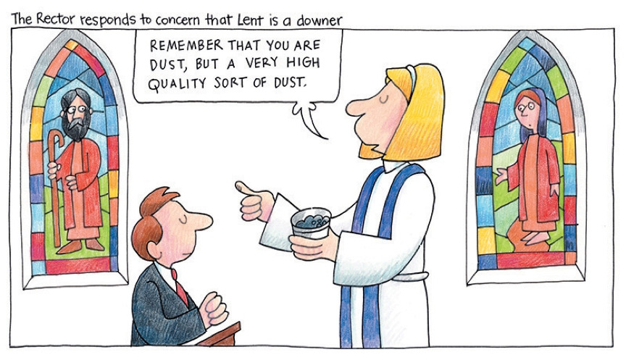

FOOD BASKET – don’t forget your donation to the Social Services Food Basket. This is a very worthy cause, as there are families in Whitianga who are really struggling.
Hello everyone. This will be the last Network News from me. So I am wanting someone else in the congregation or maybe someone who watches on-line to take over writing up this wee monthly magazine for St Peters starting with the April edition….
It is not a big chore and hopefully one of you will consider this and bring something new to the table.
I have enjoyed writing this for the last 6 years but feel someone else can take over now.
Alison

WHOS WHO AT ST PETERS
Clergy: Priest in Charge | Rev. Dr. Gillian Reid
Licensed Lay Ministers: | Sharon Short  Maxwell Reid  Nicky Hewlett
Vestry: People’s Warden | Jill Laird
Priest’s Warden | Sharon Short
Synod Reps | Brenda Taylor
 | Nicky Hewlett
Secretary | Kaye Evans
Treasurer | Bob Schibli
Webmaster & Safety Officer | Maxwell Reid  Dawn Schibli
Worship Team: | Gillian Reid
(Roster Coordinator): | Maxwell Reid
 | Dawn Schibli
 | Nicky Hewlett
 | Sharon Short
 | Brenda Taylor
Pastoral Care Team: | Dawn Schibli
 | Gillian Reid
 | Nicky Hewlett
 | Jill Laird
 | Sharon Short

website: wwwanglicanchurchwhitianga.org.nz
Facebook: ww.facebook.com/stpeter.thefisherman.96
Mercury Bay Mission District contact person: Jill Laird
Ph. 8660641, jilliannelaird48@gmail.com

