NETWORK NEWS
ST PETER’S ANGLICAN CHURCH
MERCURY BAY MISSION DISTRICT
FEBRUARY 2022

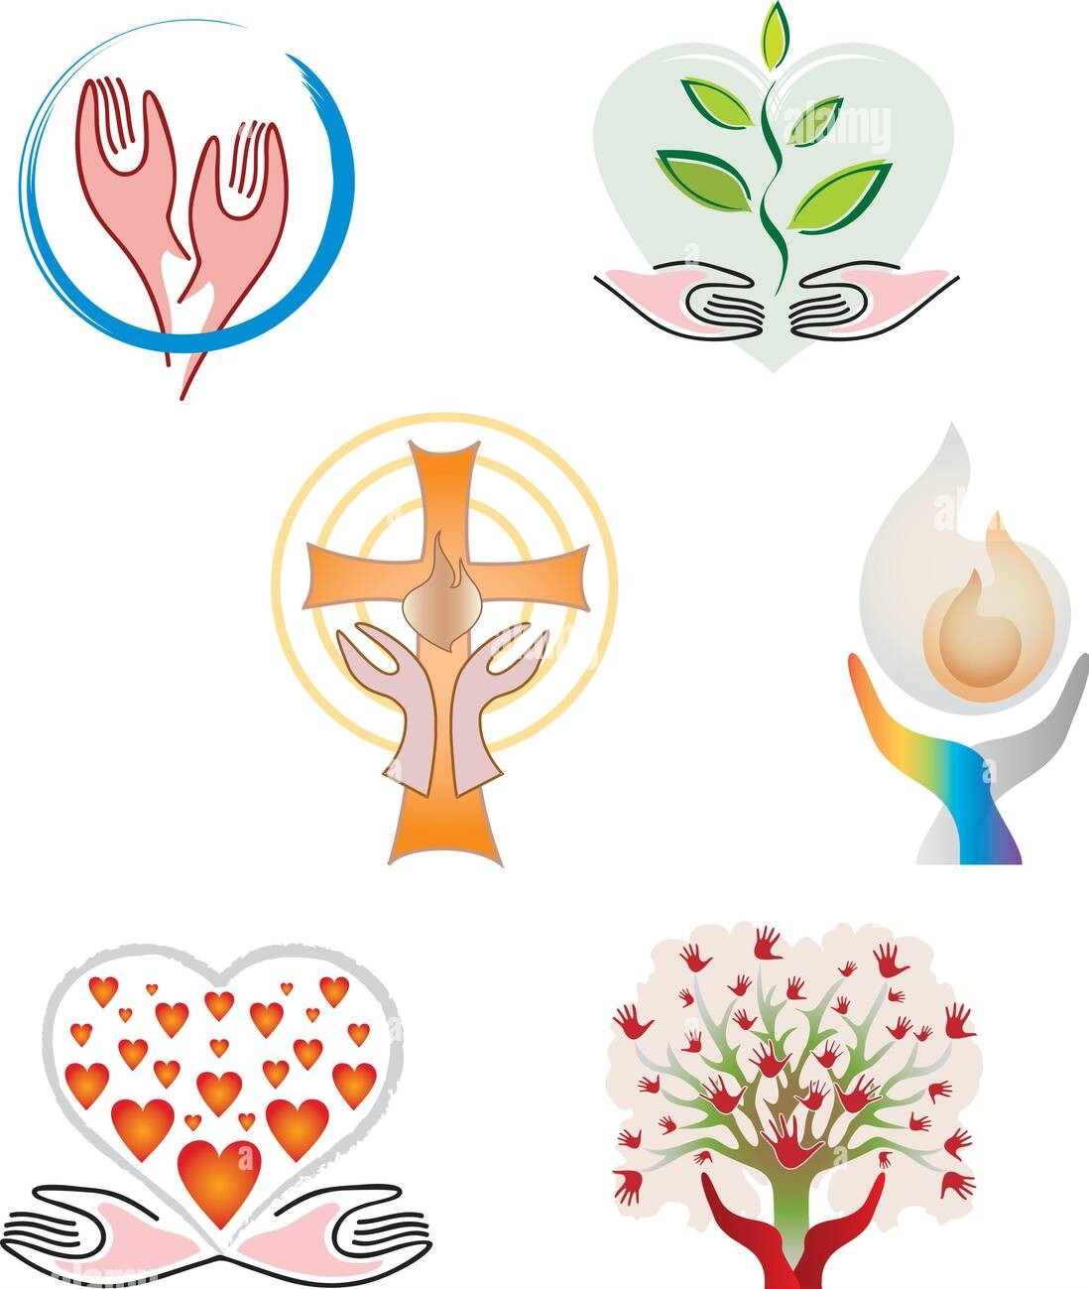

(Faith, religion, spirituality?)

OUR MISSION STATEMENT:

TO KNOW AND MAKE KNOWN THE LOVE OF GOD”

FEBRUARY WORSHIP SERVICES AT ST PETER’S
Sunday 6th February  Presider: Gillian Reid  Gospel and Reflection | HOLY COMMUNION 9.30am  Liturgist: Nicky Hewlett  Gillian Reid
Sunday 13th February  Presider: Gillian Reid  Gospel and Reflection | HOLY COMMUNION 9.30am  Liturgist: Sharon Short  Maxwell Reid
Sunday 20th February  Presider:  Gospel and Reflection: | NO COMMUNION  Liturgist: Dawn Schibli  Video
Friday 27th February  Presider: Gillian Reid  Gospel and Reflection | HOLY COMMUNION 9.30am  Liturgist: Sharon Short  Maxwell Reid

Weekly Service Roster
If you swap a duty with someone else – reading, chalice bearer, prayers etc, as well as changing it on the roster by the door please would you let the Liturgist for that Sunday know as they may not check the alterations during the week. This will make it much easier for them when putting the service together. Many thanks.
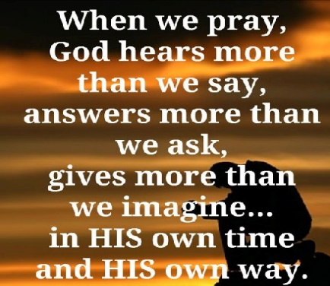

GILLIAN’S MONTHLY MUSING
I was asked recently “what exactly is Faith?”, which definitely stretched my theological abilities to the max. Put together with two other powerful words ‘Religion’ and ‘Spirituality’ we can generate a debate which is likely to be never-ending, or, depending on the participants, end in bloodshed. Our NN Cover this month provides some images which can be used to illustrate all three. Considering both the meaning, and the difference between each of these, is a complex process, as they work better together than held as separate functions or belief systems. Firstly, Faith. Faith is our belief and trust in a Higher Power, even when there is no apparent actual proof. It is believing in things we cannot perceive through the five senses, but which can be felt through the sixth sense: intuition. Our intuition tells us that there is something bigger than ourselves — the signs of this are everywhere if we open our souls to them — and faith is our belief that this is true. it is something that we carry with us at all times in our hearts and souls.
Religion may be defined as, “Any system of belief about a deity, often involving rituals, a code of ethics, a philosophy of life, and a world view,” all guided by tradition, rules and culture. It is most often based upon the lives, teachings, and beliefs of a historical or archetypal figure (e.g., Christ, Buddha, Moses, Krishna, Muhammad). The details of their lives as holy or highly evolved beings have been carried to us across the mists of time through oral tradition and written scriptures. These figures are the subject of worship and devotion and form the foundation of religious practices and rituals in a community.
Spirituality is more nebulous. It is more an individual connection to God, nature, others, and our surrounding world. Spirituality is associated with quality and meaning in life. It brings purpose and meaning to personal life. It helps us understand our place in the world and honour the things that are greater than just us — community, service to others, and a relationship with a Higher Power, whatever name we choose to apply.
Though all religions emphasise spirituality as being part of faith, a person can be spiritual without being religious or a member of an organised religion. As worshipping Christians, we mostly sustain our faith through our religious practices, but our belief in the teachings Jesus Christ gave us, and the guidance we can get from the Holy Spirit, define our spiritual attitudes and subsequent behaviour. Thus, when we are living in a world that seems to be overwhelmed with conflict, tragedy, pandemics, and environmental disasters, constantly revisiting the fundamentals of our faith, keeps our spiritual compass pointing to God, and shows us how we need to live and respond to needs which at times can feel too huge to cope with.
What would God want us to do about protecting ourselves and those we care about in the threat of this Covid-19 pandemic? What would God want us to do about our neighbours in Tonga trying to rebuild their shattered lives following the recent Tsunami? What would God want us to do about those people in our own community who are unable to make financial ends meet week after week? What would God want us to do ………?
Manaakitanga. Gillian

A six week course to get stuck into
60’s plus Strength, Balance and Mobility Classes run by LISA JURY
Starts on Thursday the 3rd of February, weekly from 10am to 11.30am to be held at St Peter’s Anglican Church in the lounge.
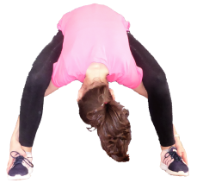
Lisa is a health coach and has a Post Grad Certificate in Health Sciences specializing in sport and exercise.
A Graduate Diploma of teaching.
And is a Bachelor of Sport and Recreation.
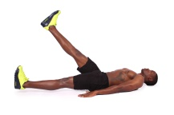
Lisa is passionate about helping people with chronic conditions to manage their health better and to live a healthy life, as well as supporting older people (yes, that’s us) to regain strength, balance and mobility.
Entrance is a gold coin donation.
See you there!
***********************************************

LAUGHTER Really IS THE BEST MEDICINE !!!!

Sam: Hey John!
John: Hey!
Sam: Did you know Microsoft just bought Skype for ten million dollars?
John: Really?
John: Idiots.... They could have downloaded it for free.
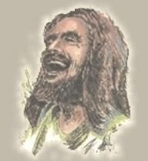
A bus full of ugly people had a head on collision with a truck. When they died, God granted all of them one wish. The first person said, "I want to be gorgeous." God snapped his fingers and it happened. The second person said the same thing and God did the same thing. This went on and on throughout the group. God noticed the last man in line was laughing hysterically. By the time God got to the last ten people, the last man was laughing and rolling on the ground. When his turn came, he laughed and said, "I wish they were all ugly again."

Childhood memories – FROM MAXWELL
I was born, and lived in the small South Auckland town of Pukekohe. My immediate family consisted of my mother, and my sister, twin brothers, and myself. In Pukekohe in the 1950’s the treatment of Māori people was such that I am appalled that I was brought up to view it as normal. They had to attend a separate Māori School, and they were not allowed to sit upstairs, or in the back-stalls downstairs in the local cinema. Their use of the public swimming pool was limited to Fridays only, the day before it was cleaned. Growing up through those years, we never thought to question the discrimination that had become normalised. This attitude was further reinforced by the movies we watched as children, which often portrayed the John Wayne attitude that all problems can be solved with violence, and the baddies were inevitably the coloured Red Indians.
In 1956 we moved to Hamilton to live with our grandparents, and I basically forgot about what was going on in Pukekohe, until a scandal erupted there related to the anti-racist mood, which was developing over the country, particularly in the 1960 “No Māori’s, No Tour” protests. Pat Walsh, an All Black was not allowed to go to South Africa, because he was a Māori. He was in the Counties Rugby Team who were to play in Pukekohe one Saturday, and the team decided to go to the movies on the Friday night. Pat Walsh was in the group, but was refused access to upstairs because he was a Māori. The incident became national news. We had this centre of racism right in our own back yard. Interestingly, and inexplicably, that Picture Theatre burned down very shortly afterwards.
There are lots of things that happen in childhood that don’t seem to mean anything much until many years later. I went to school and Sunday school with a boy called John Patterson, went to his birthday parties, – who in later life ended up as Bishop of Auckland. He had a very good singing voice, of which I had my memory reinforced in 1957 when we were both on camps in the Te Puru valley. At the campfire he got up to sing “On Ilkla Moor Baht At”. I told Gillian to ask him, just after he became Bishop, if he could still sing it. When she did ask him, he spun around and said, “Who is your husband?” What a heap of memories for both of us came out of that conversation, when from time to time we met and were able to reminisce.
On reflection, the biggest changes in my growing up have been the recognition of other people’s rights, and a time for major reform in the treatment of minority and underprivileged groups. I see these changes in my life as an emergence from the comfortable cocoon of my own social world, some shedding of naivety, a growing awareness of injustices, and other people’s rights.

PRAYERS AND THOUGHTS

Today I have the courage to follow my own inner voice that I hear in prayer and meditation. Today I dare to be true to myself and my own needs, whether anyone agrees with me or not.

Today I will look inside for my answers.
Today I will trust my instincts and my connection to my Higher Power.

This Saturday do something you have wanted to do for years.
Something just for yourself.
And repeat this process once every month.
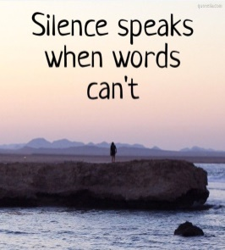
The meeting of two personalities is like the contact of two chemical substances: if there is any reaction both are transformed.

We hear all kinds of theories and tips these days as to how, in this modern world of instant communication, we should take more care over the often hasty comments that can be made in the heat of the moment.
I think the American humorist and philosopher Will Rogers Jr. got it right when he said: “Lead your life so you won’t be ashamed to sell the family parrot to the town gossip’’.
Now, isn’t that a tip worth following??

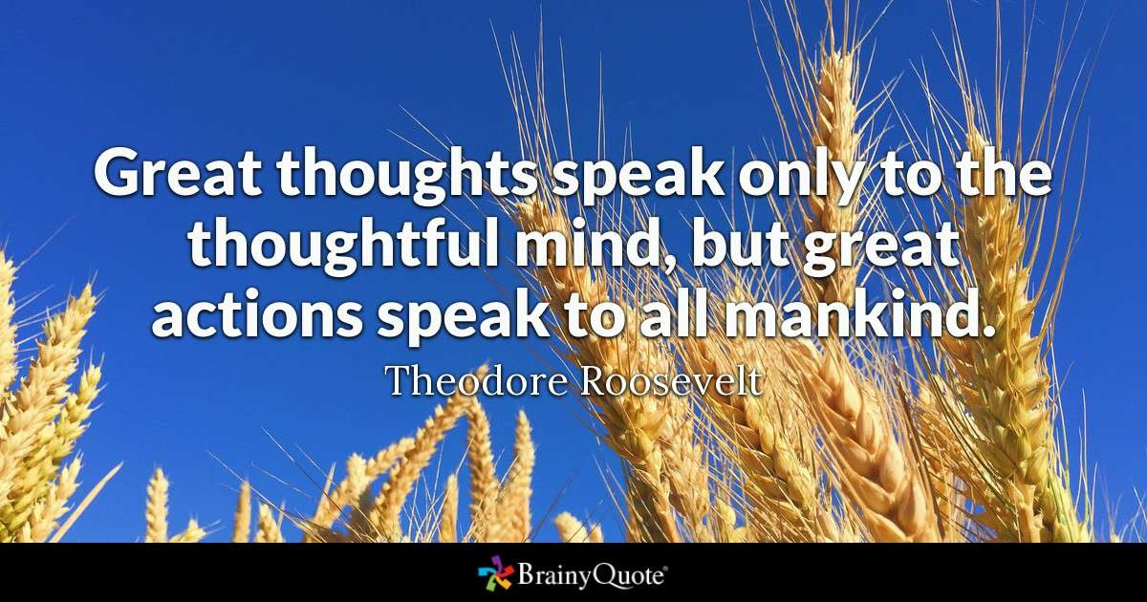

BOOK REVIEW FOR FEBRUARY by Maxwell
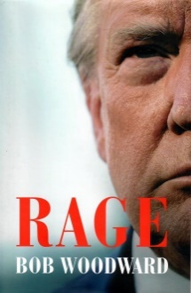
I’ve pretty much exhausted the religious books in the library. Alison suggested I review other books. I thought I would look at some current best sellers, so here goes.
RAGE by Bob Woodward.
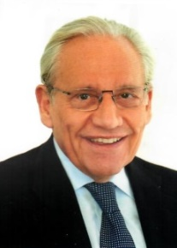
Woodward has uncovered the precise moment that President Trump was warned that the Covid-19 epidemic would be the biggest national security threat to his presidency. In dramatic detail, Woodward takes readers into the oval office when Trump is told in January 2020 that the pandemic could reach the scale of the 1918 Spanish Flu that killed 675,000 Americans.
In 17 on-the-record interviews with Woodward over seven volatile months we are party to an utterly vivid window into Trump’s mind, in which the President provides a self-portrait that is part denial and part combative interchange. These are further mixed with surprising moments of doubt as he glimpses the perils of presidency and what he calls the “dynamite behind every door.”
At key decision points, Rage shows how Trump’s responses to the crises of 2020 were rooted in the instincts, habits, and style he developed during his first three years as president.
Revisiting the earliest days of the Trump presidency, Rage reveals how the Secretaries of both State and Defence, plus the Director of National Intelligence struggled to keep the country safe as the president dismantled any semblance of collegial national security decision-making.
Rage draws from interviews with first-hand witnesses as well as participants’ notes, emails, diaries and confidential documents.
Bob Woodward is an associate editor of the Washington Post, where he has worked for 49 years. He has shared in two Pulitzer prizes, first for the Post’ coverage of the Watergate scandal and the second as the lead reporter for the coverage of the 9/11 terrorist attacks. Bob has always tried to get as close to the truth as possible and he’s continued doing this all his life in 19 books. This is his 20th book. He is one of the great reporters of our time, and no matter how famous and legendary he might be, he has never stopped looking for facts.

FOOD BASKET – don’t forget your donation to the Social Services Food Basket. This is a very worthy cause, as there are families in Whitianga who are really struggling.

WHOS WHO AT ST PETERS
Clergy: Priest in Charge | Rev. Dr. Gillian Reid
Licensed Lay Ministers: | Sharon Short  Maxwell Reid  Nicky Hewlett
Vestry: People’s Warden | Jill Laird
Priest’s Warden | Sharon Short
Synod Reps | Brenda Taylor
 | Nicky Hewlett
Secretary | Kaye Evans
Treasurer | Bob Schibli
Webmaster & Safety Officer | Maxwell Reid  Dawn Schibli
Worship Team: | Gillian Reid
(Roster Coordinator): | Maxwell Reid
 | Dawn Schibli
 | Nicky Hewlett
 | Sharon Short
 | Brenda Taylor
Pastoral Care Team: | Dawn Schibli
 | Gillian Reid
 | Nicky Hewlett
 | Jill Laird
 | Sharon Short

website: wwwanglicanchurchwhitianga.org.nz
Facebook: ww.facebook.com/stpeter.thefisherman.96
Mercury Bay Mission District contact person: Jill Laird
Ph. 8660641, jilliannelaird48@gmail.com

