NETWORK NEWS
ST PETER’S ANGLICAN CHURCH
MERCURY BAY MISSION DISTRICT
April 2022
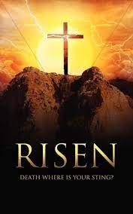

OUR MISSION STATEMENT:

TO KNOW AND MAKE KNOWN THE LOVE OF GOD”

APRIL WORSHIP SERVICES AT ST PETER’S
Sunday 3rd April  Presider: Gillian Reid  Gospel and Reflection | HOLY COMMUNION 9.30am  Liturgist: Nicola Hewlett  Maxwell Reid
Palm Sunday 10th April  Presider: Gillian Reid  Gospel and Reflection | HOLY COMMUNION 9.30am  Liturgist: Dawn Schibli  Gillian Reid
Good Friday 15th April  Presider: Gillian Reid  Gospel and Reflection: | HOLY COMMUNION 9.30am  Liturgist: Sharon Short  Gillian Reid
Easter Sunday 17th April  Presider: Gillian Reid  Gospel and Reflection | HOLY COMMUNION 9.30am  Liturgist: Nicola Hewlett  Gillian Reid
Sunday 24th April  Presider: Gillian Reid  Gospel and Reflection: | HOLY COMMUNION 9.30am  Liturgist: Dawn Schibli  Gillian Reid
Weekly Service Roster
If you swap a duty with someone else – reading, chalice bearer, prayers etc., as well as changing it on the roster by the door please would you let the Liturgist for that Sunday know as they may not check the alterations during the week. This will make it much easier for them when putting the service together. Many thanks.

GILLIAN’S MONTHLY MUSING
The season of Lent is racing past, and our festival of Easter is almost upon us again. Our two big “waiting and anticipation” seasons of Advent and Lent have quite different feels to them. Advent carries the excitement of a joyful arrival – the birth of Christ. All celebration. Lent is a tougher one. We are reflecting on the difficult journey Jesus took, in obedience to God his father, towards his death, walking it in complete trust that the promise of his subsequent resurrection would be delivered.
That is a level of trust and obedience demonstrated by very, very few, previously, and Abraham’s willingness to risk his son Isaac’s life as a sacrifice is probably the most likely one to spring to mind. Two examples of total trust in God and acceptance of His plan. Are regular humans, like me, like us, capable of such trust, such faith that we would put ourselves into such a ‘life-risk’ situation? I don’t know, and in truth, I am pretty nervous about the prospect of ever having to find out. Thus, the willingness of Jesus to make the commitment he did, is truly extraordinary, and as we journey through Lent, we have the opportunity to reflect on how much he was willing to give, for us.
It's a humbling thought and can make this annual recognition of Jesus’ final days on earth, a sobering rather than a celebratory experience. I think we just have to get over that dark part of Jesus’ trial, and crucifixion, and focus on the reason for it all – the proof that God does love us all, flawed as we are. Loves us enough, in spite of all the times we trip, fall, or downright wreck our lives, that he used his Son to be the perfect sacrifice to cleanse us of our sins – then and into the infinite future. The joyful arrival at the end of Lent is as great as Christmas – Jesus is resurrected from the dead. Death is no longer an end; it is a passing though to the chance to be with God, in eternity. All our sins were washed away with that one event. Easter is about resurrection – a rebirth to a new life, and thus gives us every reason to celebrate.
Manaakitanga, Gillian
A good course to get stuck into
60’s plus Strength, Balance and Mobility Classes run by LISA JURY
on Thursday weekly from 10am to 11.00am held at St Peter’s Anglican Church in the lounge. Come and join in any time!

See you there!
***********************************************

Our 2022 Easter Programme

- Palm Sunday – April 10th. We will be making Palm crosses during morning Tea the previous Sunday April 3rd to be blessed and distributed during our Palm Sunday service.
- Maundy Thursday – April 14th. We are having a special service of a shared meal, at church, starting at 5.00pm. A time to reflect on the message Jesus was trying to bring to his disciples about how they should keep his memory alive following his imminent death. This will be followed by all of us helping to strip everything out of the Sanctuary in preparation for Good Friday.
- Good Friday – April 15th. Together we will step through the trial and crucifixion events, contributing items which reflect both of those. A time to reflect on the sacrifice Jesus was willing to make for us. A very important day for all Christians.
- Easter Sunday – April 17th. A great celebration of the final outcome of Jesus’ life on earth. The beginning of the spread of the Good News his existence generated, which has continued to flourish for over 2,000 years.

LAUGHTER Really IS THE BEST MEDICINE !!!!

I was proud of myself because the side of the puzzle box said 3 -4 years, and I finished it in two months.
The shovel is a groundbreaking invention.
Life is sexually transmitted.
Death is the number one killer.
Health nuts are going to feel silly one day, lying in the hospital dying of nothing.
Don’t worry about old age, it doesn’t last long.
I remember the good old days when snap, crackle, pop were sounds I heard from my cereal, not my body.
Some people try to turn back their Odometers. Not me! I want people to know why I look this way. I’ve travelled a long way, and some of the roads weren’t paved.
Childhood memories – Suzie Munroe
My mother once told me that she met my father at the tennis club attached to the company they both worked for, she in the office, he in the factory. He courted her for six years before they were married and settled in the new house, they had bought at Crofton Park near Lewisham. I was born some three years later and lived there for almost five years.
I have few memories of that time apart from the coalman walking through the
house with a sack of coal on his back. Our house was the middle one of three with
no back entrance and the coal bin was in the back garden. My brother was born in that house, and I remember my dad taking me into their bedroom to see the new arrival, another red head like me but a rather battered looking one.
When my brother was a month old, we moved house to another new one in Hayes, Middlesex and Dad went to work at EMI as a scientific instrument worker and tool maker. War broke out just three months later when I was about to start school but that was delayed until the following January so that the underground shelters could be built. I do recall that Christmas I received a brand-new tricycle, and I was delighted.
I spent two terms in the reception class and then moved back into the infant block. By this time the Blitz was in full swing and many a day was spent underground for a while the battle raged in the skies. Lessons still continued but there were no break times and toilets were a sack enclosed in a tin can. How I hated them! If the air raid occurred just before school closed for the day we were not allowed out of the shelter unless collected by a parent and my mother wouldn’t venture out with my brother in the pram. One occasion my teacher asked a friend’s father if he would take me home as I was the last one left since he had taken his daughter and thankfully, he agreed.
I well remember the assembly sometime later when a new teacher was introduced, and she was a married woman! Up to that time married women were not accepted in the profession but with so many men serving in the armed forces the rules were relaxed. The school was very overcrowded as another was being built as war broke out and construction stopped. It was much closer to where I lived but it didn’t open until quite some time after the war finished. All my teachers were women until I reached Standard 3 when Mr. Parsley became my teacher for the next two years. He was the only male teacher after all the others had been conscripted to serve in the armed forces, but he was too old. He was a kind and very good teacher.
We were very lucky during the war and suffered no damage despite being close to London. In August 1944 on a hot summer’s day during the school holiday the air raid warning sounded just after lunch and Mum told my brother and I to get into the Morrison shelter in the dining room while she finished washing the dishes. Shortly after there was a whoomph and a heavy thump
while the net curtains all rolled up the windows. It was a doodlebug, an unmanned aircraft set to bomb the London area and we discovered it later about half a mile away. It had swiped one house and then landed in the gardens at the back of the houses killing two people. Because it was a hot day, we had all the windows open and suffered no damage but across the road the people had gone out for the day and the blast blew out all their windows at the front. There was a wonderful street party to mark the end of the European conflict in May 1945.
In February 1946 I sat, along with all my class, the 11+ exam for entry to a grammar school. Results came out in late June and I was delighted to have gained entry to my chosen grammar school, Bishopshalt School. My class that year numbered 59 pupils and 39 of us had passed the entrance exam for various grammar schools setting a new record for the school. I was one of just eleven who had gained entrance to Bishopshalt. The school was so named as it had been a resting place for the bishops of Worcester on their way to London some two hundred years before. To the old manor house classroom blocks had been added as well as prefab. huts out on the sports field. We had a blue uniform with a thin red and gold stripe on the jumper and had to wear black woollen stockings. Clothing was still on ration, so my family had to give me some of their coupons. We also had a green phys. ed uniform which my mother sewed.
I was placed in 1A which meant I learned both French and Latin as well as the core subjects. It was a mixed school so while the boys had woodwork lessons, we girls had sewing class. Oh horror the sewing machines were all hand operated and I was used to using my mother’s electric one. Our first task was to sew a pair of bloomers, something I would never wear, and which finished up in the waste bin at home. Later while the boys had metalwork, we girls had cooking classes. Shortly after the war ended my father left EMI to work at Technicolor and just eighteen months after I started at Bishopshalt I left as my parents had decided to emigrate to Canada. The house was sold, and we were off in March 1948 sailing in the ss Empress of Canada. After an exciting time looking at whales and icebergs we docked at Halifax, Nova Scotia a week later and then took a two-day train journey to Toronto. I loved looking at the very different scenery while the assistants were all imposing negroes.
On arrival in Toronto the people who met us told us we were booked into an hotel on Centre Island some distance offshore in Lake Ontario which could be reached by ferry. It was really a holiday spot and while Dad looked for work. Mum trailed all around the city looking for somewhere better to stay without success. Mum and Dad were very disillusioned and although Dad was now working at Toronto Hospital they decided to return to England. That year marked the Olympic Games taking place in London and they were told that berths were unlikely to be free until after that took place. However, one Monday in late May there suddenly was a message to say there was a 4-berth cabin cancellation for that Friday which they grabbed. The next day we went into the city to buy another trunk and Mum bought material for curtains, nylons and clothing as rationing and coupons still existed in England. We took the train to Montreal and there a single decker bus took us to the docks. I had to laugh as we travelled over the cobbled streets at the sign above the driver’s head which read “Ne blasphemy pas”.
Dad had once again been offered his job back at Technicolor so from Liverpool we took the train to London and then on to Hayes where we stayed with our ex next door neighbours until a house was bought some three weeks later. It had cost the family a lot of money, but we were all glad to be back. I was lucky enough to get back to my school as one of the girls was leaving to go to a

boarding school. The next week | started school and had end of year exams when I came bottom of the class not having been to school for several months.
I joined the school choir and was in the chorus when they put on “The Mikado” at the local church hall in1949. I was hooked and singing and performing became a love of my life. Two years later we performed “lolanthe” at the RAF theatre in Uxbridge with the RAF orchestra and all proceeds went to the RAF.
In 1953 I left school with eight Ordinary passes and two Advanced passes in the new General Certificate of Education and entered Avery Hill Training College at Eltham where | spent two years living in a college hostel in Chiselhurst and from where I cycled into college. It was a very different life to the one students enjoy today with set times for study and no going out for pleasure except at the weekend unless it was something organised by the college. One of my teaching practices was in North Woolwich and when I watch Call the Midwife it takes me back to those days for the children played in the street, ships funnels loomed over the end of the street and most of their fathers worked in the docks.
On leaving College I was offered a position in a secondary school near home, and I stayed there for three years before leaving for a newly opened school at Mill Hill where on being shown around the school during an interview we were informed that some of the classrooms were unused! They had only taken Form 1 and Form 2 pupils and it had been open just six months. For a while I continued living at home but then went flatting with the Art teacher closer to the school. During my second year at Moat Mount, I saw an advertisement in the Education Gazette where the New Zealand government was Offering free passage to any teachers willing to go to New Zealand for a minimum of two years. I decided that appealed to me and duly applied. After
I said farewell to my parents at Southampton docks and boarded the SS “Southern Cross” not knowing it would be the last time I was to see my dad. It was a one class ship, and I was in a cabin with five other ladies on D deck. We set sail at 3pm and as I leaned over the rail looking for my parents I had the oddest feeling as water became visible between the ship and the dock. Too late now to change my mind!
Seasickness had me in its throes for the first few days as we headed south off the Spanish coast before turning westward towards Trinidad where we went ashore and watched a steel band perform outside a tavern. Then it was on to Curacao where I joined some others for a swim in a cage in the warm: sea with sharks cruising around outside. Quite an-experience! Next, we travelled through the Panama Canal while an American told us all about its construction for several hours over the loudspeaker system which became a little tedious before docking in Panama City where we went ashore to sample the coffee and wine. Our next port of call was Tahiti where we had a day to explore a tropical island before sailing on to Suva in Fiji where I was
astounded to see the big Fijian dockers were barefoot. As we wandered around the town I was impressed with the traffic police in their striking uniform of blue tops and white sulu standing on little roundabouts in the middle of the crossroads. Our final destination was Wellington five weeks after leaving England. What a glorious five weeks it had been with’ special’ celebrations to mark Christmas and New Year.
In Wellington we were given tickets for the overnight train to Auckland which was very different from long distance trains in’ Britain while the run to be first in the queue at the pie shop when the
train pulled into a station was a real eye opener. At Auckland station there was a van waiting to take us and our luggage to the immigration hostel at Mangere.
Following an interview at Auckland Education office I was handed over to the South Auckland office in order to do my country service as I had taught for more than five years and would encounter a salary bar if I did not do it. Thus I received a telegram telling me to report to PioPio District High School on Tuesday following Auckland Anniversary Day. The hostel manager helped me book a seat on the White Star bus and so began my life in New Zealand, but that is another story.
a

BOOK REVIEW FOR APRIL – by Maxwell
The Moment of Lift - by Melinda Gates
Melinda Gates’ book, The Moment of Lift is listed by the New York Times as a best seller. The book describes how empowering women changes the world, and could be described as a moral appeal to all of us, imploring each of us to look around – at our families, our workplaces, and our own place in a gigantic but highly connected world – and do what we can to make it more equal. We need this message more than ever. In reality, the book is a horror story, documenting the horrific treatment, and the quaint customs of some people in what we now call the third world.
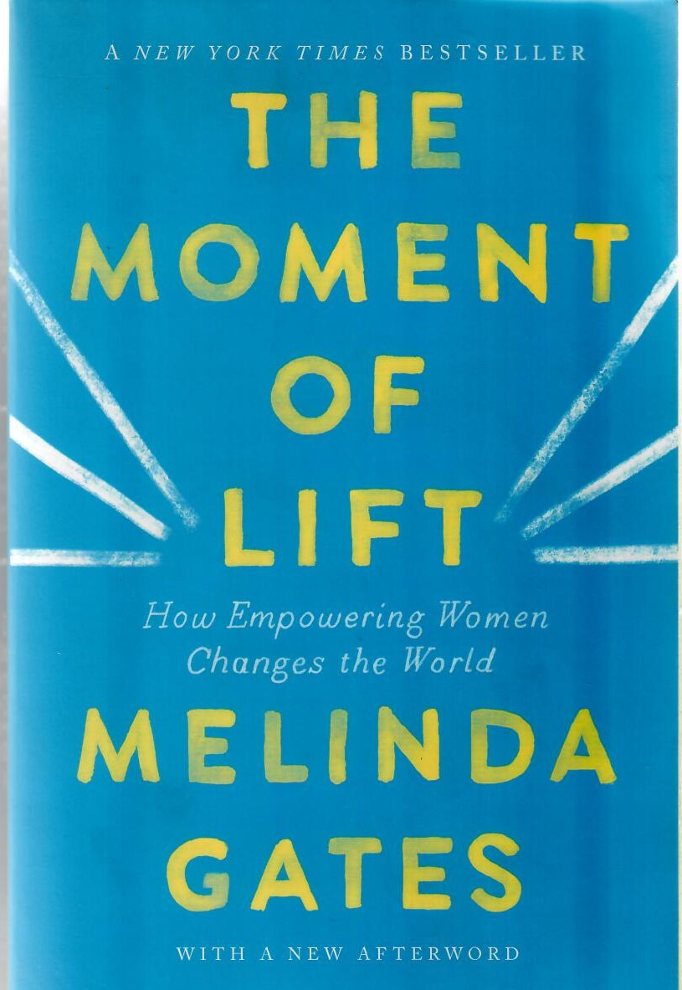
The term Third World is commonly used nowadays when referring to a country with an underdeveloped economy. The original term was used during the Cold War to describe those countries not in the first two; i.e. the NATO partners and the WARSAW Pact membership countries.
For the last twenty years, Melinda Gates has been on a mission to find solutions for people with the most urgent needs, wherever they live. Melinda’s journey has taught her that in order to lift a society up, you need to stop keeping women down. In this moving and compelling book, Melinda shares lessons she’s learned from the inspiring people she’s met during her work around the world, along with unforgettable stories backed by startling data about issues such as child marriage, unpaid labour, and lack of access to contraceptives. Furthermore, for the first time, she writes about her personal life and the road to equality in her own marriage. Throughout the book, she shows how there has never been more opportunity to change the world, and ourselves.
Melinda Gates is a philanthropist, businesswoman, and global advocate for women and girls. She is co-chair of the Bill and Melinda Gates Foundation and founder of pivotal ventures. Melinda grew up in Dallas, Texas, and received a bachelor’s degree in Computer Science and an MBA.
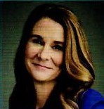

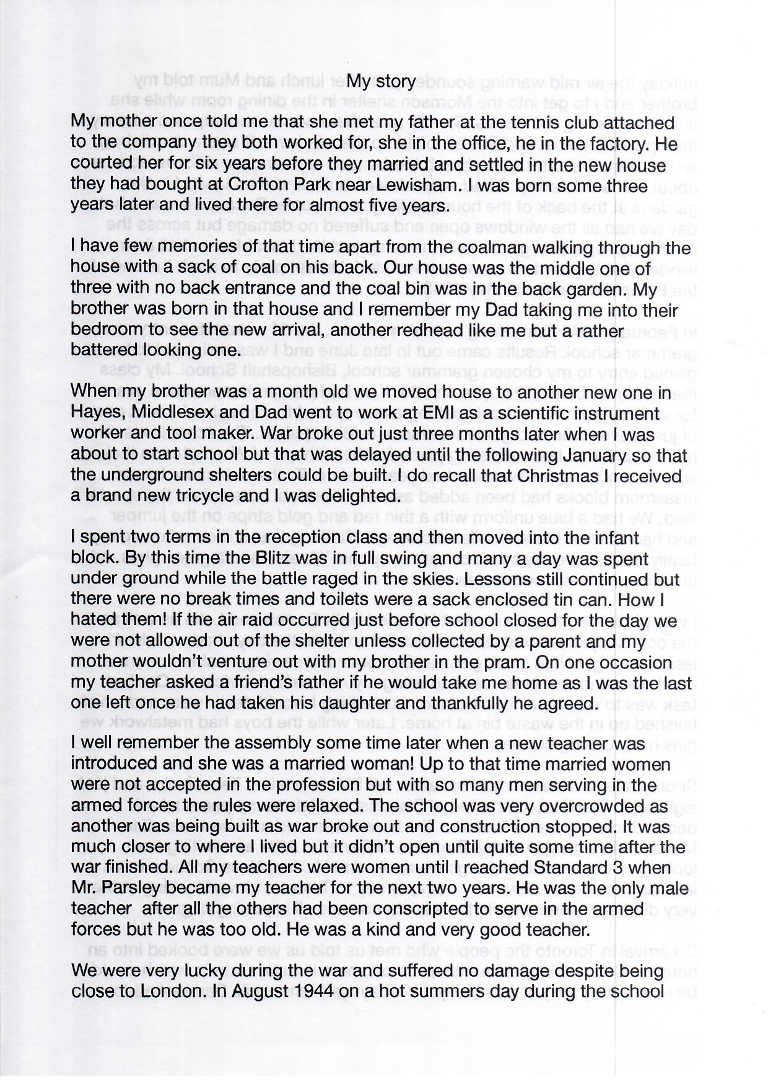
FOOD BASKET – don’t forget your donation to the Social Services Food Basket. This is a very worthy cause, as there are families in Whitianga who are really struggling.

PRAYERS AND THOUGHTS
Generous God, as you call us to faith, you gift Jesus to us as a mark of your love. When we, like Abraham and Nicodemus, try to live our faith, remind us afresh that you gift not only life to us but also the ability to respond to life. May we not hoard this gift but share it willingly with all creation.

A Sad and special Goodbye
This Easter we have to farewell our much-loved Suzie Munroe, who is moving to Nelson to be closer to her family. Suzie, you have been a valued member of the St Peter’s congregation for many years, and a great contributor to the quality of our worship. We will really miss you, but hope that your new life in Nelson with your boys and their families, is all you hope it will be. You go with our love and blessings.

Some Interesting things about Easter

Easter Sunday is coming up faster than Peter Cottontail hopping down the bunny trail. The Christian holiday, which will be celebrated on Sunday, April 17 this year, has been observed since the second century as a celebration of the resurrection of Jesus Christ. Over the years, many Easter traditions have also arisen to mark the occasion, including everything from chocolate bunnies to Easter egg hunts. Some of them are regional, others depend on your family's cultural origin and still others can vary even from household to household.
However, you celebrate, there is so much that makes this holiday the special occasion that it is today — whether people mark it in a religious or secular way. Here, we've rounded up some of the history of Easter.
Easter Eggs
From dyed eggs to chocolate eggs to egg hunts, nothing says "Easter" like the incredible edible. Yet our modern take on collecting, dyeing and decorating eggs comes from a tradition dating back thousands of years, long before the time of Jesus Christ.
Many ancient cultures, including the Greeks and Egyptians, saw eggs as a sign of fertility and new life. They used eggs in religious rituals and hung them in pagan temples
Later, as Christian missionaries observed community members hunting for eggs in the spring, they began using the food as a tool to describe Christ's new birth in resurrection. "They would dye the eggs based on what colors meant to the church: yellow for resurrection, blue for love, red for the blood of Christ. Or, they would paint
various scenes from the Bible on eggs and hide them; the child who found the egg would come back and tell the story painted on that egg,

Lent
We can thank Lent for our celebratory Easter feasts. Originally, Lent required people to fast for 40 days (excluding Sundays). These days, most observers abstain from meat that isn't fish on Fridays only, as well as give up an indulgence, like caffeine, chocolate, television or social media.
The exact end date for Lent can vary slightly depending on whether the church is following Western or Eastern practices, but it tends to end either at the beginning of Holy Week or on Easter itself. Either way, people are definitely ready to dig into some of the sweet and savory dishes they've been missing by the time the ham comes out of the oven.
The Easter Bunny
Like many traditions, the Easter Bunny evolved out of ancient fertility and spring celebrations. Rabbits give birth in the spring so, when the fields became overrun with baby bunnies, it seemed natural to incorporate the rabbit as a symbol for spring and, eventually, Easter.
Hot Cross Buns
These festive rolls trace back to ancient Egypt, Rome and Greece, where they served as symbols of honour toward their goddesses, according to the Oxford Companion to Food. Later, the sweet breads became popular at Easter, especially in England where bakers were forbidden to sell spice breads except on special holidays, like the Friday before Easter.
Many English people believed hot cross buns baked on Good Friday would never grow mouldy so they were kept as good luck charms, accompanied sailors on voyages or were buried in piles of grain to ward off rodents. Today, they're mostly representations of the Christian symbol of the cross, as well as a sweet, buttery addition to an elegant Easter meal.

Don’t Forget our Outreach and Activity Groups
Knit for a Purpose:
Meets on the first and third Friday of the month, from 10.00am to 12.00pm, for good coffee, morning tea, and fellowship, while making garments and blankets for children in the care of the Anglican Trust for Women and Children. Knitting yarn, needles and patterns supplied, along with encouragement and helpful advice if needed. New members are always welcome.

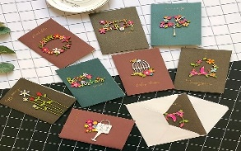
Card Making:
Meets on the second and fourth Friday of the month, from 10.00am to 12.00pm, for good coffee, morning tea, fellowship, and loads of laughs as we try to follow our teacher’s guidance to make personalized greeting cards. (There are no such things as mistakes, just creative differences, easily concealed if desired). Heaps of resources available to share. New members, skilled or unskilled, are always welcome.
Seniors Strength, Balance and mobility classes:
Meets every Thursday morning, 10.00am to 11.00am. For ‘seniors’ - how to exercise sitting down or leaning on a chair, without breaking out in a sweat. All levels of personal unfitness welcome! Join in any time.

Men’s gardening group:
Meets on Friday afternoon, 1.00pm for a couple of hours working in the church garden producing vegetables for Community Social Services and maintaining the church grounds. All keen (or just hopeful) gardeners welcome. Contact Maxwell on 027 4906120.

WHOS WHO AT ST PETERS
Clergy: Priest in Charge | Rev. Dr. Gillian Reid
Licensed Lay Ministers: | Sharon Short  Nicky Hewlett  Maxwell Reid
Vestry: People’s Warden | Jill Laird
Priest’s Warden | Sharon Short
Synod Reps | Nicky Hewlett
Secretary | Kaye Evans
Treasurer | Bob Schibli
Webmaster & Safety Officer | Maxwell Reid  Dawn Schibli
Worship Team: | Gillian Reid
(Roster Coordinator): | Maxwell Reid
 | Dawn Schibli
 | Nicky Hewlett
 | Sharon Short
 | Brenda Taylor
Pastoral Care Team: | Dawn Schibli
 | Gillian Reid
 | Nicky Hewlett
 | Jill Laird
 | Sharon Short

website: wwwanglicanchurchwhitianga.org.nz
Facebook: ww.facebook.com/stpeter.thefisherman.96
Mercury Bay Mission District contact person: Jill Laird
Ph. 8660641, jilliannelaird48@gmail.com

